Eco Centre Office Space
Here at The Eco Centre we can offer office space between 30sq m to 104sq m
Our rental costs are very competitive and include all business rates and utilities. Internet and telephone connections are not included.
All offices have wall mounted trunking including power points and can be adapted for data points. The building has communal kitchens on both the ground and first floor. Reception services operate Monday to Friday and include meeting and greeting visitors, signing for parcels and delivering post to individual offices.
The Eco Centre is open between 5.00am and 11.00pm seven days a week and provides free car parking (first come first served basis). Access into the building, and individual offices, is via electronic key fobs and all offices have individual intruder alarms.
The Eco Centre boasts both a Board Room and Conference Room which are available for hire at reduced rates for tenants.
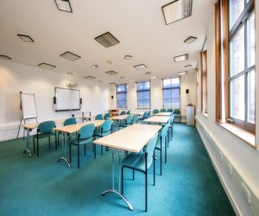 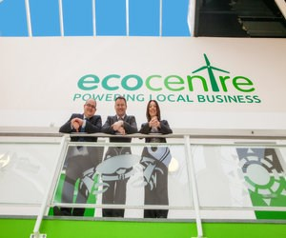 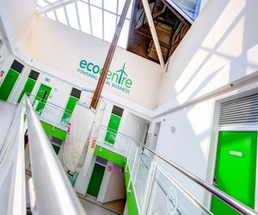 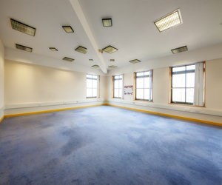
For more information contact The Eco Centre Team today on 0191 428 1144 or emailecocentre@groundwork.org.uk

