Eco Centre Room Hire
The Eco Centre has a high-quality Board Room and Conference Room available for hire. Our expert and friendly team will work with you to ensure that your meeting or event runs smoothly. We can provide facilities such as PowerPoint equipment, flip charts and projectors upon request. Free car parking is available for all Board and Conference room users, on a first come first served basis. Additional car parking is available locally.
Room | Cost | Capacity | Refreshments | Catering
MacFarlane Room (Board Room) | Full Day: £80  Half Day: £40 | 15 people (formal)  25 people (informal) | Tea and Coffee: £1.50 per head (includes biscuits) | Via local specialist companies (upon request)
Patterson Room  (Conference Room) | Full Day: £110  Half Day: £65 | 25 people (formal)  40 people (theatre)  50 people (informal) | Tea and Coffee: £1.50 per head (includes biscuits) | Via local specialist companies (upon request)
Click here to download a Room Hire Booking Form
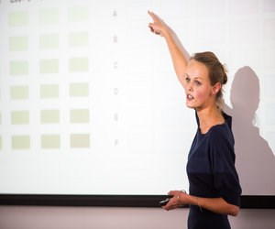 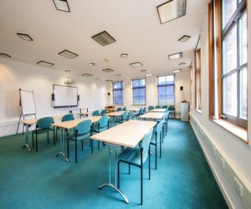 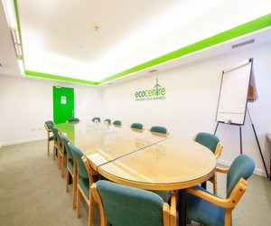 
For more information contact The Eco Centre Team today on 0191 428 1144 or emailecocentre@groundwork.org.uk
Hebburn NE31 1SR
<!-- JSON-LD markup generated by Google Structured Data Markup Helper. --> <script type="application/ld+json"> { "@context" : "http://schema.org", "@type" : "LocalBusiness", "name" : "The Eco Centre", "telephone" : "0191 4281144", "email" : "ecocentre@groundwork.org.uk", "address" : { "@type" : "PostalAddress", "streetAddress" : "Windmill Way", "addressLocality" : "Hebburn", "postalCode" : "NE31 1SR" } } </script>

