GROUNDWORK  CHANGING PLACES  CHANGING LIVES |  | 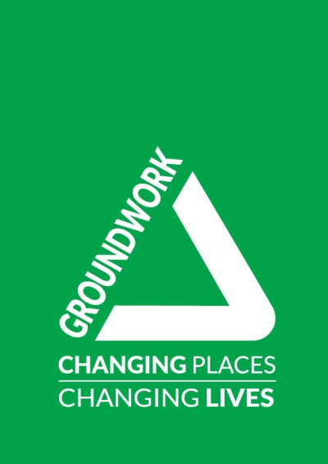
Learning programmes subcontractor policy
Date of last review: August 2019
Date of next review: August 2020

Rationale
Groundwork UK works to support Groundwork's local delivery through national relationships, resources and representation. We manage major programmes and contracts delivered by local Groundwork Trusts and other delivery partners through subcontracting arrangements. All our learning programmes are delivered in this way, with no learning delivered directly by Groundwork UK. This provides a national delivery model with local reach, covering England, Northern Ireland and Wales.

Groundwork UK’s management model for contracts and programmes centres on collaboration and partnership, utilising an experienced supply chain of organisations with a strong track record of engaging target groups and delivering tailored and effective interventions. At all times Groundwork UK ensures that the approaches and methods of our subcontractors has a clear strategic fit with our mission, objectives and values, and is in the best interests of learners.

Supply chain fees and charges statement
It is Groundwork UK’s policy to be fair, open and transparent about the fees and charges it sets in relation to the management of contracts and programmes delivered by third parties. As a responsible contractor Groundwork UK seeks always to ensure it balances fairly the need to retain sufficient resource to manage performance, quality and compliance while ensuring optimum resource is available to subcontracted partner organisations to enable high quality delivery and to support organisational development.

Fees and support
Groundwork UK aims to act as an effective, efficient and ethical prime contractor. We recognise that every programme, contract and supply chain we manage will be different, requiring a tailored approach to management, quality and support. In order to resource this management, we retain a management fee from all subcontracted partner organisations, which typically ranges from 10% to 20%. However, this is not fixed.

The fees charged reflect the cost of the procurement process, management requirements of the commissioner and support required by subcontracted partner organisations. Not all subcontracted partner organisations are charged the same management fee with the differences in fees being dependent upon the level of support required, the experience of the subcontracted partner organisation, their target learners, track record, published success rates and the level of risk as determined by our due diligence process. The exact mix and level of support for each subcontracted partner organisation will vary. Management fees help us provide the following support and service for our subcontracted partner organisations:

- pre-contract and implementation meetings and support
- processing and checking of all deliverable achievement documentation
- regular monitoring visits with detailed feedback identifying good practice and areas for improvement
- regular compliance checks
- quality management system and process
- partnership meetings
- management information system and support

Subcontracts will include a list of specific costs for the services offered to each subcontracted partner organisation, along with an explanation of how each cost is reasonable and proportionate to delivery, and how each cost contributes to the delivery of high quality learning.

Improving the quality of teaching and learning
Subcontracted delivery partners will participate in Groundwork UK’s quality assurance processes, with Groundwork UK being committed to supporting, developing and sharing good practice in order to continuously improve the quality of teaching and learning, through:

- open feedback mechanisms for participants to report their experiences
- observations of practice by Groundwork UK, external consultants, or peers from other delivery partner organisations
- self-assessment processes and continual review

The quality of provision by subcontracted partner organisations will be monitored and managed in line with Groundwork UK’s quality framework and associated self-assessments and improvement plans to ensure continuous improvement in all parts of the learner journey.

Payment terms
Payment arrangements will be negotiated with subcontracted partner organisations subject to the terms of the commissioning authority, the nature of the contract and the needs of the supply chain. All payments will be made in arrears on the basis of approved and unpaid claims as they appear on Groundwork UK’s management information system on the final working day of each claim period. All valid claim applications received by the last working day of the period will be processed by Groundwork UK for the next scheduled monthly return to the funder. Each subcontracted partner organisation will be sent a Statement of Claims that have been approved for payment by Groundwork UK in line with agreed timescales in the Programme Requirements document and only after Groundwork UK has received the funding from the Funding Agency. Payment of subcontracted partner organisation invoices will then be made within 30 days of Groundwork UK receiving a valid claim for payment.

Policy review and communication
This policy is given to all subcontracted partner organisations as part of their contract. In supplying this policy alongside a breakdown of the services we will offer within the contract, we will ensure that the following are clearly communicated prior to an agreement being finalised:

- our reasoning for subcontracting,
- the services we will provide
- the cost of these services, and our justification (describing how each cost is reasonable and proportionate to delivery)
- how our costed services contribute to high quality learning

The policy is published on the Groundwork UK website and is reviewed on an annual basis.

