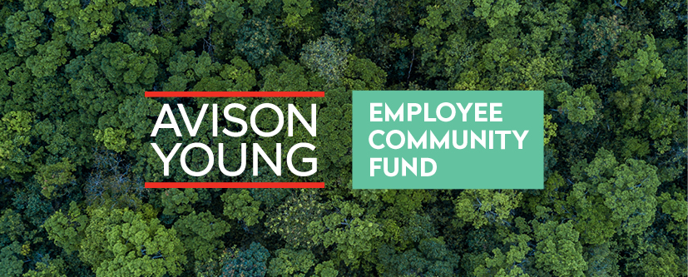
Welcome to the Avison Young Employee Community Fund.

As part of our ongoing commitment to the communities we live and work in, we have developed this fund so that you can put forward the causes, projects and charities that you are involved with and that you think we should support. We know that many of you are involved in the work of charities or other organisations (e.g. schools, church groups) and this is your chance to support them financially as well.

We will be working with Groundwork as our chosen charity partner. Groundwork is a national charity dedicated to improving UK communities and they are experienced grant managers. They will manage the application and award processes to ensure that our funding is going to the organisations and projects that need it most whilst ensuring that we manage our investments properly.

Throughout this year, we will be fundraising with Groundwork’s support so that we can maximise the investments made by the Employee Community Fund. This approach to charitable support is innovative and the more we fundraise, the more causes and projects, that you care about, we can support.

Please take time to read and understand the process. Check the priorities and make sure that your project ideas meet at least one of these. You will lead the initial steps in the process, working closely with the organisation that you are putting forward for funding. This will require you to answer certain questions on their behalf.
We look forward to supporting some wonderful projects and really making an impact in your communities.
Good luck!

The process

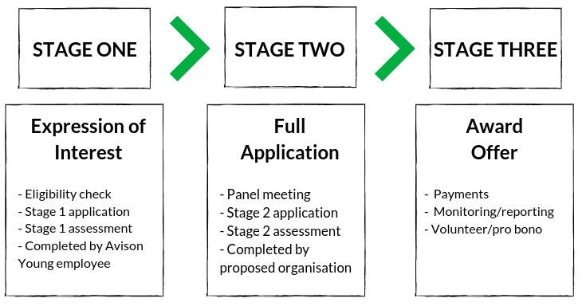

- Eligibility Check and Stage 1 application
You should submit this to Groundwork as the Avison Young employee.

You will need to upload your response by following the link in the ‘Apply’ section of the website, or by clicking here. It is not possible to save the web form as you go, so only start to fill this in when you are sure you have all the details you need. Work on this word document and when you are ready copy and paste your answers into the web form.

You will need to work closely with the organisation you are proposing to answer some of the questions accurately. The organisation you are proposing will need to be able to answer YES to the eligibility questions. Groundwork and Avison Young need assurance that the organisation is set up to receive grant funding, has robust management and that the project will complete as intended. Before we award funding, Groundwork will request eligibility evidence from the organisation so it is essential that organisations know these requirements before you start the process.

If the application is for funding of less than £500, then this stage 1 application will be all you need. Applications over £500 will be panel assessed.

You can submit stage 1 applications at any time. We will assess stage 1 applications within 1 month of receipt. A panel of Avison Young employees will carry out assessments

- Panel Decision
A panel made up of Avison Young colleagues and Groundwork will assess the application. If successful, Groundwork will send Stage 2 application forms directly to the organisation you proposed. Groundwork will let you know this has happened.

- Stage 2 Application
Completed and submitted by the organisation you have proposed. Once submitted this will be assessed by the Panel.

Avison Young Employee Community Fund Priorities

The list below highlights the priorities of the programme, and makes a number of suggestions of potential project ideas that could be eligible. This list is not exhaustive and your idea might fit within one of the priorities but not listed here.

Priorities | Potential project ideas
Poverty and inequality | to help lift people out of poverty, alleviate the perils of hunger and provide support for people who face homelessness
Environmental protection | to protect and restore soil, freshwater, forests and biodiversity
Health and wellbeing | to ensure healthy lives and promote the physical and mental well-being of people at all ages
Education and employment | Strengthen the UK workforce through high quality education, training and skills development
Buildings and Facilities | Improve buildings that benefit the local community such as a Scout hut, church or village hall, changing facilities for sports
Outdoor space | Developing outdoor space, play area, allotments, parks, school grounds, and woodland or wildlife areas
Community Cohesion | Help families or individuals from diverse or disadvantaged backgrounds come together for mutual support and a common purpose
Social care | helping people with day-to-day living because of old age, illness or disability

We know that you have many interests, and we have tried to reflect that variety within the priorities of the programme. If you are unsure however whether your project fits the bill then please contact Groundwork via email ayecf@groundwork.org.uk

Avison Young Employee Community Fund

Stage 1 Application

Now that you have confirmed that the organisation is eligible, you will need to submit a stage 1 application form. We have kept this light touch to provide the information we need to progress this into the next stage.

You, as the Avison Young employee, will need to submit this form but the organisation you are proposing can help you to complete the form.

You can submit a stage 1 application at any time and once received, Groundwork and the Avison Young panel will assess the application within 4 weeks.

- Avison Young Colleague contact details

Lead contact first name:
Lead contact surname
Job title:
Direct phone number:
Mobile number:
Email address:
Office Address:

- Charity / organisation / Partner name

Organisation Name:

- Why are you putting this organisation forward for support? We want to understand why this project or cause is important to you.

Why are you putting this organisation forward for support?

- Charity / Organisation / Partner contact details

Lead contact first name:
Lead contact surname
Job title:
Direct phone number:
Mobile number:
Email address:
Office Address Location:
Office Address Postcode:
Website:

- Please tick this box to confirm that the charity partner has been contacted and their details can be shared for the application submissions purpose

Tick box

- By ticking the boxes below, you are indicating that, ‘YES’ the organisation I am proposing will meet these expectations. It is important that each of these is a YES and that you check these with the organisation.

Eligibility checker | Yes / No
Is the organisation you are putting forward a registered charity, voluntary organisation, community group, community facility, sports club, school or other organisation dedicated to community?
Does the organisation have a governing document in the name of the organisation? (e.g. a constitution)
Does the group’s management committee consist of at least 3 unrelated members?
Does the organisation have relevant insurance that covers the activities?
If we award the organisation funding, will the project start within 3 months of the award, and complete within 12 months?
Does the organisation have a demonstrable track record of successfully delivering projects? Can they provide evidence?
The project is not religious or political in nature. (NB this doesn’t exclude projects coordinated by churches for the benefit of local communities)
Does the organisation commit to providing photos, case studies and completing monitoring information requests in a timely fashion?
Should the stage 1 application be successful, does the organisation commit to completing the stage 2 application and provide the evidence as needed to award funding?
Answer only if your project is a land improvement project. If the organisation does not own the land where the project will take place (e.g. a community allotment, park), does the organisation have the landowners permission to do the work?

- Avison Young Employee Community Fund Priorities

Please mark in the boxes below which priority you feel your project meets. Please mark more than one if appropriate.
Priorities |  | Yes / No
Poverty and inequality | to help lift people out of poverty, alleviate the perils of hunger and provide support for people who face homelessness
Environmental protection | to protect and restore soil, freshwater, forests and biodiversity
Health and wellbeing | to ensure healthy lives and promote the physical and mental well-being of people at all ages
Education and employment | Strengthen the UK workforce through high quality education, training and skills development
Buildings and Facilities | Improve buildings that benefit the local community such as a Scout hut, church or village hall, changing facilities for sports
Outdoor space | Developing outdoor space, play area, allotments, parks, school grounds, and woodland or wildlife areas
Community Cohesion | Help families or individuals from diverse or disadvantaged backgrounds come together for mutual support and a common purpose
Social care | helping people with day-to-day living because of old age, illness or disability

- Project Information

Project title:
Project location(s):

- Project Summary (Max 300 words)

Tell us about the project, what it aims to achieve, what it will do, the difference it will make, and who will benefit, etc.

This will be the main section we will use to assess the project, so make sure you really ‘sell’ it!

- Project cost

How much funding is the organisation seeking?

(Grants available between £250 and £5000)
Is this grant request part of a larger project?

If so, please describe.

When you have answered all these questions, you are ready to submit. Please submit the application via the web form, available here.

We will confirm receipt and we commit to assess the stage 1 application within 4 weeks.

If successful, we will invite the organisation you have proposed to complete a Stage 2 application. We will also notify you that this has happened so that you can continue to support them in the process.

For applications for support of less than £500, we will assess and award based on this form.

Privacy Information
Who we are
Data Protection laws changed on 25 May 2018. This notice sets out most of your rights under the new data protection laws - the General Data Protection Regulation (GDPR) - which replace the Data Protection Act. Personal data is information that relates to, or could be used to identify you or another person. Data protection legislation does not relate to non-personal information – for example, about an organisation or your project.

Groundwork is the data controller and contract holder (ICO registration number Z6601182) responsible for personal data about Avison Young applicants and approved grantees. We do not trade personal data for commercial purposes and will only process your data if required by law, necessary to administer your grant, or with your consent.

How we will use your personal data
We will process the personal data you provide for the purpose of administering your grant application (assessing your application, grant due diligence, processing grant payments grant variations, grant monitoring, end of grant reporting) on the basis of a contract (the Grant Agreement) between yourself and Groundwork.

The personal information we will hold will be your name, contact details and payment information. If you are using an accountable body to process your grant funds, we will hold the organisation information and organisation payment information.

Where you choose to receive email marketing about Groundwork’s other activities, we will process your contact information out on the basis of your consent for us to do so.

To protect our legitimate interests, we may also conduct checks against records held by other government departments, and other agencies for the purposes of assessing your eligibility for a grant, preventing fraud, or for the purposes of the prevention or detection of crime.

Information may be shared with the funding body Avison Young if necessary. We need to keep the details of financial transactions for 7 years, in the event of a tax or banking enquiry.

