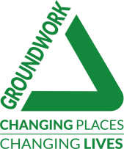
BARNSLEY ALLOTMENT APPLICATION FORM

GROUNDWORK IN YORKSHIRE
Unit 5, Oakwell Business Centre
Oakwell View
Barnsley
South Yorkshire
S71 1HX

Please note this is not an open office, all forms must be returned by post.

01142 636422

I, the undersigned wish to make application for an allotment garden provided by the Council.

First Name

Last Name

Address:

Post Code:

Phone: Mobile:

E-mail:

DOB: (All applicants must be aged 18 years or over)

Area or site name where allotment is required:

Do you rent any allotment at present from the Council? Yes No

If ‘YES’ please give site and plot details:

Disability Discrimination Act: Please inform us of specific needs.

How did you find out about the provision of allotments? Please tick:

Local knowledge Family/Friends Advertisements

Other—Please specify:

In the event of my application being granted I agree, when required by Groundwork Yorkshire, to sign an agreement in accordance with the rules and regulations of the Council governing allotments, and pay the initial administration fee as demanded.

Date: Signed:

Please specify what you intend to use the allotment for and what you plan to put on it.
(Leaving this blank will void your application)

