GROUNDWORK REPORT |  | 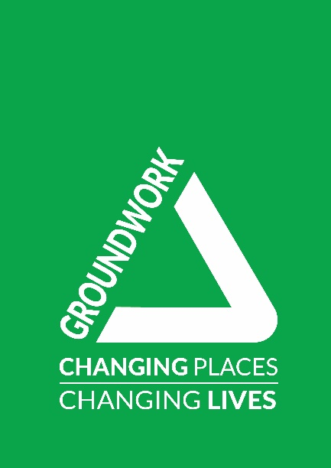

Nourish: Edward Woods Estate – Greening Open Spaces
Stage 2 Consultation Survey Summary Report
August 2021

Contents

1. Executive Summary 1
2. Introduction 3
3. The Consultation Process 4
3.1 Engagement Approach…………………………………………………………. 4
3.2 Engagement Delivery…………………………………………………… 5
3.3 Consultation Outcomes……………………………………………………… 5
3.4 Summary of online survey results…………………………………………… .6
4. Next Steps……………………………………………………………………………… 9
5. Contact details………………………………………………………………………………19

Appendices

Appendix 1: Edward Woods Online Survey and comments on the proposals
Appendix 2: Consultation Publicity

1. Executive Summary
As part of the Nourish programme, Groundwork London’s Landscape Architecture team conducted a feasibility assessment of Edward Woods estate’s green spaces to identify potential areas that could be improved. From September 2019 the Groundwork London Communities team (GWL) undertook consultation with the residents at Edward Woods Estate to discern greening priorities for the estate.

Following this a set of final proposals were drawn up and during the first half of 2020 a 2nd stage consultation process took place.
The premise behind this consultation was to gain final comments or feedback on the proposals.

1.1 How we collected your comments:
- creation and distribution of an online survey
- meeting with the EWE Tenants and Residents Association
- Working with the Edward Woods Community Centre and Nourish Hub to support the consultation process by capitalising on their relationships and experience with Edward Woods estate residents
- Distribution of physical leaflets with links to website and online survey to households
- Displaying posters with links to the website and online survey around Edward Woods estate and in local business premises
- Face-to-face conversations through pop-up events and door knocking

This document outlines that all 750 households received a letter informing them of consultation and opportunities to engage, 49 people were engaged with 24 completing the on-line survey and 25 having a face-to-face conversation, a further 137 were given a reminder of the online survey.

Despite the range and intensity of the consultation being stifled somewhat by the effects of Covid-19, we still managed to undertake face-to-face conversations (pop-up events), collect on-line surveys, set up on-line meetings (Tenants and Residents Association (TRA)) and carry out door knocking with leafleting (Norland House, Swanscombe House).

1.2 Findings
On the whole, the vast majority of feedback from the surveys was positive in response to the proposals for improving green spaces. Even individuals who had queries and some concerns around certain aspects of the proposals accepted the scheme as something they would like to see go ahead. The ‘Summary of on-line survey results’ table on page 6 reflects this.
The main themes from survey responses were:
- Gardening. There seemed an appetite for gardening from some members of the community as well as how more residents can be encouraged to get involved in gardening.
- Maintenance of green sites. There was concern around the long-term upkeep of garden and green spaces. The area’s most of concern in this respect were the proposed community garden and the existing planters on Swanscombe Road and outside the Nourish Hub. Residents commented that the planters in particular seemed to lack any consistent maintenance strategy and attracted a lot of littering even though there are bins nearby. The concern being that even after they have been revamped how could they be kept in good condition?
- Dog walking / fouling. There were also comments around dog fouling and how it can be managed better, especially when a community garden is introduced. There were comments around dedicated dog walking areas and signage to support this.
- Issues outside this project. Some people took the opportunity to highlight other issues outside the remit of this development, they have been noted to pass onto to the relevant bodies. These include existing trees that obscure CCTV being cut back, maintenance of sites outside of those in this project, waste disposal.

1.3 Recommendations based on feedback
- To set up final focus groups with the TRA and Community Champions to ensure as many people as possible have had the opportunity to feedback and have seen the final proposals.
- Identify keen gardeners in the community to help planting in the community garden and getting other residents involved.
- Work closer with the TRA and Community Centre to promote the community garden and showcase the new development.
- Introduce signage based on concerns such as littering, dog fouling and getting involved in the community garden. One other discussion that took place was around general signage highlighting all the green spaces within the Edwards Woods Estate – including areas not part of this development. This could act to signpost people to the most appropriate space and increase engagement through a sense of pride and belonging.

1.4 Next Steps
The immediate next steps in the process will be for GWL to Identify opportunities where the final proposals can be show-cased, and any final focus groups can be arranged. A project programme has been included in this report in section 4 which provides dates for future project stages including final design development, tender process, on-site work start and finish.

2. Introduction
Nourish is a large-scale project being delivered as part of the Good Growth Fund, a Mayor of London initiative to promote sustainable development of London. The London Borough Hammersmith and Fulham is working with Groundwork London to talk to residents, community organisations and businesses about how we can enhance housing estates using retrofit SuDS, Green Infrastructure and community food growing.

The project was awarded funding to run community consultation, develop designs for the space and complete the capital improvement. Funding has come from Thames Water, Section 106 and Greater London Authority.

The aims of the projects are to:
- Provide residents of Edward Woods Estate with opportunities to inform the design of their communal green spaces; and
- Deliver a high quality, improvement project which will serve to provide improved opportunities for social interactions and activities for residents and enable them to use the green/ open spaces for gardening, food growing, play and social activities.

3. The Consultation Process
3.1 Engagement Approach
Once the 2nd stage proposals for the green site developments were complete, residents were given a further opportunity give their feedback and comments. The activities to promote the survey and for residents to give feedback are outlined below.

Activity | Details/Target Numbers | Dates 2021
Online Survey | Total of 24 surveys completed | From May
TRA Zoom Meetings | TRA members - 1 attendee from the TRA | May
Poster Distribution | Around Edward Woods Estate (external railings) and notice boards (Norland House, Swanscombe House, outside Boxmoor)  To local businesses (Swanscombe Road), community centre and Nourish Hub. | June
Pop-up Events x2 | Corner of St Anne’s Road and Swanscombe Road in collaboration with UK Harvest  Outside the Edward Woods Community Centre  A total of 25 people stopped to talk about the proposals as opposed to picking up a leaflet only | 9th & 10th June
Leaflet Posting  (Leaflet was smaller version of Appendix (ii)) | Leaflets delivered through letterbox flats 1-41 Swanscombe House  Leaflets delivery to flats 1-66 Norland House  30 Leaflets delivered to houses adjacent to Nourish Hub on St Ann’s Road and on Darnley Terrace. | July
Door conversations | Post July 19th Covid-safe door-to-door conversations and leaflet drop. This took place in Norland House.  3 doorstep conversations, online surveys completed | July

3.2 Engagement delivery
- All households received a letter advising them of the consultation and opportunities to engage and feedback
- A Consultation letter was also delivered to adjoining RBKC properties (St Ann’s Road and Damley Terrace)
- A total of 48 people responded via on-line survey or a face-to-face conversation
- 137 households in Norland House and Swanscombe House received reminder leaflets with links to the online survey
- 24 people responded to the online survey
- 25 Conversations were had face-to-face (socially distanced) during 2 pop-up events and 3 on doorsteps of Norland House residents

3.3 Consultation Outcomes
Below is a summary of comments raised through face-to-face conversations during 2 pop-up events and physical door knocking
Pop-up Events Comments

Lots of comments about who would lead the gardening, how will on-going maintenance be handled?
A local resident who helps out with the gardening at the Community Centre would be happy to lead some of the gardening activities.
We need something in place to get residents involved with gardening around the estate.
Who looks after the planters on the street? I know an old lady who is always looking after them now and again but no one else
How can we stop people using the flower beds as bins?
Need something in place to make sure people respect the community garden.
Maintenance of Norland Open Spaces Park, it’s not in the proposals but apparently being used as a public park for estate residents and people from the outside.
Signage is needed to stop dog fouling in the green areas
Can we get cyclists to dismount along the narrow paths?
Door knocking Comments

Gardening for elderly people please
Flexible gardening would be nice with someone to show you what to do

3.4 Summary of online survey results
Survey Questions | Number of people answered | Some of the Comments relating to the proposals | Other Comments
Opening the space to the front of the community centre | 19 | - Love it  - Yes more space needed  - Outside gym would be nice  - Good to have open spaces. I would want there to be enough benches / seating areas  - Will there appropriate signs around the community garden. Mainly for people to respect it and how they can get involved | - trees obscuring CCTV and growing closer to buildings including the community centre itself. Who would be responsible for cutting these back a bit?  - We need the bins emptied more frequently and litter collected
Widening the paths and reducing narrow entrance ways | 14 | - Makes me feel happy  - Good, there is concern over cyclists, can we get cyclists to dismount in those areas?  - Yes, the pinch points have been well identified some more locked bike shelters would be good too | - Not enough.... how about lifts for low rise buildings  - Pruning of the trees along these paths?  - Will uneven paths be rectified together with the council? Good idea
Improving the existing planting areas | 16 | - Great idea for the community and the environment  - Must be well maintained regularly. Could run gardening projects to do this  - Yes, low bushes  - Would be nice to get kids involved in the gardening and make it accessible for them  - Maintenance concern. Who will maintain these areas? How can this be put in place?  - Who will lead the gardening? What about the water? | - The trees and bushes are sparse and haven't been well maintained. They are filled with pigeons
Creating a community garden | 16 | - Would like plenty of safe spaces  - Cherry trees  - young kids to be involved. having an ongoing maintenance plan in place  - At the moment that area is full of dog poo, how can this be stopped when there is a community garden?  - must be seen to be accessible for all  - Fruit and veg edible things, link in with nourish hub. More money spent on plants rather than paving  - As mentioned earlier, why is the garden facing outward (entrances are facing the community centre instead of Norland House)
Would you be interested in signing up to community activities? | 21 | Yes = 18  No = 3
Do you have any feedback for us about the improvements to Nourish Hub? | 9 | - Love the ideas  - I live directly across the road from the nourish hub. I find the colours of the hub a bit 'patronising', almost like it's a children's centre  - The beds outside the nourish hub - The beds have been used as rubbish dumps. How can this be stopped? Could there be signs explaining how the flowers can about and please respect the area? There are bins around, but some people ignore them.  - Nourish hub need to guarantee that they will do something at the back of their premises so that residents can continue to use the secluded garden there.  - Perhaps spending money on engaging, competitions for kids. Areas that allow people to talk to others is good  - Community cafe needs to be reasonable priced
Do you have any feedback for us about the improvements to the land adjacent to Hume House? | 8 | - Love the idea of planting more trees, the more trees the better  - There is an area by Norland house by the A4, can that be turned into the dog area.  - Billboard huge. Don't like it | - What about Norland Open Spaces Park? Is that part of the plans? Just to spruce it up a bit?
Total | 104

Common Concerns and Other Observations

Signage.
There are many concerns around littering and dog fouling that currently exist and how this will impact on the new development.
There is currently some signage directing people to dog areas, these could be looked at and an introduction of additional signs deterring people from allowing dogs to foul in community areas. In terms of littering, there are bins near to the planters but only near to the ones on Swanscombe Road.
The planters themselves could benefit from signage too, perhaps reminding people why the planters are there, who they are for and the importance of them looking nice. There could be an opportunity to involve local children who attend holiday clubs in the Nourish Hub to design signs for the planters. It was also suggested that signs be put up to ask cyclists to dismount when sharing pathways where people walk.

Gardening
There were a lot of people interested in gardening but also scepticism about how many local residents would actually get involved. This suggests that some assistance or interventions are needed to invoke a sense of ‘ownership’ amongst the residents so local people are involved in using, maintaining and taking pride in the green spaces. Further work to identify potential ‘lead gardeners’ in the community as well as how gardening activities can be made accessible for all in terms of timing, sharing skills and physical accessibility would help.

Feedback also suggests that engagement around gardening for young children is of interest. The community garden would be situated next to the children’s playground so an ideal opportunity for engagement with families with children under 5. The Nourish Hub is also running Holiday Clubs for Primary aged school children so gardening and education around food growing and nutrition can be an additional activity as part of their programme.

On-going Maintenance
There were lots of comments and discussion around on-going maintenance of the community garden and green spaces. Work will have to be undertaken with the TRA and other residents groups to talk about ownership of the estate’s green spaces by the residents. Our suggestion would be to look at a strategy for residents to be involved in maintaining communal areas and how gardening programmes can work. Clarification of any current maintenance provision in place would be needed and shared with residents.

4. Next Steps
The following table outlines the project programme going forwarded and when expected work stages will start and finish.
RIBA DESIGN STAGES | ACTIVITIES | DATE
Stage 3  Spatial Coordination | Planting Plan and Cost Plan - to be agreed by Housing and Parks officers | Aug 2021
Stage 4  Technical Design | Tender process | Sept - Oct 2021
 | Tender assessment and appoint contractor | Oct 2021
Stage 5  Construction | Contractor Mobilisation | Nov 2021
 | Start on site | Dec 2021
 | Practical Completion  Nourish Board Project Sponsor to sign off PC Certificate | Feb 2022
Stage 6  Handover | End of Defects/ handover  Review and identify and outstanding issues | Feb 2023
 | End of Defects Certificate  EoD Certificate to be issued to contractor and council  And meeting minutes and operation’s & maintenance manual to be shared with LBHF internal stakeholders | Feb 2023

APPENDICES Appendix 1: Edward Woods Online Survey and comments on the proposals

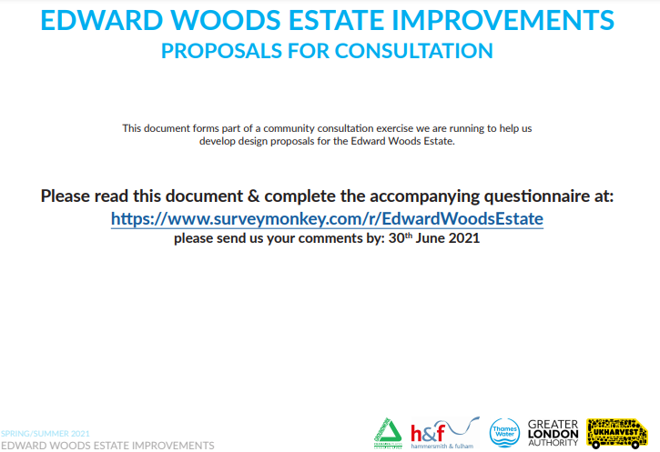
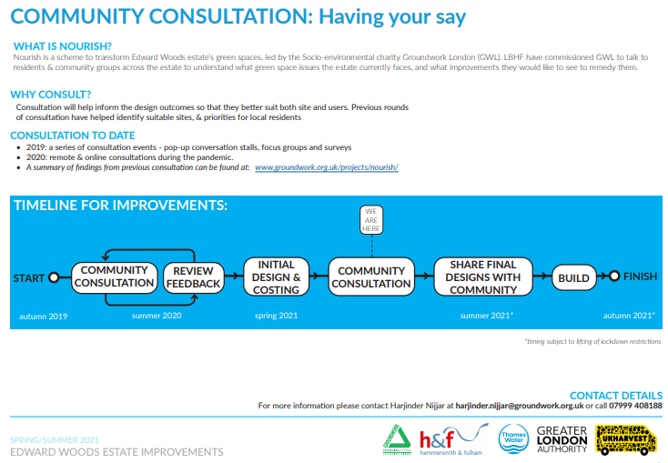
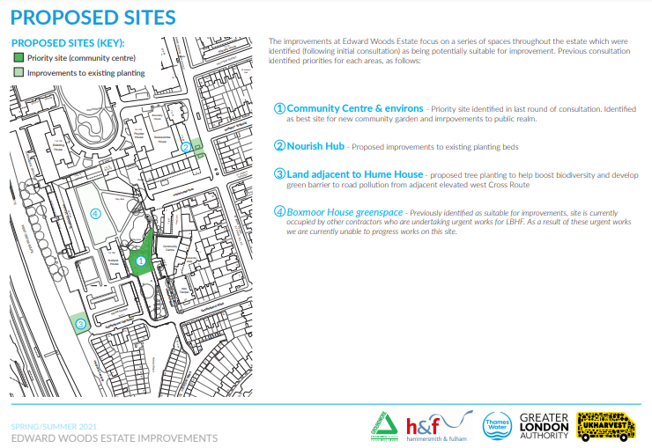

Opening the space to the front of the community centre
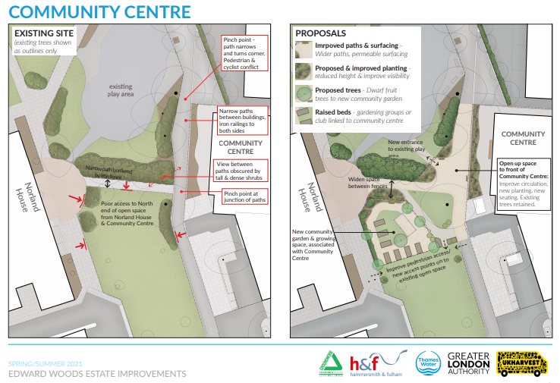
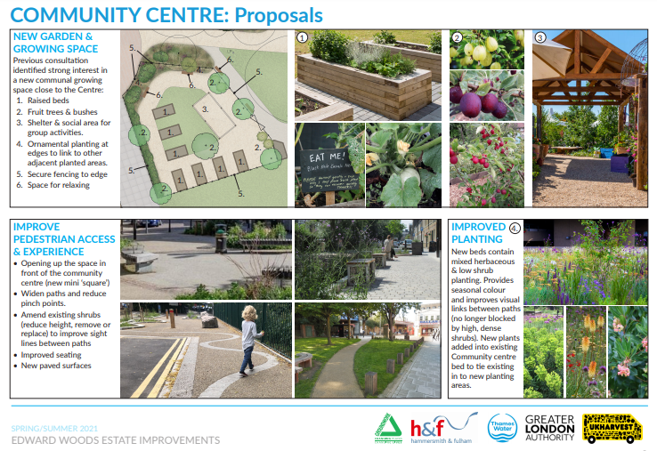

Opening the space to the front of the community centre
Answered: 19, Skipped: 5
Number | Comment
1 | Good
2 | Yes more space needed
3 | Good but I would also like to see the area around the pub more animated. Shops put back in and developed a bit more
4 | Lack of useful improvements for whole estate
5 | Outside gym would be nice
6 | Good scheme looking forward to it!
7 | Open spaces are good, sometimes not always a need to put lots of things into them, simplicity is good
8 | Good
9 | Good to have open spaces. I would want there to be enough benches / seating areas
10 | Will there appropriate signs around the community garden. Mainly for people to respect it and how they can get involved?
11 | Good idea generally about more space but another issue around that area is trees obscuring CCTV and growing closer to buildings including the community centre itself. Who would be responsible for cutting these back a bit? (not getting rid of the trees), is this part of the project? There are uneven pavements around the community centre area, who’s responsible for this? council?
12 | Can dog walking be directed to the back of Norland House? there is a strip of green by the A4, the whole of that could be used for dogs instead. Currently it may be too dark or dirty that might be why people don't use it?
13 | The green space outside the community centre adjacent to the play area is used regularly as a dog toilet, can some signage be put up? if its going to be a community garden it should be free of dog poo.
14 | We must remember to make the gardening accessible for all, young and old and disabled and isolated. Will there be a watering point for the community garden?
15 | Good idea
16 | Yes, definitely. Would be into it. Love gardening
17 | No particular opinion on that one
18 | We need the bins emptied more frequently and litter collected
19 | Love it

Widening the paths and reducing narrow entrance ways
Answered: 13, Skipped: 11
Number | Comment
1 | Yes good idea
2 | Not enough….how about lifts for low rise buildings
3 | Better for kids
4 | Good, there is concern over cyclists, can we get cyclists to dismount in those areas?
5 | Pruning of the trees along these paths?
6 | Will uneven paths be rectified together with the council? Good idea
7 | Space is good, wide open space
8 | Get cyclists to day dismount. They are aggressive when approached
9 | Good, we get bikes and scooters coming down here, dangerous for kids
10 | Very good idea
11 | Good idea but what about the existing trees and their roots
12 | Yes, the pinch points have been well identified some more locked bike shelters would be good too
13 | Makes me feel happy

Improving the existing planting areas
Answered: 16, Skipped: 8
Number | Comment
1 | I would be very interested in gardening, particularly for older people
2 | Yes low bushes
3 | Must be well maintained regularly. Could run gardening projects to do this
4 | Would be nice to get kids involved in the gardening and make it accessible for them
5 | Concerns over the ongoing maintenance of these areas. How can this be achieved, instilling responsibility
6 | Maintenance concern. Who will maintain these areas? How can this be put in place?
7 | I plant flowers and would be interested. How do we get people who live here to help manage the spaces? I am from a socialist background, which, when it's good, people work together
8 | Who will lead the gardening?
9 | Good
10 | What about the water
11 | Planting for kids would be good
12 | Good idea
13 | Agreed!
14 | Good
15 | The trees and bushes are sparse and haven't been well maintained. They are filled with pigeons
16 | Great idea for the community and the environment

Creating a community garden
Answered:16, Skipped: 7
1 | I am interested in gardening
2 | Yes everyone involved
3 | Cherry trees
4 | Maintaining things and someone taking the lead in gardening
5 | young kids to be involved. having an ongoing maintenance plan in place
6 | At the moment that area is full of dog poo, how can this be stopped when there is a community garden?
7 | How can people be informed about gardening, if someone is dyslexic then leaflets don't work
8 | must be seen to be accessible for all
9 | Fruit and veg edible things, link in with nourish hub. More money spent on plants rather than paving
10 | Yes all for it. At the moment acts as a dog toilet
11 | Include something for kids
12 | Yes
13 | Excellent!
14 | As mentioned earlier, why is the garden facing outward (entrances are facing the community centre instead of Norland House). You’ve planned hedges on the Norland House side when it should really be the other way around - doesn’t seem like a ”community” garden when you have hedges covering line of site of residents. It’s as if you’re cordoning off parts of the estate to benefit the centre and not the residents
15 | Good idea
16 | Love the idea, and would like plenty of safe spaces for all to be able to rest and enjoy the garden in peace

Would you be interested in signing up to community activities
Answered 20, Skipped 3
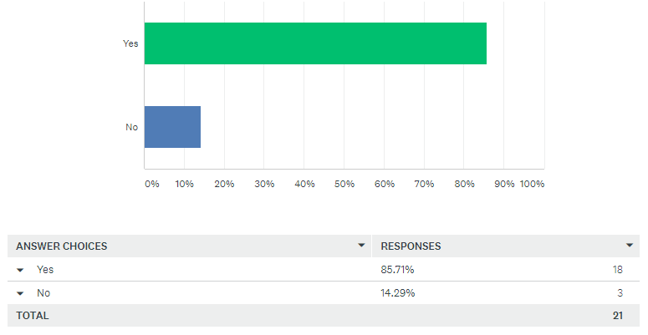
Do you have any feedback for us about the improvements to Nourish Hub?
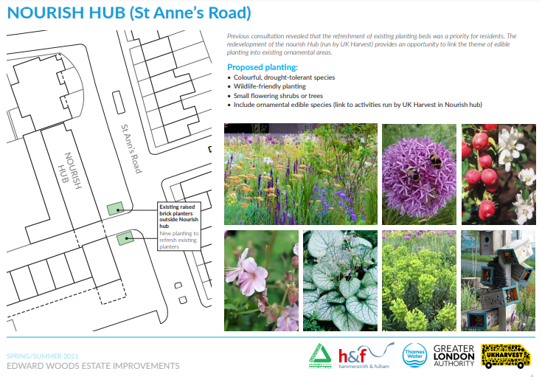

Do you have any feedback for us about the improvements to Nourish Hub?
Answered: 9, Skipped: 15
1 | I live directly across the road from the nourish hub. I find the colours of the hub a bit 'patronising', almost like it's a children's centre. With the amount of money I assume that been spent on it,I think it could have looked better, better colour scheme
2 | The beds outside the nourish hub - The beds have been usedas rubbish dumps. How can this be stopped? Could there be signs explaining how the flowers can about and please respect the area? There are bins around but some people ignore them.
3 | Perhaps spending money on engaging, competitions for kids.
4 | Areas that allow people to talk to others is good
5 | Community cafe needs to be reasonable priced
6 | Nourish hub need to guarantee that they will do something at the back of their premises so that residents can continue to use the secluded gaden there. Also I am not sure who is responsible for the upkeep of that gardne but it needs some urgent attention
7 | Add wooden panelling around the brickwork. As they’re black they don’t look nice so would be great if they were covered
8 | They currently collect litter and rodents. They need to be maintained well
9 | Love the ideas

Do you have any feedback for us about the improvements to the land adjacent to Hume House?
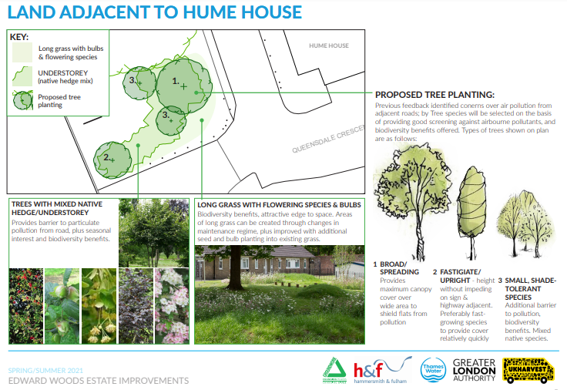

Do you have any feedback for us about the improvements to the land adjacent to Hume House?
Answered: 8, Skipped: 16
1 | There is an area by Norland house by the A4, can that be turned into the dog area. What about Norland OPen Spaces Park? Is that part of the plans? Just to spruce it up a bit?
2 | Billboard huge. Don't like it
3 | no
4 | Excellent idea!
5 | Not clear what you are referring to
6 | No
7 | Love the idea of planting different types of tree, and more trees in general. The more trees the better
8 | no

I give consent for Groundwork London to send me email updates
Answered 17, Skipped 7
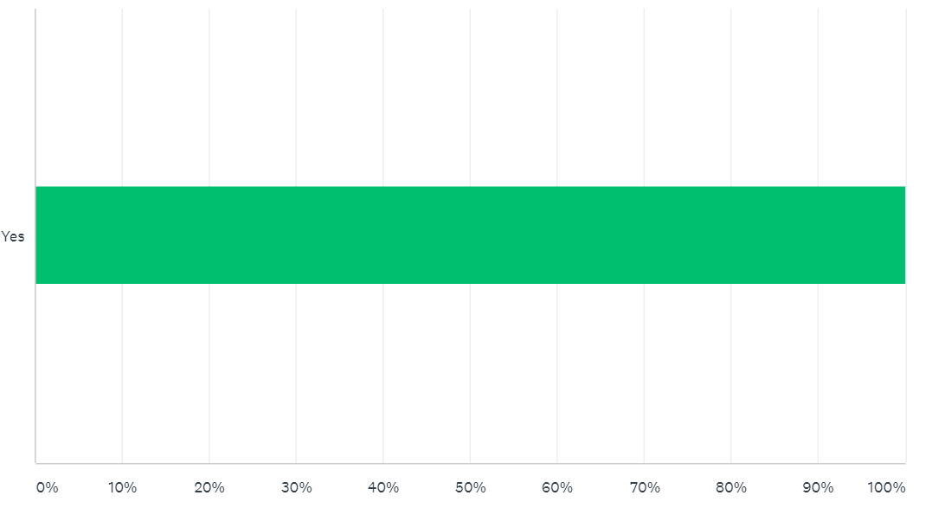

Appendix 2: Consultation Publicity
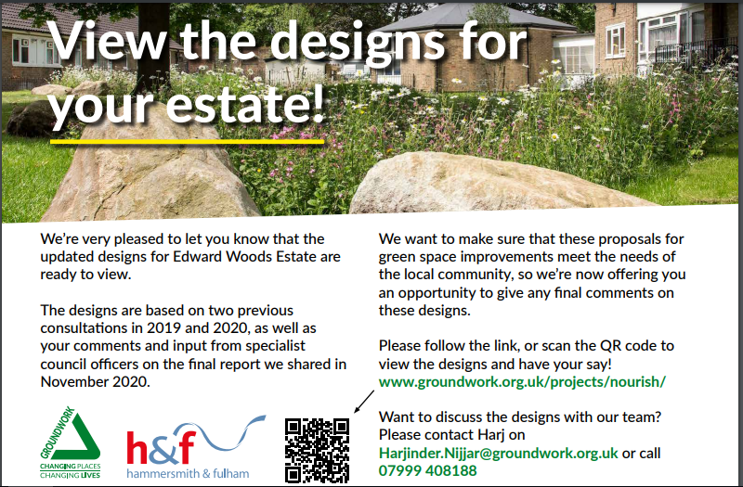

Contact Details
This report was written by Harjinder Nijjar, Groundwork London.

Groundwork London is one of a federation of 50 Groundwork Trusts operating in the UK. We are a charity providing environmental regeneration in deprived areas, and have been delivering sustainable improvements to communities in West London since our foundation in 1994.

Groundwork's projects cover a wide range of disciplines; from regenerating neglected land for community use to working with local businesses.

We work in partnership with local councils, housing associations, tenant and resident associations, schools, community groups, voluntary organisations, regeneration agencies and the private sector to deliver our projects. By involving a wide range of local stakeholders, we work to create a sense of community ownership of our projects that will ensure their impact is long lasting.

The Groundwork London team offers a wide range of skills and experience, including community development, landscape design and consultation. Our multi-disciplinary and highly motivated team also contains specialists in youth work, education, nature conservation, business development, project management, marketing and fundraising.

Contact Groundwork London (West Office) at:
Unit BMLG.11
Barley Mow Centre
10 Barley Mow Passage
London
W4 4PH
Telephone: 020 8743 3040

