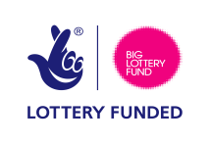
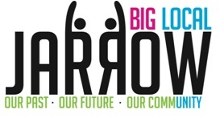
New Ideas – Initial Project Proposal

Applicant Details
Name of Group/Organisation/Individual:

Type of Group/Organisation(if applicable):

Contact Name:

Position in Group/Organisation(if applicable):

Address:

Telephone No & Email:

Preferred method of contact:

What dates are you available to meet with a panel of members of the Big Local Partnership to discuss your project? | Dates:

Project Title:

Project Description
Please give us a brief description of your project idea:

Return form to:
Anne Corrigan, Project Coordinator (Big Local Central Jarrow): anne.corrigan@groundwork.org.uk

