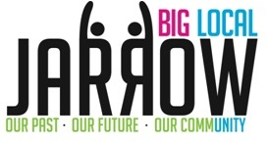

**Applicant**

**Informed of decision**

Discussed at next Board meeting

Application scored

**No further action.**

**Inform applicant of decision**

Initial Proposal submitted to the Partnership Board

Application to Panel made up of Partnership Board members and further discussion

Complete Application Form

**Yes**

**No**

Meet with panel of 3-4 members from Partnership Board for informal discussion

Does the proposal meet with the vision of the Big Local Plan?

**New Ideas Project – up to £2, 000**