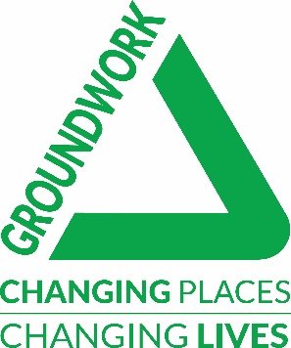
PROJECT

CONSENT

FORM

Complete all parts of this form if any aspect of your Comic Relief Community Fund (England) project involves a physical change to an indoor or outdoor space.

SECTION 1 - LANDOWNER/LEASEHOLDER CONSENT

Notes for LEASEHOLDERS
If you lease land and have a lease agreement approved that exceeds three years, your group can sign this form.

I am the Landowner the Leaseholder
(for the location of the project) (Leaseholders need to have a lease agreement of at least 3 years or more)

Contact Details:

Title (Mr, Mrs, Ms etc)
Full Name
Group Name
Contact Address
Postcode
Contact Number | Mobile
 | Landline
Email

Multiple Sites (where applicable):
This project takes place on more than one site.*

*Please provide additional Landowner / Leaseholder details for all sites in the ‘Additional Information’ box at the end of this form. Include; the Landowner / Leaseholder’s Full Name(s), Contact Address(es), Contact Number(s) and email address(es). You will also need to ensure that each Landowner has been consulted on points 1 and 2 of Section 2.

SECTION 2 - SIGNATURE

Project Name
Organisation Name

All four boxes must be ticked.

- I confirm that the Landowner / Leaseholder has read the project proposals and is happy with them.

- I confirm that I have considered whether any permissions are required (eg. Planning Permission, project permissions (e.g trips), Environmental Agency, English Heritage) and will adhere to any conditions attached.

- I confirm that any required insurances (eg. public, employer liability) are in place for the project to go ahead.

- I confirm that any relevant legislation (eg. Health and Safety, Equal Opportunities, Child Protection) will be adhered to.

Signed
(this can be typed in)
Print Name

Date

Additional Information (If there is anything else you wish us to be aware of please note it below. If applicable, also provide additional Landowner / Leaseholder details):-

