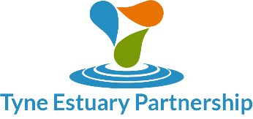**Tyne Estuary Partnership Pledge**

The Tyne Estuary Partnership (TEP) is a strong, strategic, influential partnership invested in the long term environmental and economic enhancement of the River Tyne from the mouth of the Tyne to Wylam.

The TEP brings together stakeholders from across sectors to tackle the collective challenge of enhancing the River Tyne. It responds to the Government’s 25 Year Environment Plan; to create connections between existing initiatives and real practical actions. It has a bold vision for developing a healthy and vibrant river estuary and the pledge acknowledges that change cannot be achieved by a few regulatory tweaks, or any single organisation. Solutions are multi-sector and highly interconnected.

This Pledge builds on the work of the existing River Catchment partnerships declaration and the TEP Feasibility Study Report which can be found on the Partnership [website.](https://www.groundwork.org.uk/projects/tyne-estuary-partnership/)

Please sign the TEP Pledge to demonstrate your organisation's strategic support for the project. This is non-binding and does not commit your organisation to any financial/resource investments; however it will demonstrate your organisation's willingness to be engaged with and consulted on the project and will vastly strengthen our funding applications. The outcome of which will enable the Partnership to deliver more interventions on the Tyne Estuary, therefore delivering effective environmental and economic management that benefits all.

Name: ...................................................................

Organisation: ........................................................ Role: …………………………………………………..



Signature: ............................................................. Date: ……………………….