How to promote your project in Social media
A picture says more than a thousand words: Add a photo to your post/tweet. Remember to get consent before taking and uploading a picture of a person or group.
Tip: You can take great pictures of your project without needing to identify individuals, see examples:

Get the hang of Handles: This is a chance to involve as many people as possible in your post/tweet. The more you include others, the more your post/tweet will be seen and shared.
Every time you write and post/tweet, use ‘@’ to mention another account for example: @GroundworkNI, use ‘#’ hashtags to add a theme and join a campaign, for example: #MensHealthDay #MensShed #ChangingLives #ChagingPlaces
Tip: Time your tweets/posts at a time where people are going to work (8am-10am), getting out of work (5pm-6pm) or during lunch time (12noon-1pm)

Make it personal: Your Shed has an amazing story to tell, don’t hide it. If your Shed involves making the lives of people in your community better and more enjoyable, use this to tell the story.
Tip: Don’t forget to have a written consent from the people you talk to, that you can use their picture and their story.
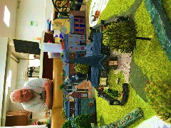
“Coming to the Shed, gives me a great feeling to know that my skills are valued and I am able to share this with others.”
Men’s Shed member

