Partnership Opportunity
Invitation to Tender, March 2020

Progress: Building Better Opportunities for young people across Coventry & Warwickshire

English and Maths Functional Skills Provision
REF: CovW/1/3/EM2020

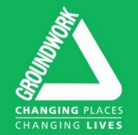

Contents

Overview 2
Context 3
About ‘Progress’ 3
Opportunity 5
Partner Requirements & Further Details 6
Procurement Process 7
Further Information 7
APPENDIX A: Customer Journey 8
APPENDIX B: Tender Submission Template 9
APPENDIX C: Scoring Matrix 9
APPENDIX D: Form of Tender 9

Overview
Groundwork UK is seeking a Specialist Partner to deliver English and maths functional skills for 15-24 year old NEET and at risk of NEET young people across Coventry & Warwickshire.

This programme is financed by The National Lottery Community Fund and European Social Fund.

Context

Groundwork UK is delivering a The National Lottery Community Fund (NLCF) and European Social Fund (ESF) co-financed programme called Building Better Opportunities (BBO) in partnership with 10 VCS and statutory organisations.

Progress started delivery in October 2016 and will run until March 2022. Groundwork UK and its partners will deliver ‘Progress’ – a tailored programme of coaching support and bespoke activities to NEET and at risk of NEET young people aged between 15 and 24, enabling them to access training and employment opportunities. Progress brings together a unique partnership of local organisations – with support from local councils – to transform the prospects of some of the most marginalised young people in Coventry and Warwickshire. Our partnership will ensure that young people facing the most significant barriers to accessing learning and work are able to recognise their talents and realise their potential.

About ‘Progress’

Progress aims to:
- help young people overcome the personal barriers and challenges preventing them from engaging positively in learning or work
- provide a clear pathway for young people to increase their skills and take the first steps on their future career path through training or employment

In order to achieve these aims we have developed a partnership that brings together leading youth and employment charities, organisations specialising in supporting young people with complex needs, and training providers. Together, our focus will be on identifying and helping those young people most in need of support including care leavers, lone parents, young offenders, and young people with disabilities.

Progress will support at least 1,436 young people aged 15-24 years old, 40% of which will be unemployed and 60% classed as economically inactive. At least one fifth of those we support will be young people with disabilities and at least one in ten from a minority ethnic background.

Our approach will be to work closely together and collaboratively with local stakeholders, in particular local authorities, to provide an accessible and responsive service that encourages young people to succeed and provides clear pathways into positive progressions.

Our delivery model has been designed in consultation with young people and local stakeholders, and draws on a range of successful interventions delivered previously by partners. Central to our model is the deployment of Progress Coaches – experienced youth work professionals who will build trust with young people, encouraging them to set positive goals and helping them navigate a tailored path towards employment. Progress Coaches are employed by our End-to-End Partners who are responsible for the journey of the young person through the programme. Specialist Partners work closely with Progress Coaches to provide specialist support service to programme participants. This support is accessed via an internal referral mechanism based on the needs of the individual.

We will support young people through a five-stage process:
- Getting on board - using communications, outreach and referral pathways with a range of partners to identify those most in need, ensure their eligibility and promote positive engagement in the programme.
- Preparing and planning - helping young people to identify barriers they need to overcome and working together to develop an individually-tailored action plan containing clear goals and fostering ownership from the outset.
- A pathway to success - helping young people to access and benefit from specialist support services, offered from within the partnership and through local agencies, to help overcome personal challenges such as mental health issues, debt problems or substance misuse.
- Building strengths - using group work, training and volunteering to help young people grow in confidence or acquire new skills that will support their journey to employment.
- Achieving goals - identifying the most appropriate progression route for each young person, supporting a move into training or work and maintaining contact after the transition to help ensure success is sustained.

Our model is designed to be:
- flexible - providing intensive, long-term support to those who need it most while ensuring those who are ready to progress aren’t held back
- tailored - offering a bespoke path through the programme based on individual aims and aspirations
- trusted - using youth work approaches to build relationships that offer support and understanding but also push and challenge when required
- integrated - working closely with other local services and provision ensuring clarity for those involved and maximising the impact of the programme.

Locations
Progress will support young people in all parts of Coventry and Warwickshire, with 60% of participants living in priority wards identified by the Coventry & Warwickshire Local Enterprise Partnership (CWLEP). 70% of all activity will be focused in Warwickshire. We will address known areas of high need and focus efforts to engage young people who may be ‘hidden NEETs’, affected by isolation and not engaged through other initiatives. Progress partners will operate from a range of accessible local delivery hubs, including community buildings and youth clubs giving us capacity in urban centres and reach into more rural areas.

Outcomes
Progress has been designed to form part of the solution to local challenges, linking with existing services to provide a suite of integrated interventions that will lead to the following outcomes:
- young people demonstrating increased confidence, and self-esteem
- young people with increasingly positive attitudes towards work and their own employment prospects
- young people with better skills for finding and sustaining employment
- young people reporting improved well-being.

To deliver these outcomes, we will aim to achieve the following results:
- 30% (431) of participants moving into education or training on leaving the programme
- 20% (287) of participants moving into employment or self-employment on leaving the programme
- 30% (259) of participants who were economically inactive before joining the programme regularly looking for work by the end.

Partnership Management
The Progress partnership will be led and managed by Groundwork UK, who will be responsible for ensuring high quality and compliant delivery within a supportive partnership framework, geared towards sharing learning and driving continuous improvement. Partnership governance arrangements will be underpinned by a Partnership Agreement setting out clear roles and responsibilities, and Partners and stakeholders will oversee performance through an inclusive steering group.

Opportunity

Groundwork UK is looking for a Specialist Partner to deliver English and mathematics functional skills to the target group of young people across Coventry and Warwickshire.

Consultation with existing partners has highlighted a demand amongst participants for entry level, level 1 and level 2 English and maths functional skills provision.

Proposals are sought from organisations with experience in delivering English and maths functional skills to young people aged between 15-24 who are facing significant barriers to engaging with education, employment and training, and can offer a high degree of pastoral care.

Proposals are welcomed from organisations who are able to offer small group provision (under 10 learners) which is welcoming and accessible to young people who have historically struggled to engage in a traditional classroom environment. Experience to date has shown us that flexibility is key to engaging with this cohort of young people, and the ability to deliver in the heart of communities where support is needed most is important.

Participants access Specialist Partner support via a referral from their Progress Coach. Whilst accessing specialist provision, the young person will also continue to receive support from their Progress Coach. Specialist Partners and Progress Coaches work together to track the progress of participants and ensure that they are taking the maximum benefit from the programme. Commitment to collaboration and partnership working is therefore essential, as is a flexible approach to the scheduling of activity, to respond to the needs of young people and partners.

The partner will be in a position to deliver from accessible locations across Coventry & Warwickshire, and will be supported by in-depth knowledge of the challenges and opportunities affecting young people resident in these areas. Proposals are particularly welcome from organisations who are able to provide tailored support for young people with more intensive support requirements, such as those with learning differences, disabilities and physical disabilities, and who have experience supporting young people in rural areas.
Please note that all Building Better Opportunities activity must represent additional activity to any delivery paid for by other means.

Funding available:
A total of £128,700.00 is available for the delivery of additional activity for young people across Warwickshire. This must provide access to English and maths functional skills provision for 85 young people. In addition, up to 25 learners will be able to access certificated courses outside of Functional Skills, including Health and Safety Level 1 and CSCS Card Training, to be agreed upon depending on the learner needs.

Proposals will be considered and a tender / tenders awarded based on the merit of the submissions. Where there are more than one successful tenders, Groundwork UK reserves the right to distribute the total funding between multiple organisations in order to obtain the best possible offer for programme beneficiaries.

Partner Requirements & Further Details

We are looking for organisations:
- Able to deliver entry level, level 1 and level 2 English and maths Functional Skills to 15-24 year olds
- Able to deliver additional courses outside of Functional Skills to 15-24 year olds
- Able to deliver small group sessions - ideally in community settings
- With delivery history and capacity in Coventry and Warwickshire – with experience of working with NEET / at risk of NEET young people and/or young people with complex or specific barriers to engagement with education, employment or training
- With experience and track record in supporting young people
- Committed to open communication and collaborative, partnership-focussed working
- Ready to commence delivery from April 2020
- Who will add value to the Progress partnership overall, supporting other partners to recruit and progress suitable young people
- With the experience, capacity and capability to manage the requirements of the European Social Fund

Existing partners are welcome to apply in the interests of diversifying or increasing their role in the programme, but they will not be at an advantage, with all tenders reviewed objectively and awards made on merit.

Due Diligence
Successful organisations will be subject to a full due diligence process to assess financial management capacity, financial stability, staffing capacity and relevant policies and procedures. Successful partners will be supported where possible to meet minimum requirements. A Due Diligence Template is available for information on request.

Delivery Dates
Delivery will need to start during March 2020 and will end in March 2022.

Partnership arrangements
A Service Level Agreement will be put in place to outline delivery requirements.

In addition, partners will sign one shared Partnership Agreement within which all individual targets, profiles and due diligence commitments will be stated. Partners will be expected to operate collaboratively and in the spirit of partnership.

In doing so, there is a requirement to attend partnership meetings and meetings with stakeholders. Partners should expect to attend meetings designed to support ongoing collaboration and service integration at least monthly.

Funding and Payment
Payment will be made as a grant to the successful organisation(s) in quarterly instalments, subject to successful completion of Due Diligence requirements

Groundwork UK reserve the right to withhold payments due to poor performance.

Management Information & Security
Successful partners will be required to use the management information processes and systems provided by Groundwork UK for all young person records and claims, and to comply with data security requirements as outlined in the Partnership Agreement in line with the Data Protection Act.

Quality, Compliance, and Evaluation
Successful partners will be expected to fully take part in programme-specific quality and compliance activities. Partners will be expected to regularly self-assess delivery quality, and to make files available for regular audits and spot checks by Groundwork UK and the funder. Partners will also be required to contribute to the external evaluation of the programme.

Procurement Process

- With reference to the Scoring Matrix (Appendix C), please complete the following and submit both documents below to karen.field@groundwork.org.uk and contracts@groundwork.org.uk by 5pm on Friday 27th March 2020:
  - Tender Submission (Appendix B) and
  - Form of Tender (Appendix D)
- Groundwork will assess and score tenders and respond to all tenderers by 5pm on Monday 30th March 2020.
- The highest scoring tenderers may be invited to interview at Groundwork UK (Central Birmingham) on Tuesday 31st March 2020. Please ensure suitable representatives are available on one of these dates.
- The outcome of the process will be communicated by Wednesday 1st April 2020.
- Delivery to commence on or before Thursday 2nd April 2020.

Further Information

For further information or clarification please email progress@groundwork.org.uk stating “BBO Partnership Tender” in the email subject line, or contact Sarah Duncan or Andy Harrison on 0121 236 8565.
The final deadline for tender-related questions is midday, Thursday 19th March 2020.
More information regarding BBO Progress, can be found on the Groundwork website
http://www.groundwork.org.uk/projects/progress/

Full details of the Building Better Opportunities programme can be found on the National Lottery Community Fund website: https://www.tnlcommunityfund.org.uk/funding/programmes/building-better-opportunities
Full guidance documents from the National Lottery Community Fund can be found here: https://www.biglotteryfund.org.uk/global-content/programmes/england/building-better-opportunities/building-better-opportunities-resources

APPENDIX A: Customer Journey
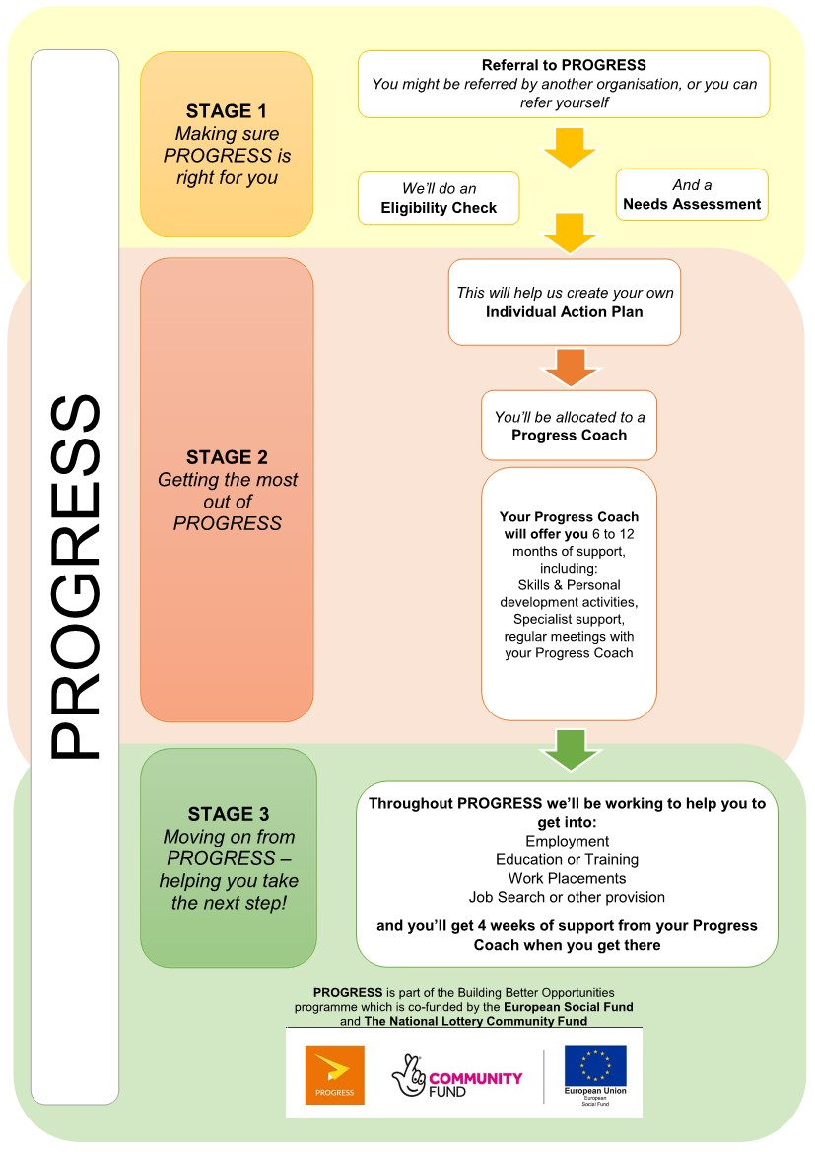

APPENDIX B: Tender Submission Template
Please refer to separate document:
BBO_ITT_APPENDIX B_SubmissionTemplate_CovW-1-3-EM2020_Mar20

APPENDIX C: Scoring Matrix
Please refer to separate document:
BBO_ITT_APPENDIX C_ScoringMatrix_CovW-1-3-EM2020_Mar20

APPENDIX D: Form of Tender
Please refer to separate document:
BBO_ITT_APPENDIX D_FormOfTender_CovW-1-3-EM2020_Mar20

