How to promote your project in Social media
A picture says more than a thousand words: Add a photo to your post/tweet. Remember to get consent before taking and uploading a picture of a person or group.
Tip: You can take great pictures of your project without needing to identify individuals, see examples:

Get the hang of Handles: This is a chance to involve as many people as possible in your post/tweet. The more you include others, the more your post/tweet will be seen and shared.
Every time you write and post/tweet, tag us @GroundworkNI, please also use these hashtags #ChangingLives #ChagingPlaces #TheLCF #AughrimProgramme
Tip: Time your tweets/posts at a time where people are going to work (8am-10am), getting out of work (5pm-6pm) or during lunch time (12noon-1pm)

Make it personal: Your project has an amazing story to tell, don’t hide it. If your project involves making the lives of people in your community better and more enjoyable, use this to communicate your project.
Tip: Don’t forget to have a written consent from the people you talk to, that you can use their picture and their story.
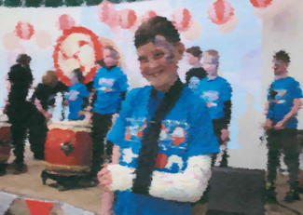
“Despite a very bad break to his arm, one team member did not miss one practice, class or performance. He learned to play all pieces with one hand!”

