Stronger Communities Fund

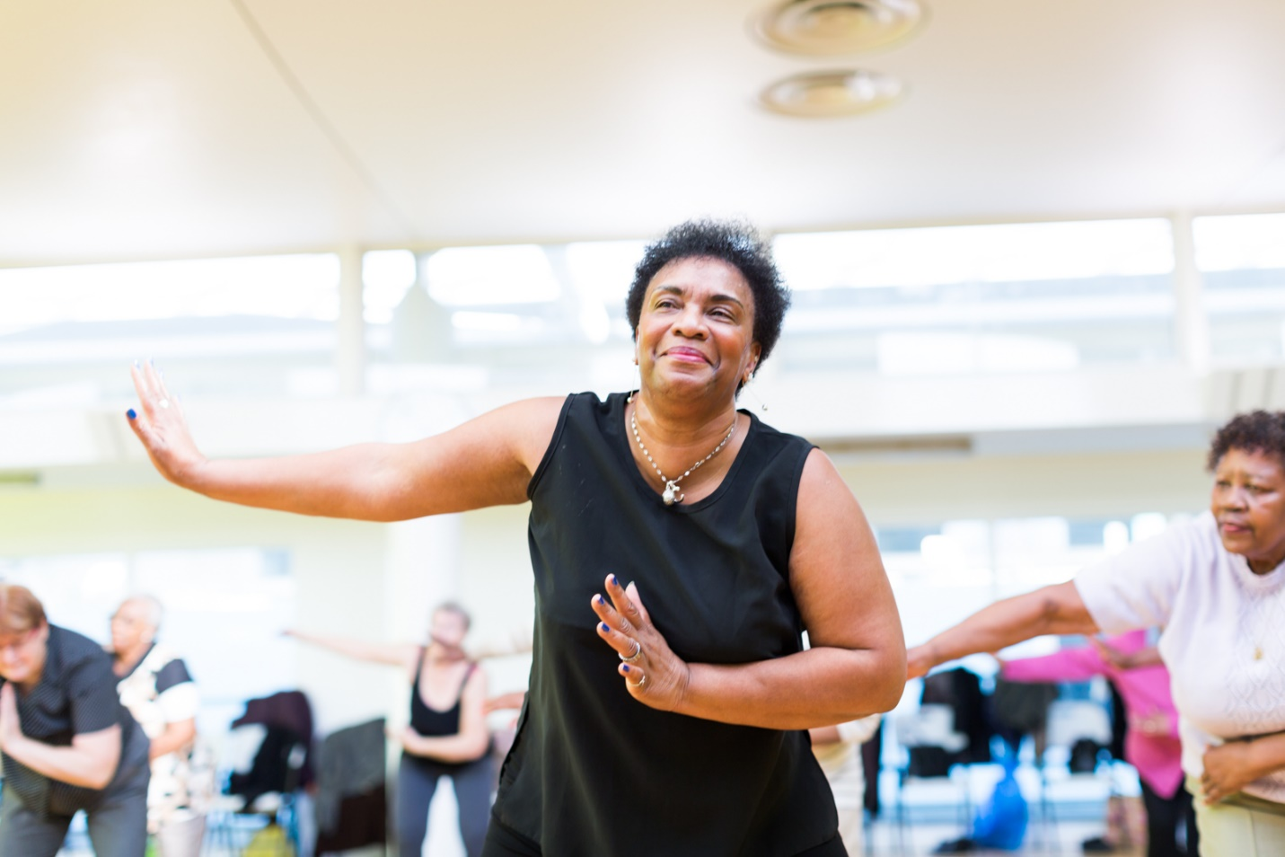

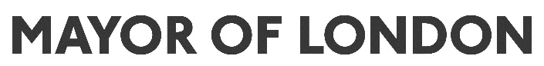

Contents

Introduction to the Stronger Communities fund…………….3
About the Stronger Communities fund………………………4
Eligibility………………………………………………………...7
Budget and supporting information……………………….... 9
How to apply…………………………………………………..11
Successful applicants………………………………………..13

Introduction to the Stronger Communities fund

In July 2019, the Stronger Communities fund was launched to award grants for sport and physical activity projects that: (i) bring Londoners together from different backgrounds, cultures and faiths, and (ii) help socially isolated or lonely Londoners feel better connected to their local communities. This Stronger Communities fund forms part of the Mayor of London’s multi-million-pound community sport investment programme, Sport Unites.

Due to COVID-19, and enhanced government restrictions for the sport and physical activity sector, a decision was taken in March 2020 to stop accepting new applications for funding. As of 24 August 2020, we are pleased to reopen applications to the Stronger Communities fund, with some changes made to the funding opportunity to respond to the challenges and impacts of COVID-19 on organisations and Londoners.

Together with the sample application form, these guidance notes are intended to give you clear information about the fund; help you decide if your project or idea is a good fit; and support you in applying for a grant if you decide to go ahead.

Should you have any additional queries, you are welcome to contact us on 0207 239 1390 or StrongerCommunitiesFund@groundwork.org.uk.

About the Stronger Communities fund

What is the Stronger Communities fund?

This final round of Stronger Communities funding will support sport and physical activity projects that address increased levels of loneliness and social isolation that have spiked during COVID-19 due to prolonged lockdown and social distancing measures. Grants are aimed at those who find it hard to access funding – for example, individuals and small grassroots organisations.

What types of projects are you looking to fund?

Findings from City Intelligence show that isolation has been reported as one of the most widespread COVID-19 issues by London’s community sector, with an initial 80% increase in demand for loneliness services since lockdown. Whilst all Londoners have felt the challenges and negative effects of loneliness and social isolation, we know some groups have been disproportionally more at risk. In response, this funding opportunity will look to support projects which use sport to rebuild participants’ confidence to return to participating in sport and physical activity back in the local community and strengthen their local connections for further and long-term support.

We will give priority to:

- Projects that work with Londoners who have been disproportionately more at risk of loneliness and isolation during COVID-19 such as (but not exclusively): deaf and disabled people or those with long-term health conditions, people from Black, Asian and minority ethnic (BAME) communities, LGBTQ+ Londoners, parents with young children, people on lower incomes, and those with limited access to digital technology and the internet.

- Groups that already have strong connections in their communities and can reach and connect with people at high risk of loneliness and social isolation;

- Smaller organisations and individuals, who typically find it hard to access funding.

We will fund project delivery taking place both online and in-person, but we would like to see a majority of the funding being used to deliver in-person socially distanced physical activities.

Is there any support for organisations delivering socially distanced physical activity and sport?

Applicants will need to show how they will deliver against the latest government guidelines, and what robust social distancing and safeguarding measures they have in place. A number of resources are available to help applicants develop their project:
- Mayor of London / London Sport ‘Talking COVID-19 and Sport’ webinar on Socially Distanced Sport
- London Sport COVID-19 sport-specific guidance published by National Governing Bodies (NGBs)
- Sport England ‘Return to Play’ resources including inclusion and accessibility guidelines
- Public Health England (PHE) COVID-19 guidance

How much can I apply for?

You can apply for grants of between £2,000 and £10,000, and we are interested in funding a range of grant sizes between this scale.

When does my project activity need to take place?

All successful projects will need to be delivered between November 2020 and February 2021.
All project activity must be completed by 14 February 2021 and final reports submitted by 1 March 2021.

We want to offer a flexible approach to your delivery within these timescales but do expect projects to last for at least 4 weeks (these do not need to be consecutive weeks). You will be asked to provide a project timeline, including your key milestones and targets at the application stage to tell us what you plan to do. We appreciate that project delivery could be impacted by changing government guidelines and we will regularly assess and adapt decisions on funding within these guidelines if necessary.

Do you need to work with the priority groups of people?

There are no restrictions on who you work with and we would encourage projects to be inclusive. However, we may give priority to projects working with Londoners we know are most at risk of loneliness and social isolation. It is important that you show you know your participants, any challenges or barriers they may face, and how your project will benefit them. Your explanation will help us to see the need for the project.

In your application you should demonstrate how your project has been designed to reach, engage and address the needs of your target audience, and whether these are new or existing participants.

How will you decide which projects to fund?

We will consider several factors:

- Fit to fund – how well your project meets the fund priorities given above.
- Project design and approach – we’ll assess your project idea, including your project outline and the overall changes the project is intending to achieve.
- Participants (who you are reaching and how you will reach them) – we want to fund projects that work with Londoners who have been most impacted by increased levels of loneliness and social isolation since COVID-19. You should show a good understanding of your participants and how they will benefit from your project. We will examine how effective your plans are to reach participants.
- Safeguarding – we expect all applicants to have robust safeguarding measures and policies in place and to have considered risks and mitigations for all participants including children, young people, and adults at risk of harm. Project delivery plans should incorporate social distancing measures, following government guidance and advice from appropriate National Governing Bodies (NGBs) for the specific sport.
- Impact – identified measures of success against the fund priority, and able to show the how the project will link into your wider work or external exit pathways to benefit participants beyond the project.
- Budget – project finances clearly defined with a full breakdown of individual costs.
- The amount of public funding you have received before – we want to reach individuals and organisations who don’t usually receive GLA funding, so we may at times prioritise these applications.

Eligibility

Who can apply?

Applications will be accepted from individuals/unconstituted groups and the following organisations as long as you work on a not-for-profit basis:
- Registered, exempt or excepted charity
- Charitable incorporated organisation (CIO)
- Local authorities
- Social enterprises/CICs
- Charitable company (limited by guarantee)
- Registered Community Sports Club
- Faith groups
- Constituted but unincorporated club or association
- Constituted community group

All organisations must have an annual turnover of less than £300,000. You will be asked to provide evidence at the application stage.

If you are applying as an individual or unconstituted group:
- You will need a letter of reference from an organisation listed above, such as a local authority, registered charity or company, who can vouch for your work in the local community.
- We are not able to pay money into an individual’s or informal group’s bank account, so this organisation will also need to receive the money on your behalf for the purposes of the project.
- You must upload your letter of reference at the application stage which outlines they are happy to support and accept funds on your behalf so we can take this into consideration when assessing your application.
- If you are applying for more than £5,000, the organisation accepting funds on your behalf will have to submit governing documents and policies so we are able to undertake a higher level of due diligence to reflect the higher level of funding.

What do you mean by constituted?

The first stage in becoming a formal organisation is often to adopt a ‘constitution’. A constitution is a simple set of rules which help make it clear to everyone involved what you intend to do, and how you operate. If you want some good examples of a constituted group, take a look at this website: https://mycommunity.org.uk/resources/types-of-organisational-structure/

What do you mean by fully incorporated?

An incorporated group is when an organisation is formally set up as a company. This usually happens when an organisation begins to trade, manage a significant amount of money, employs staff and enters into contracts. There are four types of incorporated legal structure most commonly adopted by community organisations and community enterprises:

- Community Ltd by Guarantee with charitable status (CLG)
- Community Interest Company (CIC)
- Community Benefit Society
- Charitable Incorporated Organisations (CIO)

More advice on this is available at http://www.nicva.org/resource/legal-structures-voluntary-and-community-groups

I have previously received a Stronger Communities grant; can I apply again?

You are able to apply for further funding if you have finished delivering your previous project and have submitted your end of project monitoring and evaluation report. We recommend that you get in contact with us about your application prior to starting a new form to check you are eligible.

Am I eligible to apply?

Before proceeding to application, check the table below and make sure you can say ‘yes’ to all the statements.

To apply for a Stronger Communities grant
You must be able to say ‘yes’ to all the following:

- I work/my organisation works on a not-for-profit basis
- My project will happen within the Greater London Boundary
- My project will help Londoners (rather than tourists or short-term visitors)
- The main focus of my project delivery will be sport or physical activity
- My project addresses the fund priority to reduce loneliness and/or social isolation
- My project will take place at some point between November 2020 and February 2021
- I am applying for funding between £2,000 and £10,000
- I have all the necessary safeguarding policies and procedures in place
- The grant will be used for revenue items and not for capital costs

Additionally, if you are applying as an individual or unconstituted group: | Additionally, if you are applying as an organisation:
- I am able to provide a letter of support from an organisation that can vouch for my work and accept the funds on my behalf.  - If applying for more than £5,000, the organisation accepting the funds on my behalf will provide documents for further due diligence checks. | - I am able to prove my organisation is fully incorporated and constituted, with its own bank account  - My organisation’s annual turnover is less than £300,000

Budget and Supporting Information

What will we pay for – and what won’t we?

If your project involves costs for the following, we will pay for it (as long as the total is within the maximum limit of your grant, and you can show how the various things are needed to deliver your project effectively).

We will fund:

- Staff delivery costs: directly related to the running of your project. This could include sessional coaches or instructors which have been created specifically for your project.
- Staff training costs: to equip your workforce with the skills and knowledge to support participants with in-person delivery after months of loneliness and isolation. For example, mental health awareness training.
- Equipment: the hire or purchase of any items of equipment or clothing you may need to run your project – including specially adapted items to ensure equal access and opportunity.
- Venue hire costs: for example, what it costs you to rent a pitch or other type of space for your project.
- Transport: to help you, your staff and volunteers get to your project and back.
- Refreshments: for you, your staff and volunteers, and the people coming to your project (limit of 10% and not for supplements such as energy gels, high protein recovery drinks etc.)
- Marketing information: so that you can spread the word and make sure people know to come
- Accessibility costs: we are aware that making a project inclusive can incur additional costs. For example, when meeting deaf and disabled people’s access needs. We encourage you to include any reasonable accessibility costs within your project budget.
- Monitoring and evaluation costs: to ensure you can sufficiently monitor and report on the impact of your project.

We won’t fund:

- Normal management and admin salaries
- General office costs and overheads that aren’t directly related to your project
- Core capital costs such as building works or large fixed items of equipment.

Do I need match funding?

There is no requirement for match funding. However, if you are receiving match funding, either in cash or ‘value in kind’, then let us know. Please tell us where your match funding is coming from and whether it has been confirmed. Value in kind funding can include volunteer time, free use of your venue, or the donation of equipment. The Stronger Communities grant should cover at least 65% of the overall project costs.

What is a good budget?

We generally like to see a ‘balanced’ budget, with as much detail as you can put in at this stage. We assess budgets on a case-by-case basis, so as long as you can back up your requests, they fall within the total grant limit, and within the items listed above, this should be fine. Please make sure you provide a breakdown of your budget into the key headings and describe what each cost is associated to. This will help the assessor understand your budget against the project description.

What supporting documents do I need?

Before completing your application, please make sure you can meet the following requirements:

- You must provide your organisation’s UK bank account details or if you are an individual, you must attach a letter from your partner organisation to confirm they can hold and ringfence the funds on your behalf alongside their governing documents.

- You will be responsible for all financial and legal aspects of your project. By time of project delivery all successful applicants (including individuals and non-constituted groups) must have relevant insurance, risk assessments, public liability insurance, employers liability and an up-to-date safeguarding policy (including digital safeguarding policies for any online delivery) if you are working with children, young people and vulnerable adults. You should tell us how you will meet these requirements in your application. If successful, you will be asked for copies of the relevant documentation at the funding agreement stage.
- If applying as an organisation, you must provide your organisation’s governing documents.
- If applying as an individual or non-constituted group, you must provide a copy of a reference statement which vouches for your work in the local community.

How to apply

How do I apply?

You’ll need to take our short online eligibility test first. This will check that your project is eligible for funding. You can take the eligibility test here. If your project meets the criteria, you’ll be given a link to the application form.

You apply for funding online, through Groundwork’s GIFTS online system. If this is your first time submitting via the GIFTS system you must create an account. Click on the ‘new account’ link to register your email address and password. These will be your login details. You’ll need them every time you use our online application system, so keep them handy. If you forget your password or any other part of your login details, please use the ‘forgot password?’ link on the log-in page to reset this information.

We strongly recommend you only create one account, no matter how many times you submit a new application form. This will help you to view all applications you may have worked on or submitted under one email address account.

Applicants are advised to download the ‘Sample Application Form’ and read the ‘Application Guidance Notes’ before applying, to familiarise yourself with the questions and understand what information we expect on each section.

Can I talk to someone about my application before I apply?

Yes, we are happy to speak to you about your application so please get in touch with the team at Groundwork.

Phone: 0207 239 1390
Email: StrongerCommunitiesFund@groundwork.org.uk

If you require the application materials in a different format let us know.

We will be hosting a series of online Q&A sessions for applicants with additional questions to support their application. There will be a short overview of fund priorities, but time has been allocated to take questions. You can sign up to any of the sessions via Eventbrite.

Q&A Session | Time | Sign up link
1 | 1 September 15.00-16.00 | https://www.eventbrite.co.uk/e/stronger-communities-fund-qa-session-1-tickets-117258654793
2 | 3 September 12.00-13.00 | https://www.eventbrite.co.uk/e/stronger-communities-fund-qa-session-2-tickets-117409911205
3 | 7 September 16.00-17.00 | https://www.eventbrite.co.uk/e/stronger-communities-fund-qa-session-3-tickets-117410009499
4 | 9 September 11.00-12.00 | https://www.eventbrite.co.uk/e/stronger-communities-fund-qa-session-4-tickets-117410356537

We will keep our webpage updated with frequently asked questions (FAQs) from these sessions.

When will I find out if I have been successful?

Applicants will find out if they have been successful by 2 weeks following a grant panel meeting. Please contact StrongerCommunitiesFund@groundwork.org.uk if you would like feedback on your application.

Successful applicants

What happens if my application is successful?

You will be contacted by Groundwork following the grant panel with a grant acceptance offer outlining the terms and conditions of the grant. You may be asked to supply further information at this point on your organisation as part of our due diligence checks.

When will I receive my grant?

On passing our due diligence checks, and on receipt of your signed terms and conditions of the grant, you will receive your first grant payment. The grant must be used exclusively for the Stronger Communities project and you must keep a record of your spending, with receipts, to show how your grant has been spent.

What will I need to monitor and report on?

We really want to hear about your project achievements. All successful grantees will have to complete a Stronger Communities ‘End of Project Grantee Data Form’ in Groundwork’s GIFTS online system. This will ask you to report on the following:
- Reflections on the whole grant – we want to know about the significant achievements over the lifetime of the grant and what you’re most proud of
- Beneficiary numbers and demographics – how many people participated in your project
- Activities – what sessions did you put on and how often
- Outcomes – how your project met the fund priorities
- Budget and finances – you will be asked to submit evidence on how you spent your grant, including invoices

A template of the end of project report form can be downloaded here.

You can view the Sport Unites Theory of Change Social Isolation Pathway here to support your application. This provides recommended outcomes and indicators to help you monitor your project.

