Groundwork UK
Recruitment Pack

PR & Communications Coordinator
October 2020

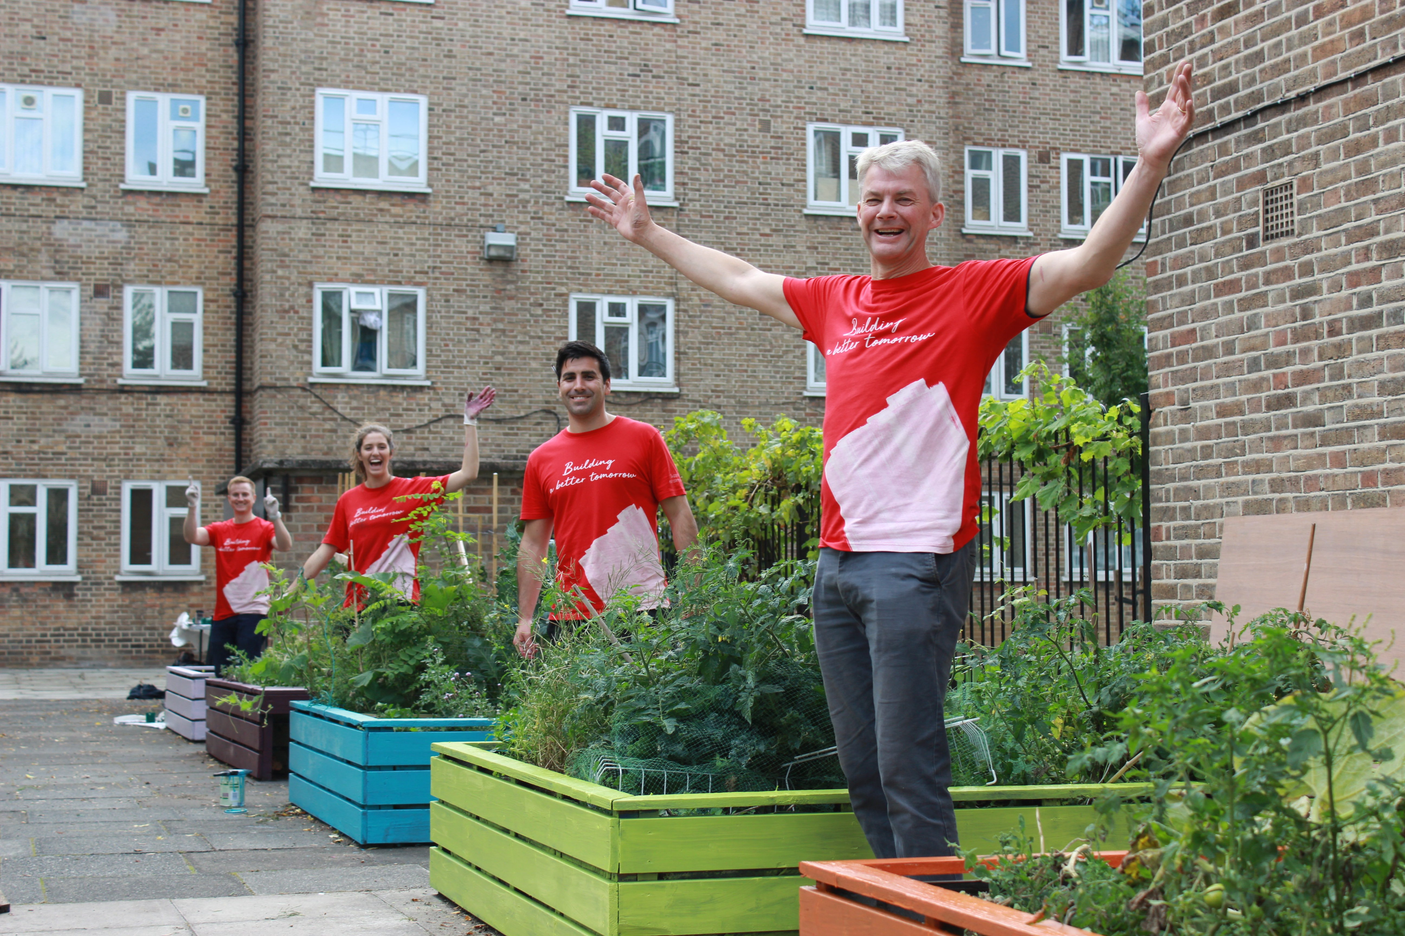
Help us change places and change lives

Join our community

Thank you for your interest in applying for a position at Groundwork UK.

Groundwork’s origins lie in the economic recession of the 1970s and our organisation was established as a radical experiment in bringing together public and private resources to support communities to tackle social and environmental challenges.

Over the last four decades we’ve learned what works to help community organisations become more resilient, to help young people face the future with confidence and to help those who are vulnerable or isolated improve their prospects and networks.

This learning has enabled us to adapt our services and programmes to support communities through the Covid-19 crisis – providing emergency grants to local organisations, helping young people stay connected and finding innovative ways to encourage people to enjoy the natural world.

The experimental approach and entrepreneurial spirit that characterised our early years needs to be at the forefront as we apply ourselves to the challenges ahead. Our aim is to support a recovery that is both green and fair, that puts communities in control of the decisions that affect them and that helps to create a society that promotes healthier and more sustainable lifestyles.

Groundwork UK sits at the heart of a wider community – managing programmes, campaigns and networks that improve the lives of tens of thousands of people each year. We’re a small team with a busy and diverse workload, which means there is huge scope to collaborate, learn and grow. We offer excellent working conditions and benefits and are committed to helping all of our employees develop their careers.

I hope you’ll want to join us as we set out on the next exciting phase of our organisational journey.
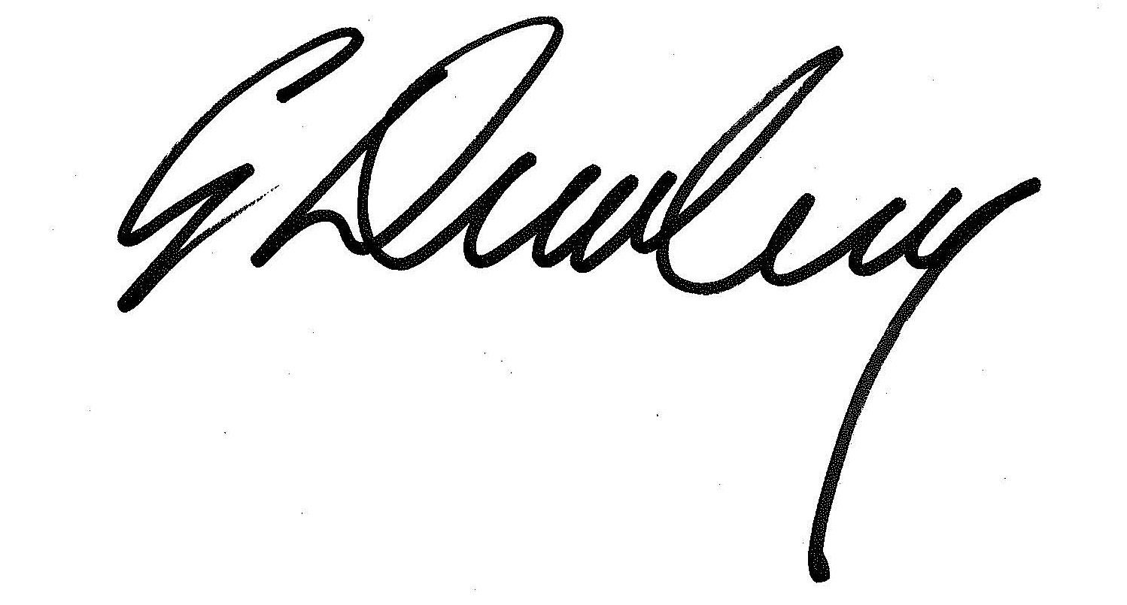

Graham Duxbury, Chief Executive

PR & Communications Coordinator

We are currently recruiting to a PR & Communications Coordinator vacancy within the established PR & Communications team at Groundwork UK – Groundwork’s national office based in Birmingham.

We are seeking someone with experience of working with on all aspects of communications, PR, marketing and online activity, generating national brand awareness.

You will carry out your duties with a high level of customer service, and be a team player who is quick to adapt to shifting priorities in a dynamic working environment.

Groundwork UK is committed to being an inclusive employer and offers flexible working arrangements and supportive, family friendly policies. We encourage people to think about whether they could fulfil this role working part time or in job share arrangements.

The Groundwork UK team is currently working at home in line with government recommendations. We expect to return to our office base in central Birmingham over the coming months.

Benefits

- Starting salary £31,990
- 29 days holiday entitlement
- Flexi-time arrangements
- Enhanced paid maternity leave
- 7.5% pension contribution
- Travel loan scheme
- Health cash plan through BHSF
- Salary sacrifice benefits including childcare vouchers and cycle to work scheme

About Groundwork
Groundwork is a charity working locally and nationally to transform lives in the UK’s most disadvantaged communities.

We help people to carry out thousands of diverse projects each year. Projects that tackle climate change and help people out of fuel poverty. Projects that bring out the best in young people by helping them to improve their local area. Projects that build stronger communities by improving green space or creating jobs.

Last year Groundwork accessed £96 million of funding to support our mission and distributed £29 million in grants to help local groups improve their neighbourhoods.

This contributed to the following outputs and outcomes.

- More than 9,100 community organisations supported
- learners of all ages supported to achieve nearly 6,000 qualifications
- 50,000 days of social action unlocked
- 25,750 people helped to achieve new goals in education, training or employment
- 7.4 million m2 of land improved and nearly 59,000 trees planted
- 5.9 million kg of CO2 and 1.4 million kg of waste prevented

You can read more about the impact our work has here.

Our strategy for 2020 – 2023 sets out our ambition to build our visibility, our reputation and our resource base so that we can be a significant, radical, national force for driving change in attitudes, behaviours, places and prospects in the local communities that need it most.

Our strategy document has been provided with this information pack.

Groundwork UK

Groundwork UK is the national body of the Groundwork federation, supporting, championing and representing the work of Groundwork Trusts across the country. This includes building national relationships with funders and policymakers, securing resources to support local delivery and acting as a managing agent for programmes and contracts delivered by Groundwork Trusts and other partners.

Working for Groundwork UK

- Values
Our values inform what we do and how we do it. We are environmentally aware and focused on communities in need. We are collaborative, show integrity and strive for quality in everything we do.

- We are open, honest and transparent
- We are polite and professional
- We demonstrate our integrity in all our dealings with colleagues, customers and partners


- We actively engage with colleagues to find innovative solutions to problems and tasks
- We celebrate success together
- We work closely with partners to develop join initiatives
- We monitor all our work to make continuous improvement
- We train and develop ourselves and inspire others
- We encourage and welcome feedback
- We value the opportunities for personal and career development
- We put communities at the centre of our planning
- We encourage staff volunteering to help communities in need
- We place vulnerable people at the heart of all our work
- We respect the local and global environment
- We strive to minimise our own environmental impacts
- We ensure environmental impacts are considered in all our work
INTEGRITY
COLLABORATIVE
QUALITY
COMMUNITIES IN NEED
ENVIRONMENTALLY AWARE

- Equality and diversity

We are fully committed to eliminating discrimination and promoting equality and diversity in our workforce and employment practices, in the work we undertake, and in the provision of all our services.

We value diversity and flexibility in our workforce as we think it gives us access to a wider range of skills. We therefore strive to be an equal opportunities employer. This means that decisions concerning recruitment, promotion or any other aspect of employment will be based on the needs of the organisation and not any assumptions based on sex, race, age, disability, gender reassignment, sexual orientation, married or civil partnership status, pregnancy or maternity, religion or belief (these are known as ‘protected characteristics’). This is an important commitment, which all employees are expected to share.

- Safeguarding

We commit to doing everything we can to ensure the safety of those involved in our projects, programmes and services. Our safeguarding team ensures that our safeguarding policy and practices are rigorously implemented and continually reviewed and improved.

Our safer recruitment practices help us to ensure that we recruit colleagues who share our high standards and expectations. All job offers are conditional on the receipt of satisfactory references. Where appropriate, we ask our workers to complete a Disclosure and Barring Service (Criminal Records Bureau) check. We are also obliged to confirm your identity and obtain proof of your right to work in the UK. We ask all staff to undertake safeguarding training when they join us.

- Sustainable development

Groundwork UK is committed to minimising its environmental impact and promoting positive environmental behaviour among its employees, service users, suppliers and partners. Our sustainable development policy sets out how we will manage our assets and activities in a way that’s consistent with our values and demonstrates our commitment. The policy relates to all areas of our work and contains responsibilities for all employees.

Recruitment process

In order to apply for this role please send the following to recruitmentUK@groundwork.org.uk by no later than noon, Monday 26th October 2020.

- An up-to-date CV. (Your name and any information that could be used to identify your age, gender or ethnicity will be removed by our recruitment team before shortlisting)

- Supporting statement. This should be a maximum of two pages of A4 setting out why you wish to apply for the position, and how your knowledge, skills, experience and values meet the requirements of the role.

- Signed GDPR Statement acknowledgment*

- Completed Equal Opportunities Monitoring Form*

- Completed Self-Disclosure form*

- A completed Referees form.* this should contain contact details of 2 referees, one of which should be your most recent employer if you have one. Please note referees will not be contacted unless you are successful at interview stage.

* These documents will be removed by our HR team prior to shortlisting.

Groundwork UK collects this data to help ensure that there is no discrimination in employment practice with regards to appointment, access to training, and promotion. This is a condition of the GDPR under which processing of sensitive data can take place.

Interviews

We will contact you to let you know whether you have been shortlisted for interview.

We expect to conduct interviews (by telephone or video call) during the week beginning
2nd November 2020.

Job Description

Job Title: PR & COMMUNICATIONS COORDINATOR
Responsible to: Communications Manager
Location: Central Birmingham (remote working considered)
Term: Permanent

JOB SUMMARY

The PR & Communications Coordinator will contribute to all aspects of Groundwork UK’s PR, marketing and online activity to support fundraising campaigns, business development activities and the management of national programmes, with particular responsibility for generating national awareness of Groundwork’s local delivery activities.

MAIN DUTIES

- Work with colleagues in Groundwork UK and in Groundwork Trusts to identify and promote local projects and stories to support national policy and positioning activity
- Coordinate media enquiries acting as first point of contact for all and work with colleagues to generate appropriate positions and responses
- Coordinate a proactive press office and lead journalist outreach programmes, developing and pitching stories drawn from across the Groundwork federation
- Supporting the planning and delivery of communications activities to ensure national programme and contract requirements are met to the satisfaction of partners and funders and generate maximum brand value for Groundwork.
- Work with colleagues in both the Programmes and Contracts teams and with partners and funders to develop and manage communications plans and branding guidelines for Groundwork Trusts and other groups and organisations and ensure compliance.
- Monitor and evaluate communications activity across programmes, reporting as necessary.
- Research and write articles for publication in online and offline magazines, periodicals and blogs.
- Maintaining effective relationships with partners, funders, delivery partners and grant recipients, offering a high level of customer service.
- Plan, manage and represent Groundwork UK at PR events, launches and photo calls and attend conferences and exhibitions as required.
- Commission external services to support national PR activity including photography, copywriting, design and print.
- Contribute to Groundwork UK’s partnership development, including supporting business development, volunteering and fundraising activity.
- Line management of PR & Communications team members (as required), supporting high performance and professional development.
- Support the Communications manager in the provision of information and advice to the Federation Executive Team and Federation Board.
- Deputising for the Communications Manager as required.

MISCELLANEOUS

- The post holder will need to have internet connectivity and potential for home working due to current Covid-19 restrictions

- The role will involve travel (potentially including out of office hours) to engage with partners and key stakeholders across the UK. This may include some overnight stays.

- The post holder will be expected to fulfil all duties in adherence with Groundwork UK’s values (environmentally aware, focused on communities in need, acting collaboratively, with integrity and striving for quality) and in accordance with our sustainable development policy.

- Groundwork UK is committed to being an inclusive employer and offers flexible working arrangements, job share opportunities and supportive, family friendly policies. Part time/Jobshare arrangements considered.

Person Specification

Specification | Essential
Knowledge, Experience & Skills
- Knowledge and experience of using Microsoft Office software to a high degree and demonstrable ability to learn to use more specialised professional software systems and digital tools used in the Communications team. | E
- Significant knowledge and understanding of PR & Communications in relation to effective external programme communications | E
- Significant experience of working with journalists, coordinating a proactive press office and developing and pitching stories | E
- Experience of planning and delivery of programme communications activities | E
- Experience of researching and writing articles for publication in online and offline magazines, periodicals and blogs | E
- Proven experience of writing reports, case studies for internal and external audiences | E
- Experience of briefing senior staff members for media interviews | E
- Ability to plan workload and deal with competing demands, and programmes | E
- Experience of Line management, proactive communication and team-working | D
- Experience of crisis communications | D
- Experience of building and managing relationships with funders and commissioners | E
Values and Culture
- Alignment with Groundwork UK’s values:  - Environmentally aware,  - Focused on communities in need  - Collaborative  - Show integrity  - Strive for quality | E

