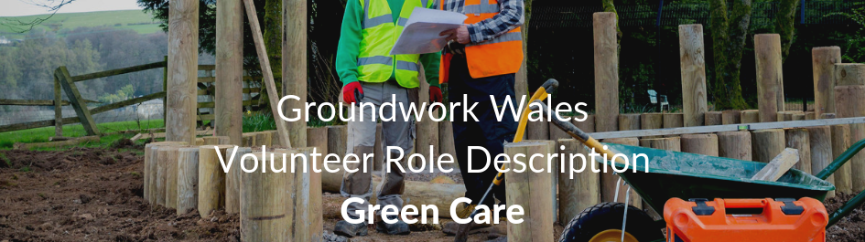

ROLE TITLE: Greencare Volunteer

LOCATION: Groundwork Wales Offices, Pontllanfraith

RESPONSIBLE TO: Greencare Co-Ordinator

NUMBER OF HOURS: 7.5 hours per day minimum
The Project

Greencare provide grounds maintenance and site specific grounds upgrades for a social housing landlord. We also provide light construction services for community groups. Services includes:

- Fencing
- Ground clearing
- Path building
- Tree Felling
- Allotment Building

Role of the volunteer

- Support existing projects
- Learn new skills
- Load and unload vehicle for daily work load
- Provide help in a team environment
Person Specification

- Flexibility and willingness to work on own initiative and as part of a team

- The ability to engage with a wide range of individuals
- Good communication skills
- Self-confidence, self-motivation and enthusiasm.
- A willingness to learn new skills
- Have a calm temperament and be able to deal with visitors and staff in a professional manner
- Dependable and Reliable

Training Opportunities
- Opportunities for other training relevant to your volunteer role can be provided

Benefits offered
- Motivation and sense of achievement
- Boost your career options
- Teamwork
- Gets you in the great outdoors

Contact us

If you have any questions about the recruitment process for this role you should contact Groundwork Wales on:

Tel: 01495 222605
Email: alison.edwards@groundwork.org.uk




@groundworkGG4H

