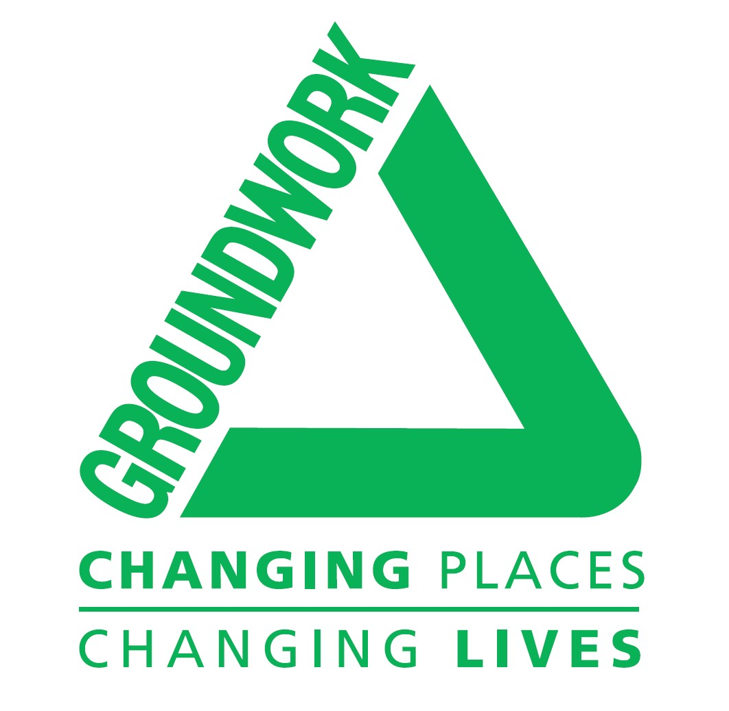
Selby Connected Programme launches
Groundwork has been successful in securing funding from the Coronavirus Community Support Fund, distributed by The National Lottery Community Fund to support a number of exciting, targeted, projects in the Selby district over the next six months.
These are:
To contribute 32 iPads to a Selby digital loaning library working in partnership with other organisations
To support veterans in Selby with their gardening requirements
To support the development of St James Community Garden in Selby, working with the community to create new growing areas
To support the development of a Selby Men in Sheds in partnership with other organisations
To deliver an alternative curriculum offer around horticulture, wellbeing and resilience to 3 high schools and 3 primary schools in Selby Town
All these programmes will contribute towards a reduction in loneliness and isolation which is a priority at this time as well as helping folks to learn new skills, remain connected and to feel supported.
We have appointed Joshua Scarlett to the post of Selby Connected Project Officer. Joshua can be contacted by email on: Joshua.scarlett@groundwork.org.uk Mobile: 07754 316 186

