Programme Evaluation
Invitation to Tender: Appendices

Natural Neighbourhoods, Green Recovery Challenge Fund
National Lottery Heritage Fund
June 2021

Reference: NN/GRCF/JUNE21

Address: Groundwork UK, Suite B2, The Walker Building, 58 Oxford Street, Birmingham, B5 5NR
Email: contracts@groundwork.org.uk
Website: www.groundwork.org.uk

Commissioning Body:

Groundwork UK
Company limited by guarantee and registered in England No. 1900511
Charity Registration No. 291558
Registered Office: Lockside, 5 Scotland Street, Birmingham, B1 2RR

Commissioning Officer: Sarah Duncan, Quality Manager

Table of Contents

Appendix A: Selection Criteria 4
Appendix B: Theory of Change 5
Appendix D: Schedule of Costs 6
Appendix F: Evaluation Tender Submission Coversheet 7

Appendix A: Selection Criteria
Please note that organisations failing the one or both of the selection criteria listed below will not be assessed for or invited to interview.
 | Criteria Type | Scoring Guide | Max. Score
Word Count | Selection | Pass – within word count maximum  Fail – over 5000 words | Pass / Fail
Context and Understanding | Assessment | 0 – no understanding of the context nor the requirements of the tender demonstrated  1 – limited demonstration of the tender requirements and/or its context  2 – reasonable demonstration of the tender requirements and its context. Includes reference to how the organisation meets the characteristics and expectations set out in the tender and some understanding of the heritage and social context of the programme  3 – good demonstration of the tender requirements, the programme structure and its context. Includes detailed reference to how the organisation meets the characteristics and expectations set out in the tender and a clear understanding of the heritage and social context of the programme  4 - excellent demonstration of the tender requirements, the programme structure and its context. Includes very detailed reference to how the organisation meets the characteristics and expectations set out in the tender, and a strong demonstration of an understanding of the heritage and social context of the programme | 4
Methodology | Assessment | 0 – no methodology given  1 – limited methodology: no or limited timescales; little indication of methods to be used; very limited linking of methodology to research questions  2 – adequate methodology: some timescales given; indication of broad methods to be used; some linking of methodology to relevant research questions  3 – good methodology: clear timescales given; clear methods set out along with strong links to relevant research questions  4 – excellent methodology: clear and practical timescales given; methods set out in detail with definite links to relevant research questions and named staff members  5 - excellent methodology: clear and practical timescales given; methods set out in detail with definite links to relevant research questions and named staff members; organisation proposes innovative and/or tailored methodology to ensure vulnerable young people are able to participate | 5
Experience | Assessment | 0 – no relevant experience and/or examples given  1 – limited experience and/or examples given  2 – moderate experience and/or examples given  3 – detailed experience and/or examples given | 3
Resources | Assessment | 0 – no detail of resource allocation given  1 – limited detail of resource allocation given  2 – adequate detail of resource allocation given, including named staff  3 – good or excellent detail of resource allocation given, including named staff, experience, their role within the proposal and copies of CVs where relevant | 3
Budget – amount | Selection | Pass – tender is within budget, including VAT  Fail – tender is over budget/does not include VAT | Pass / Fail
Budget – detail | Assessment | 0 – no budget detail given  1 – budget detail limited to headline costs  2 – fair level of budget detail given, including individual resource costs  3 – detailed breakdown of expected budget expenditure with clear reference to programme outputs | 3
TOTAL |  |  | 18

Appendix B: Theory of Change
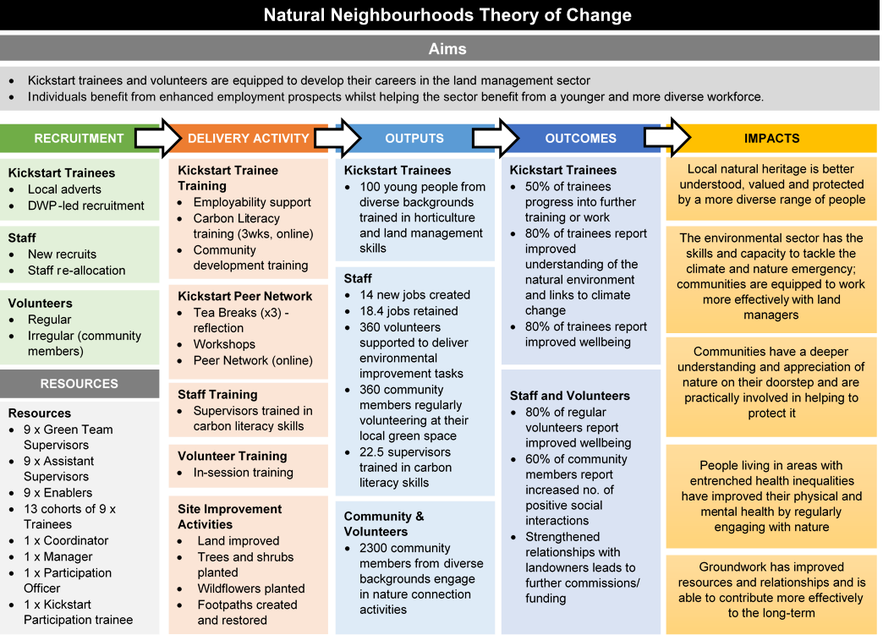

Appendix D: Schedule of Costs

This may be recreated within the body of the tender document if wished.

Cost Centre | Day Rate (if applicable) | Number of Days | Cost of This Element | Total Cost
Researcher(s)
State name of each researcher and day rate for each here (add new row as required)
Travel and Subsistence Costs
Other Costs (Specify)
VAT
Totals

Appendix F: Evaluation Tender Submission Coversheet

TENDER DETAILS
Tender reference
YOUR ORGANISATION DETAILS
Organisation Name
Registered Address
Contact staff member |  | Job title
Email address |  | Tel. no.
Registered Company / Charity number
Business Reference 1
Name
Address
Contact details
Business Reference 2
Name
Address
Contact details
Tender Checklist Your tender should include:
Names & job roles of your evaluation team relevant to this tender
Relevant experience relating to your evaluation team members
An outline Research Plan including methodology and timescales which directly refers to the Aims, Outcomes and Scope set out in the Briefing Document
A schedule of costs in the format set out in Appendix A
SIGNATURE
I/We hereby submit a bona fide tender for this work, and agree to abide by and be bound by the conditions of the brief and instructions to tenderers, and understand that this my/our tender, its contents and the brief/instructions shall form part of any contract awarded. I/we agree to prerogate the laws of England as applying to the processes of tender, award, management and discharge of contract.
Name & Position:
Signature: |  |  | Date:

