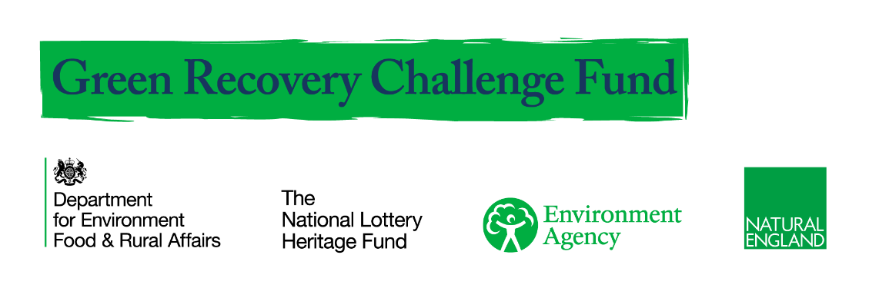

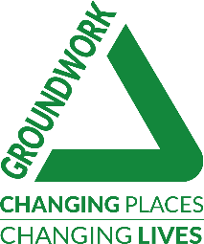

Natural Neighbourhoods
Volunteer Application Form

Thank you for your interest in joining Groundwork's Natural Neighbourhoods programme.

Before you start the application form, please ensure you have read all the information about Natural Neighbourhoods, available on our website here: https://www.groundwork.org.uk/projects/natural-neighbourhoods-uk

This form will ask you for the following information:

- Your name and contact details
- Your motivation for getting involved, and any skills you will bring to the project
- Anything we can do to help you get involved
- Emergency contact details
- Your declaration and permission to collect your data

If you are under 18, you will also need to ask for your parent or guardian’s permission to take part in the programme, and sign this form.

More information about how we use your personal data is provided in a Privacy Notice at the end of the application.

If you have any questions, please contact Francesca Sullivan at Groundwork Greater Manchester on Francesca.Sullivan@groundwork.org.uk or 0161 220 1000.

Version 1_March 2021

PART 1: About You

Your Contact Details

Title: |  | First Name:
Surname:
Address:
Postcode:
Contact Telephone No.:
Email Address:

Which Groundwork Trust are you applying to volunteer with?

Please tell us about your availability and how frequently you would like to volunteer with us?

Your Motivation

Your answers to this section will help us work out how to help you get the most out of your time volunteering with Groundwork.

Why did you choose to get involved with Natural Neighbourhoods?
Please tick a maximum of three:

☐ To help a charity/cause I believe in  ☐ To protect the environment  ☐ To add to my CV / job opportunities  ☐ To meet new people  ☐ It looked like fun | ☐ To help other people in my community  ☐ To build my confidence and teamwork skills  ☐ To learn more about things that affect me / my community / the environment  ☐ Other (please state):

PART 1: About You (continued)

Please tell us briefly why you would like to volunteer with us, and if you have any skills or knowledge that you would be interested in sharing with us.

What skills or knowledge would you like to develop through volunteering with us?
Please select all that apply:

☐ Learning about improving green spaces  ☐ Learning about horticulture and land management  ☐ Understanding carbon literacy  ☐ Meeting new people and creating social interactions | ☐ Working in a team  ☐ Improving my environmental knowledge  ☐ Improving my knowledge of nature  ☐ Wellbeing and Mindfulness  ☐ Other (please state):

Support Requirements

Is there anything we can do to make sure you are able to take part in this project? Please tell us about any additional support you may need, any accessibility or learning requirements you may have, or any relevant medical information.

Emergency Contact

Please provide details of one person who can be contacted in case of an emergency during the programme.

Full name:
Relationship to you:
Home phone number:
Mobile number:
Email address:

PART 2: Declaration & Permissions

Personal Declaration
By ticking these boxes,
☐ I declare that I wish to take part in Groundwork's Natural Neighbourhoods programme. The information I have provided is correct to the best of my knowledge.

☐ I have read, understood and agree to you using my data as per the Privacy Notice below.

☐ In my capacity as a volunteer, I agree to abide by Groundwork’s Code of Conduct, policies and procedures*.

*Please note: Policies and procedures will be shared via an induction and welcome session. In addition, Groundwork's equal opportunities, anti-bullying and safeguarding policies all apply to online spaces.

Media Consent

Please select your preference on photography and media consent:

☐ Yes - I give Groundwork UK, Groundwork Trusts and partner organisations permission to record my image and/or voice. I grant Groundwork UK all rights to add the still or moving images and any accompanying words to the library stock of Groundwork UK and to use them in any medium for its educational, promotional or other work that supports the mission of the charity.

☐ No - I do not give Groundwork UK, Groundwork Trusts and partner organisations permission to record my image and/or voice.

How did you hear about Groundwork and Natural Neighbourhoods?

☐ Facebook  ☐ Groundwork website  ☐ Twitter  ☐ Google search | ☐ Local Groundwork staff  ☐ Instagram  ☐ Friend / family recommendation  ☐ Other (please state):

Signature
Name (please print):
Signature |  | Date

Please note: All applicants under the age of 18 must also complete Part 3
PART 3: Declaration and Permissions – Under 18s

Personal Declaration
To be completed by parent / guardian of any under 18s who wish to take part:
☐ I consent to the above named young person to take part in Natural Neighbourhoods volunteering programme.
☐ I have read, understood and agree to you using the above named young person’s data as per the Privacy Notice below.

☐ I understand that in their capacity as a volunteer, the above named young person will be required to abide by Groundwork’s Code of Conduct, policies and procedures*.

*Please note: Policies and procedures will be shared via an induction and welcome session. In addition, Groundwork's equal opportunities, anti-bullying and safeguarding policies all apply to online spaces.

Media Consent

Please select the box with your preference on photography and media consent:

☐ Yes - I give Groundwork UK, Groundwork Trusts and partner organisations permission to record the image and/or voice and/or words of the young person named above. I grant Groundwork UK all rights to add the still or moving images and any accompanying words to the library stock of Groundwork UK and to use them in any medium for its educational, promotional or other work that supports the mission of the charity.

☐ No - I do not give Groundwork UK, Groundwork Trusts and partner organisations permission to record the image and/or voice and/or words of the young person named above.

Signature
Name (please print):
Relationship to applicant
Signature |  | Date

PART 4: Privacy Notice

Groundwork UK is the data controller for personal information collected through this application.

How Groundwork UK will use your information

Under Data Protection Legislation (General Data Protection Regulations 2016/679 & the Data Protection Act 2018), the following information relating to you may be used:

- Personal details (name, age, address, contact details);
- Optional special category data relating to racial or ethnic origin, gender, and disability
- Details relating to your time on programme, including notes from one-to-one discussions, training attended, achievements, and any safeguarding or other concerns.

Groundwork UK will use your information to:
- Check you are suitable for the volunteering programme
- Monitor and promote equality & diversity throughout the volunteering programme
- Keep in contact with you for feedback and evaluation on activities you take part in.
- To make sure you get the most out of this programme and signpost you to other Groundwork programmes you may be eligible for
- To evaluate, report on and promote the outcomes of the programme to funding and partner organisations, and in our external marketing.

Partner organisations include current programme partners National Lottery Heritage Fund (NLHF), DEFRA (Department for Food, Environment and Rural Affairs), and our local Trusts who are part of the Federation of Groundwork Trusts. Any of our partner organisations may also use your information for the purpose above.

Your information will be stored securely and retained until 31st March 2029 in line with our agreement with the funder (NLHF). Data may be held in both paper form and digitally to assist us during and after your involvement with Groundwork in accordance with the current Data Protection Legislation.

You may access data held by us about you by giving notice at any time during your involvement with the programme and afterwards. To enquire about your personal data, please contact contracts@groundwork.org.uk or write to Jonathan Wells, Programme Manager, Groundwork UK, The Walker Building, 58 Oxford Street, Birmingham, B5 5NR.

PART 5: Equity, Diversity & Inclusion

This final section asks some optional personal questions, which will help us to understand whether our programme is accessible to all members of our communities. Please select the “prefer not to say” options below if you do not wish to provide any of this information.

Your answers will not be used during shortlisting or recruitment of volunteers, with the exception of ensuring reasonable adjustments are made where required.

If you are successful in applying to volunteer on Natural Neighbourhoods, this information will be used to provide our funders (National Lottery Heritage Fund and DEFRA) with monitoring and reporting information. This reporting data will be anonymised.

Full name:
Volunteer role applied for:
Groundwork Trust:

1. Gender

Male: ☐ | ☐
Female: ☐ | ☐
I prefer to self-describe | ☐ | Please describe:
Prefer not to say | ☐

2. Do you identify as Trans?
Trans is an umbrella term for people whose identity differs from what is typically associated with the sex they were assigned at birth. People under the Trans umbrella may describe themselves using one or more of a wide variety of terms – including transgender.

Yes | ☐ | No | ☐ | Prefer not to say | ☐

2. Marital Status

Married: ☐ | Single: ☐ | Civil Partner: ☐ | Prefer not to say: ☐

3. Sexual Orientation

Bi | ☐ |  | Gay woman / lesbian | ☐
Gay man | ☐ |  | Heterosexual / Straight | ☐
I prefer to Self describe | ☐
Please describe:

4. Ethnic Origin
Asian or Asian British: |  |  | Mixed Heritage:
Indian: | ☐ |  | White & Black Caribbean: | ☐
Pakistani: | ☐ |  | White & Black African: | ☐
Bangladeshi: | ☐ |  | White & Asian: | ☐
Chinese | ☐ |  | Any other mixed Heritage background: | ☐
Any other Asian background: | ☐

White: |  |  | Black or Black British:
British (English/Scottish/Welsh): | ☐ |  | African: | ☐
Irish: | ☐ |  | Caribbean: | ☐
Gypsy or Irish Traveller: | ☐ |  | Any other Black background: | ☐
Any other White background: | ☐

Other Ethnic Group: |  |  |  |  | Other:
Arab | ☐ |  |  |  | Other | ☐
Any other ethnic group | ☐ |  |  |  | Please specify:
Prefer not to say | ☐ |  |  |  | Prefer not to say | ☐

5. Do you consider yourself to have a disability?

Yes: ☐ | No: ☐ | Prefer not to say: ☐

If yes, please select the primary nature of your disability or health condition:

Visual impairment | ☐ |  | Autism spectrum disorder | ☐
Hearing impairment | ☐ |  | Asperger’s syndrome | ☐
Disability affecting mobility | ☐ |  | Temporary disability after illness (for example post-viral) or accident | ☐
Profound complex disabilities | ☐ |  | Speech, Language and Communication Needs | ☐
Social and emotional difficulties | ☐ |  | Other physical disability | ☐
Mental Health difficulties | ☐ |  | Other Specific learning difficulty (e.g. Dyspraxia) | ☐
Moderate learning difficulty | ☐ |  | Other medical condition (for example epilepsy, asthma, diabetes) | ☐
Severe learning difficulty | ☐ |  | Other learning difficulty | ☐
Dyslexia | ☐ |  | Other disability | ☐
Dyscalculia | ☐ |  | Prefer not to say | ☐

If yes, please detail any assistance or adjustments you make need to take part in the volunteer selection process:

6. Caring Responsibilities

Do you have caring responsibilities? Please select all that apply:

None: | ☐
Primary carer of a child/children (under 18): | ☐
Primary carer of disabled child/children: | ☐
Primary carer of disabled adult (18 and over): | ☐
Primary carer of older person/people (65 and over): | ☐
Secondary carer: | ☐
Prefer not to say: | ☐

7. Age

16-18 | ☐ |  | 65-69 | ☐
19-24 | ☐ |  | 70-74 | ☐
25-34 | ☐ |  | 75-79 | ☐
35-44 | ☐ |  | 80-85 | ☐
45-54 | ☐ |  | 85+ | ☐
55-59 | ☐ |  | Prefer not to say | ☐
60-64 | ☐

