GROUNDWORK  CHANGING PLACES  CHANGING LIVES |  | 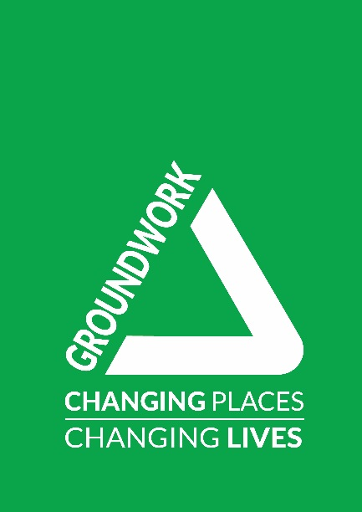

Community Outreach Worker (30 hrs per week)
Job Description & Person Specification
SALARY
£22,000 pro rata, per annum

DURATION
Temporary until end March 2023, with potential to be permanent, depending on funding.

BUSINESS UNIT
Communities Team

LOCATION
Trafford Ecology Park with some home working

ACCOUNTABLE TO
Senior Community Projects Lead (River Valleys)

RESPONSIBLE FOR
N/A

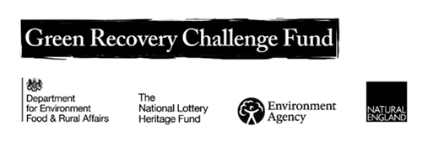
OVERVIEW OF THE POST
During the first 18 months of this post you will be working on the ‘Resilient River Valleys’ project. This project is funded by the Government's Green Recovery Challenge Fund. The fund was developed by Defra and its Arm's-Length Bodies. It is being delivered by The National Lottery Heritage Fund in partnership with Natural England, the Environment Agency and Forestry Commission.

The Community Outreach Worker will engage and involve communities in the Resilient River Valleys Programme with a view to ensuring that our natural environment is better understood, used, valued and protected by a more diverse range of people across Manchester.

You will focus on building connections between communities and local green and blue spaces, working collaboratively with internal and external partners to develop and deliver practical and digital engagement and environmental activities.

ROLE & MAIN PURPOSES OF THE POST
To provide high quality community engagement and environmental activities and events as part of the River Valleys programme.

Key service areas which the role contributes to include:
- Connecting people with nature.
- Environmental social action projects.
- Strengthening communities via capacity building and training.
- Brokering corporate engagement in communities.

Key purposes of the post are to:
- Link effectively with local communities of Black African, Caribbean and South Asian heritage,
- Create new (and building on existing) relationships with residents and groups to improve their access to, and engagement with, nature.

- Organise community events, drop-ins, and attend community groups and other gatherings to build understanding, awareness and trust.
- Using creative and digital engagement methods, involve local and diverse communities in activities to improve their green spaces, including planting, caring and maintaining the spaces and citizen science activities.
- Encourage people from diverse communities to regularly volunteer in their local green spaces and provide events and activities for their communities.
- Support to delivery of activities which build the capacity of residents and volunteers to care for their local green spaces.
- Provide regular written and oral reports, collecting relevant data required to evidence impact.
- Undertake other related responsibilities commensurate with the post and the evolution of the Trust.
- Be alert to the safeguarding of young people and children, raising any issues and concerns following policies and procedures.
PERSON SPECIFICATION
Essential experience:
- Demonstrable experience of community engagement or community development with communities of Black African, Caribbean or South Asian heritage.
- Experience of delivering environmental (nature-based, gardening, growing) engagement activities and events.
- Experience in working in partnership with a range of stakeholders from across public and voluntary sectors.
- Experience of supporting volunteers.
- An enhanced DBS is a requirement of the role.

Desirable experience:
- Experience of working within a quality management system, which assures the quality of programme delivery.

Essential knowledge, skills and qualifications:
- A good understanding of the economic and social needs of ethnically diverse communities.
- Excellent communication skills, able to communicate with a range of audiences using a variety of techniques and media including digital.
- Excellent organisational skills and time management with ability to manage / prioritise own workload, work to deadlines and balance multiple priorities.
- Computer literacy with a practical experience of using MS Office and social media channels and willingness to learn and use other software packages, including our in house financial management system.
- Ability to maintain a professional attitude and boundaries in working with partners, members of the community, including young people.
- A positive attitude towards teamwork and being able to work well with others.

Desirable knowledge, skills and qualifications:
- Ability to speak a community language.
- Awareness of safeguarding of young people, children and vulnerable adults (training is provided).

Values and ethos:
• A genuine passion for Groundwork’s mission and values;
• A commitment to the delivery of high quality services and value for money.
• Commitment to an agile project/team culture of ‘learning in action’ to ensure the team/project learns the most it can from its work in the community and adapts accordingly
• Commitment to inclusion and team-work
• A commitment to low-carbon ways of working

ADDITIONAL FACTORS
- Able to work outside of normal office hours within a flexi time / time off in lieu system.
- Undertake training and development deemed necessary for the pursuance of the post.
- Comply with the Trusts Policies and Procedures including, but not exclusively, Equality, Diversity and Inclusion, Data Protection, Health and Safety and Environment.

Date Prepared 07.10.2021
Prepared By: Michaela Howell. Head of Communities and review by Deborah Murray, Deputy Executive Director.

