GROUNDWORK  CHANGING PLACES  CHANGING LIVES |  | 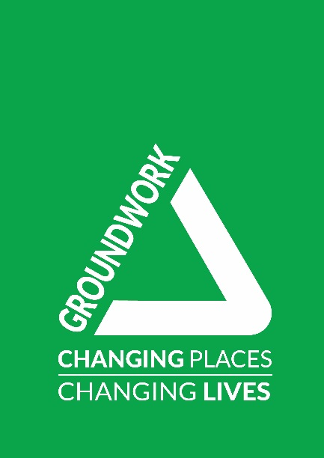

Senior Community Projects Lead (River Valleys)
Job Description & Person Specification
SALARY
£28,000 per annum

DURATION OF THE POST
Temporary until end March 2023, with potential to be permanent, depending on funding.

BUSINESS UNIT
Communities Team

LOCATION
Trafford Ecology Park with some home working

ACCOUNTABLE TO
Communities Manager

RESPONSIBLE FOR
Community Outreach Worker, Volunteers as required

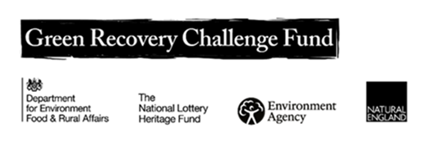

OVERVIEW OF THE POST
During the first 18 months of this post you will be working on the ‘Resilient River Valleys’ project. This project is funded by the Government's Green Recovery Challenge Fund. The fund was developed by Defra and its Arm's-Length Bodies. It is being delivered by The National Lottery Heritage Fund in partnership with Natural England, the Environment Agency and Forestry Commission.

The Senior Community Projects Lead is responsible for the engagement and involvement of local communities in the River Valleys Programme, with a view to ensuring that our natural environment is better understood, used, valued and protected by a more diverse range of people.

You will work collaboratively with internal and external partners to develop and deliver practical and digital engagement and environmental activities, which connect communities with their local green and blue spaces.

ROLE OF THE POST
To be responsible for the Community River Valley programme, including ensuring quality and growth.

Key purposes of the post are:
- Lead and manage high quality community environmental projects, ensuring they meet the needs of communities and partners.
- Work closely with community partnerships to design projects and action plans that meet community needs.
- Work collaboratively with partner organisations to plan tailored ‘connecting with nature’ programmes, including Love Your River activity.
- Line manage the Community Outreach Worker.
- Develop collaborative ways of working with partners, communities and other organisations to deliver nature and green-based activities that support joint aims.
- Lead capacity building support and environmental training programmes with a wide range of community groups.
- Support the promotion and delivery of Groundwork’s corporate social responsibility programme.
- Identify and access funding opportunities in accordance with business plan targets.
- Collect monitoring and business intelligence data, including project and financial performance and impact measures.
- Contribute to the development and implementation of marketing and sales campaigns supporting the Sustainable Communities work programme.
- Recruit, manage and train volunteers as required.
- Undertake other related responsibilities commensurate with the post and the evolution of the Trust.
PERSON SPECIFICATION
Essential experience:
- Demonstrable experience of community engagement or community development with a wide range of communities.
- Extensive experience of leading community-based nature projects, including around rivers and waterways.
- Experience of working in partnership with a range of stakeholders from across public, private and voluntary sectors.
- Experience of collecting data for monitoring purposes.
- Experience of delivering environmental education/training.

Desirable experience:
- Experience of line management.
- Experience of securing external funding for new work.
- Experience of working within a quality management system, which assures the quality of programme delivery.
Essential knowledge, skills and qualifications:
- Sound knowledge of a wide range of nature activities to inspire communities to connect with nature.
- Strong project management skills.
- Excellent communication skills, able to communicate with a range of audiences using a variety of techniques and media including digital.
- Excellent organisational skills and time management with ability to manage / prioritise own workload, work to deadlines and balance multiple priorities.
- A broad understanding of the economic and social needs of diverse communities.
- Ability to maintain a professional attitude and boundaries in working with partners, members of the community, including young people.
- A positive attitude towards teamwork and being able to work well with others.
- Computer literacy with a practical experience of using MS Office and social media channels and willingness to learn and use other software packages, including our in house financial management system.

Desirable knowledge, skills and qualifications:
- Adult learning qualification e.g. L3 Award in Education and Training or above.
- Relevant qualification in an environmental subject, carbon literacy or similar.
- Awareness of safeguarding of young people, children and vulnerable adults (training will be provided).

Values and ethos:
• A genuine passion for Groundwork’s mission and values;
• A commitment to the delivery of high quality services and value for money.
• Commitment to an agile project/team culture of ‘learning in action’ to ensure the team/project learns the most it can from its work in the community and adapts accordingly.

ADDITIONAL FACTORS
- Able to work outside of normal office hours within a flexi time / time off in lieu system.
- Environmentally aware and sympathetic to the aims and ethos of Groundwork and other project partners.
- Undertake training and development deemed necessary for the pursuance of the post.
- Comply with the Trusts Policies and Procedures including, but not exclusively, Equality, Diversity and Inclusion, Data Protection, Health and Safety and Environment.

This role may be subject to a Disclosure and Barring Service (DBS) check.

Date Prepared 07.10.2021
Prepared By: Michaela Howell. Head of Communities and review by Deborah Murray, Deputy Executive Director.

