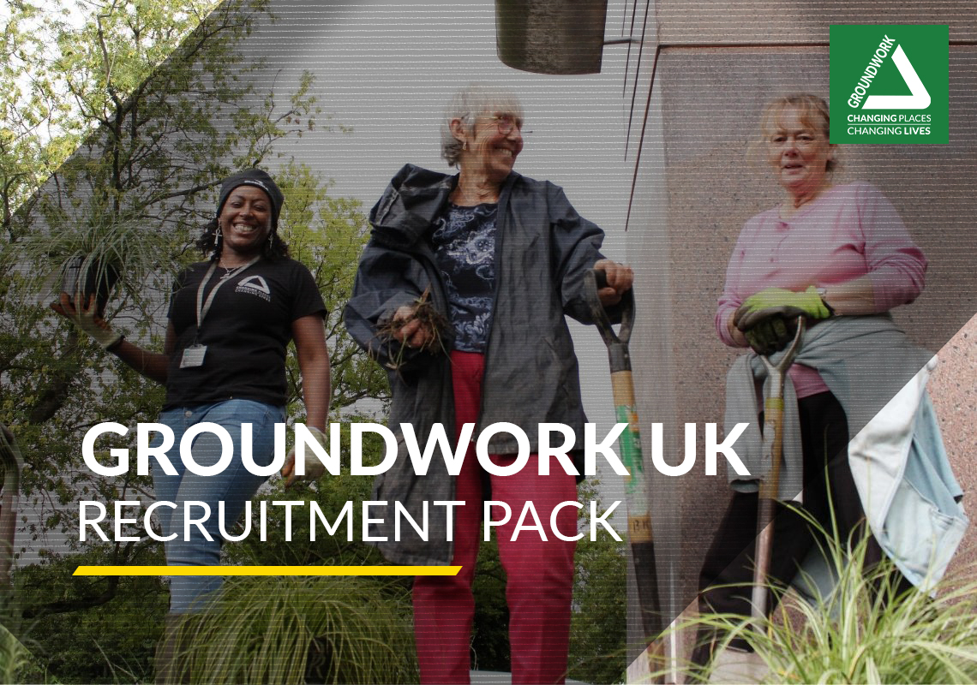

Community Grant Panel Member
CLOSING DATE: 3rd December 2021

Groundwork UK | Charity Registration number 291558  Suite B2, The Walker Building, 58 Oxford St, Birmingham, B5 5NR | 
0121 236 8565 | info@groundwork.org.uk  www.groundwork.org.uk | 

ABOUT GROUNDWORK
Groundwork is a charity working locally and nationally to transform lives in the UK’s most disadvantaged communities.

We help people to carry out thousands of diverse projects each year. Projects that tackle climate change and help people out of fuel poverty. Projects that bring out the best in young people by helping them to improve their local area. Projects that build stronger communities by improving green space or creating jobs.

Last year Groundwork accessed £96 million of funding to support our mission and distributed £29 million in grants to help local groups improve their neighbourhoods.

This contributed to the following outputs and outcomes.

 | More than 9,100 community organisations supported
 | Learners of all ages supported to achieve nearly 6,000 qualifications
 | 50,000 days of social action unlocked
 | 25,750 people helped to achieve new goals in education, training or employment
 | 7.4 million m² of land improved and nearly 59,000 trees planted
 | 5.9 million kg of CO₂ and 1.4 million kg of waste prevented

You can read more about the impact our work has here.

Our strategy for 2020 – 2023 sets out our ambition to build our visibility, our reputation and our resource base so that we can be a significant, radical, national force for driving change in attitudes, behaviours, places and prospects in the local communities that need it most.

GROUNDWORK UK

Groundwork UK is the national body of the Groundwork federation, supporting, championing and representing the work of Groundwork Trusts across the country.

This includes building national relationships with funders and policymakers, securing resources to support local delivery and acting as a managing agent for programmes and contracts delivered by Groundwork Trusts and other partners.

Panel Member
Comic Relief Community Fund

Groundwork UK is working with Comic Relief in England, to provide grant funding and support to grassroots community organisations with an annual income of less than £250,000. https://www.groundwork.org.uk/comic-relief/

We are currently looking to recruit participants to join our local grant panels and to help make decisions about where Comic Relief funding should be spent.

Local panel meetings will take place across England in February 2022, September 2022 and March 2023. Each Panel meeting is expected to last approximately 3.5 to 4 hours, members would need to review, and score panel papers in advance of the meetings. They will take place virtually (most likely by Zoom or Teams) and will be chaired a Groundwork staff member.

We are specifically looking for our panel members to have a lived experience of one of our four comic relief themes.

Children Survive & Thrive:
We are looking for panel members who have experience through supporting children and their families to reach their development potential through good health, nutrition and opportunities for early learning, support to build caring and supportive relationships and keep children safe.

Fighting for Gender Justice:
We are looking for panel members who have experience through supporting women and girls to be safe, educated and healthy and in control of their own lives, supporting women and girls to be an equal part of collective decision making in communities. This includes persons who identify with the female gender.

A Safe Place to Be:
We are looking for panel members who have experience of working to support people to recover from homelessness and resolve their situation by helping people to make positive changes and work to support community led approaches to supporting refugees or asylum seekers rebuilding their lives due to forced migration.

Mental Health Matters:
We are looking for panel members who have experience in improving the mental health and support networks of people experiencing or at risk of poor mental health; especially those from marginalised groups, increasing the accessibility of mental health services to people who need them.

Successful applicants will be assigned to a local panel, and with preference given to individuals who can attend all panels over the next 18 months.

Panel members, will be provided with training and an opportunity to meet other panel members prior to the panel dates. Out of pocket expenses are also able be reimbursed.

RECRUITMENT PROCESS

Closing date:
12 noon 3rd December 2021

In order to apply for this role please send the following to ComicRelief@groundwork.org.uk
Please note we may reopen the process in certain regions should we require further applications.

HOW TO APPLY

Please also complete the following

- Application Form

- GDPR Statement acknowledgment*

- Equal Opportunities Monitoring Form*

- Completed Self-Disclosure form*

*These documents will be removed prior to shortlisting.

Please read our Frequently Asked Questions guide which can be found on the Comic Relief page.

Next Steps
Once we have reviewed all applications, we will invite shortlisted applicants to informal meetings with the local coordinators. Some locations in England may be more popular than others, so if you aren’t successful, this time we will keep a reserve list in case we have opportunities in the future for local panel members.

Groundwork UK collects data to help ensure that there is no discrimination with regards to appointments. This is also condition of the GDPR under which processing of sensitive data can take place.


Panel member application form

Many thanks for your interest in becoming a Panel member for Groundwork UK’s Comic Relief Community Fund (England) programme. We now need some further information from you before we can complete our panel recruitment. Before completing this brief application please ensure that you have read this pack in full that you have read our FAQ document, which will provide you with the information that you need to know about being a Panel member for Groundwork UK.

Q1. Which of the following four Comic Relief themes do you have experience in? Please delete themes that do not apply.

Comic Relief Theme
A Safe Place To Be
Children Survive and Thrive
Fighting for Gender Justice
Mental Health Matters

Q2. Please can you tell us a bit more about your experience in the themes that you have selected. We are looking to hear about your local knowledge of working to support people, for example if you have worked within or volunteered to support organisations delivering against your chosen theme. Please do not write any more than 300 words
Q3. Please can you tell us if you have lived experience of your chosen Comic Relief Strategic themes i.e.:
  - A Safe Place to Be (e.g. has experienced homelessness or forced migration).
  - Children Survive and Thrive (e.g. has used early years services with their children and has an understanding of the needs of 0-11 year olds)
  - Fighting for Gender Justice (e.g. has experienced of issues that include domestic violence or of fighting for equality for women and girls).
  - Mental Health Matters: (e.g. has had experience of mental health issues and experience of accessing services to support recovery). Please do not write any more than 300 words

Q4. Please can you tell us why you are interested in becoming a Panel member? Please do not write any more than 100 words.

Q5. Please can you tell us about what qualities you think that you would bring to a decision making panel? Please do not write any more than 100 words.
Q6. If you have experience of being involved in a decision making panels, please can you tell us a little about this? Please do not write any more than 100 words.

Q7. Which region do you live in? Please delete regions that are not applicable.
- North East
- North West
- Yorkshire & Humber
- West Midlands
- East Midlands
- East of England
- South West
- South East
- London

Q8. Which area and city/town of your chosen region do you live?

Q9 Are you part of a group/organisation who has previously been awarded funding through the Comic Relief Community Fund (England) programme?
If yes, please provide application reference number
Yes or No - If yes, please provide application reference number

Q10 Have you previously been a panel member for the Comic Relief Community Fund (England) programme.
Yes or No - If yes, which panel were you part of?

Equal Opportunities Monitoring Form

Please complete this form.
At Groundwork, we want to ensure everybody has an equal opportunity, and is not treated differently or discriminated against because of their characteristics.
We need your help to develop our work to promote equality and fairness for all. We would like you to respond to the following questions so as we can ensure our services meet your needs, and there is equality of opportunity for all.
All questions are optional.
You are not obliged to answer any of these questions but the more information you supply, the more effective our monitoring will be. All information supplied will be treated in the strictest confidence.
Please answer each question in turn by choosing one option only, unless otherwise indicated. If you do not wish to answer the question, please choose the option “Prefer not to say‟ rather than leaving the question blank.
Please place an ‘X’ in the appropriate box/ boxes.

1. Age

16 - 18 |  | 65 – 69
19 – 24 |  | 70 - 74
25 – 34 |  | 75 – 79
35 – 44 |  | 80 – 85
45 – 54 |  | 85+
55 – 59 |  | Prefer Not to Say
60 – 64

- Gender and Sexuality:
Which of the following best describes your gender?

Male
Female
I prefer to self-describe (include below)

Prefer not to say

Do you identify as Trans? (Trans is an umbrella term for people whose identity differs from what is typically associated with the sex they were assigned at birth. People under the Trans umbrella may describe themselves using one or more of a wide variety of terms – including transgender).

Yes
No
Prefer not to say

Which of the following do you identify as?

Bi
Gay man
Gay woman/ lesbian
Heterosexual / Straight
I prefer to self-describe (include below)

- Ethnicity:

Asian/Asian British - Indian |  | Mixed - White and Asian
Asian/Asian British - Pakistani |  | Mixed - any other mixed background
Asian/Asian British - Bangladeshi |  | Other Ethnic Group - Arab
Asian/Asian British - Chinese |  | Other Ethnic Group - Any other ethnic group
Asian/Asian British - Any other Asian background |  | White – British  (English/Scottish/Welsh)
Black/Black British - African |  | White - Irish
Black/Black British - Caribbean |  | White - Gypsy or Irish Traveller
Black/Black British - Any other Black background |  | White - Any other White background
Mixed - White and Black Caribbean |  | Prefer Not To Say
Mixed - White and Black African

4. Disability
I consider myself to have a learning difference and/or disability, and/or limiting health condition:

Yes
No
Prefer not to say

If yes, please outline the primary nature of your disability or health condition:

Visual impairment |  | Autism spectrum disorder
Hearing impairment |  | Asperger’s syndrome
Disability affecting mobility |  | Temporary disability after illness (for example post viral) or accident
Profound complex disabilities |  | Speech, Language and  Communication Needs
Social and emotional difficulties |  | Other physical disability
Mental Health difficulties |  | Other Specific learning difficulty (e.g. Dyspraxia)
Moderate learning difficulty |  | Other medical condition (for example epilepsy, asthma, diabetes)
Severe learning difficulty |  | Other learning difficulty
Dyslexia |  | Other disability
Dyscalculia |  | Prefer not to say

5. Religion
I would describe my religion as:

Buddhist |  | Non-religious (Atheist / Humanist)
Christian (including Catholic, Church of  England, Protestant and all other  Christian denominations) |  | Sikh
Hindu |  | Other (please describe)
Jewish |  | Prefer Not to Say
Muslim

6. Marital Status

Co-habiting |  | Separated
Divorced |  | Widowed
Married / In a civil partnership |  | Prefer Not to Say
Single

7. Caring Responsibilities
Do you have caring responsibilities? (Please tick all that apply).

None |  | Primary carer of older person/people (65 and over)
Primary carer of a child/children (under 18) |  | Secondary carer
Primary carer of disabled child/children |  | Prefer not to say
Primary carer of disabled adult (18 and over)

General Data
Protection
Regulation (GDPR)
Privacy statement

Our Commitment
Groundwork UK has a consistent level of data protection and security across the organisation. We are committed to the principles inherent in the Data Protection Act 2018 and the GDPR and particular to the concepts of privacy by design, the right to be forgotten, consent and a risk-based approach. We are a Data Controller this means we hold the decision on how we process your information about you.

Our contact details are as follows:
- Registered office: Suite B2, The Walker Building, 58 Oxford Street, Birmingham, B5 5NR
- Email: info@groundwork.org.uk
- Charity registration number 291558
- Company registration Number 1900511
- Website www.groundwork.org.uk

If you need to contact us on any data protection matter, please use the email address above.

Data protection principles
In collecting and processing your personal information, we will comply with the data protection law in force at the time. This requires that the personal information we hold about you must be:

- Used lawfully, fairly and in a transparent way.
- Collected only for valid purposes that we have clearly explained to you and not used in any way that is incompatible with those purposes.
- Relevant to the purposes we have told you about and limited only to those purposes.
- Accurate and kept up to date.
- Kept only as long as necessary for the purposes we have told you about.
- Kept securely.

The kind of information we hold about you
- We currently collect and process the following information:
- Personal identifiers, contacts and characteristics (for example, name and contact details)
- Special Category data (ethnicity/age/religion/sexual orientation/health/ - delete or add to as appropriate) - this will be removed/anonymised from the recruitment making decision and only used for monitoring purposes
- Whether or not you have a disability for which the organisation needs to make reasonable adjustments during the recruitment process.

Where permitted by law, we may hold information from criminal record checks.

How is your personal information collected?
We collect personal information about our employees, workers, contractors, volunteers and clients through the application and recruitment, registration and telephone enquiry process, either directly from candidates or sometimes from a 3rd party organisation, employment agency or background check provider.

Most of the personal information we process is provided to us directly by you for one of the following reasons:
- For the purposes of applying for a role within our organisation
- For the purposes of monitoring equality, diversity and inclusion to ensure our employment opportunities are accessible to all

We also receive personal information indirectly, from the following sources in the following scenarios:
Applications received from 3rd party recruitment agencies
We use the information that you have given us in order to: Shortlist prospective employees for interview

Under the General Data Protection Regulation (GDPR), the lawful bases we rely on for processing this information are:
- We have a legitimate interest for the purposes of running the recruitment process
- Contract – to process your Personal Data to take steps at your request, prior to entering into a potential employment contract with you.
- Legal Obligation - n some cases, the organisation needs to process data to ensure that it is complying with its legal obligations. For example, it is required to check a successful applicant's eligibility to work in the UK before employment starts.

Do we need your consent to use particularly sensitive information?
We do not need your consent if we use your personal information in accordance with our written policy to carry out our legal obligations or exercise specific rights in the field of employment/care law. In limited circumstances, we may approach you for your written consent to allow us to process certain special category data. If we do so, we will provide you with full details of the information that we would like and the reason we need it, so that you can carefully consider whether you wish to consent. You should be aware that it is not a condition of your contract with us that you agree to any request for consent from us.

Why might we share your personal information with 3rd parties?
We may share your personal information with third parties where required by law, where it is necessary to administer the working relationship with you or where we have another legitimate interest in doing so.

Data retention
Your information is securely stored on a secure, restricted access drive on our server We will only retain your personal information for as long as necessary to fulfil the purposes we collected it for, including for the purposes of satisfying any legal, accounting, or reporting requirements. In some circumstances we may anonymise your personal information so that it can no longer be associated with you, in which case we may use such information without further notice to you. For unsuccessful applications, we will only hold information for six months
We will then dispose your information by deletion of electronic files and any hard copy information we hold about you.

What are your data protection rights?
Groundwork would like to make sure you are fully aware of all of your data protection rights. Every user is entitled to the following:
- The right to access – You have the right to request Groundwork for copies of your personal data.
- The right to rectification – You have the right to request that Groundwork correct any information you believe is inaccurate. You also have the right to request Groundwork to complete the information you believe is incomplete.
- The right to erasure – You have the right to request that Groundwork erase your personal data, under certain conditions.
- The right to restrict processing – You have the right to request that Groundwork restrict the processing of your personal data, under certain conditions.
- The right to object to processing – You have the right to object to Groundworks processing of your personal data, under certain conditions.
- The right to data portability – You have the right to request that Groundwork transfer the data that we have collected to another organization, or directly to you, under certain conditions.

Complaints to the ICO
You have the right to make a complaint at any time to the Information Commissioner’s Office (ICO), the UK supervisory authority for data protection issues.

Declaration

Under the General Data Protection Regulation (GDPR), Groundwork is required to notify applicants and prospective employees on how their data will be processed and used. All of this application form apart from the equal opportunities monitoring form will be retained by Groundwork for a maximum of six months, unless you are the successful applicant for the post, in which case the application form will become part of your employee record. Some of the data you provide is considered to be Sensitive Personal Data under the GDPR i.e. gender, race. This information will be used to assist us with recruitment monitoring. It will be held separately from application forms.
It will also be held in computer format.

By signing this form you are giving consent to Groundwork to use this data in the way described above.

I confirm that the information I have given on this form is correct and complete and that misleading statements may be sufficient for cancelling any agreements made. I confirm I am not subject to immigration control (Asylum and Immigration Act 1996).

Signed…………………………………………………….

Date……………………………………………………………….

Please ensure that you have read and checked this statement thoroughly prior to submission ensuring that you have followed the instructions carefully.

Self- Disclosure Form

This form must be completed by all applicants. The information disclosed on this form will not be kept with your application form during the application process.

Policy statement on recruiting applicants with criminal records

We recognise the contribution that ex-offenders can make as employees and volunteers and welcome applications from them. A person’s criminal record will not, in itself, debar that person from being appointed to this post. Suitable applicants will not be refused posts because of offences which are not relevant to, and do not place them at or make them a risk in, the role for which they are applying.

All cases will be examined on an individual basis and will take the following into consideration:

- Whether the conviction is relevant to the position applied for
- The seriousness of any offence revealed
- The age of the applicant at the time of the offence(s)
- The length of time since the offence(s) occurred
- Whether the applicant has a pattern of offending behaviour
- The circumstances surrounding the offence(s) and the explanation(s) offered by the person concerned
- Whether the applicant's circumstances have changed since the offending behaviour

It is important that applicants understand that failure to disclose all unspent convictions could result in disciplinary proceedings or dismissal.

Surname: |  | Forename:
This post is not exempt from the Rehabilitation of Offenders Act 1974. We only ask applicants to disclose convictions which are not yet spent under the Rehabilitation of Offenders Act 1974.

Do you have any unspent convictions? Yes  No 
If you have answered yes, you now have two options on how to disclose your criminal record.

Option 1: Please provide details of your criminal record in the space below.

Option 2: You can disclose your record under a separate cover provided you confirm this is your intention by stating ‘YES’ below. The file should be marked CONFIDENTIAL and state your name and the details of the post.

I have attached details of my conviction separately: YES/ NO/ NA (delete as appropriate)
DECLARATION
I declare that the information provided on this form is correct. I understand that the declaration of a criminal record will not necessarily prevent me from being offered this role at Groundwork UK

Signed: Date:

