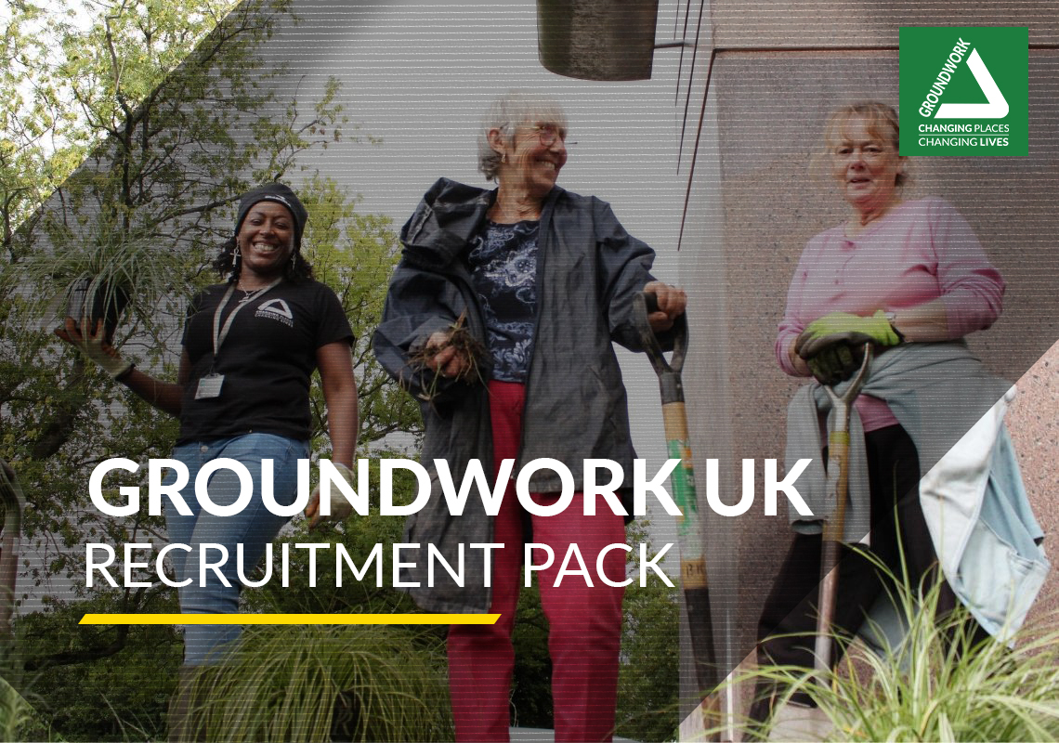

ddddddddddddddddddddddddd

Communications Trainee
CLOSING DATE: Noon 10th December 2021

Groundwork UK | Charity Registration number 291558  Suite B2, The Walker Building, 58 Oxford St, Birmingham, B5 5NR | 
0121 236 8565 | info@groundwork.org.uk  www.groundwork.org.uk | 

Help us change places and change lives   | Thank you for your interest in working at Groundwork UK.  This is a challenging time for society, but a hugely rewarding time for our organisation. Groundwork was established to support communities to tackle social and environmental challenges. Over the last four decades we’ve learned what works to help community organisations become more resilient, to help young people face the future with confidence and to help those who are vulnerable or isolated improve their prospects and networks.  This learning has enabled us to adapt our services and programmes to support communities through the Covid-19 crisis. Our aim is to support a recovery that is both green and fair, that puts communities in control of the decisions that affect them and that helps to create a society that promotes healthier and more sustainable lifestyles.  We’re excited about being able to offer jobs through the Kickstart initiative. Groundwork has a long history of offering young people their first opportunity to work in our sector – many of our staff started out as volunteers or trainees. We believe that young people are an asset to us as an organisation – we need your ideas, skills and perspectives to make us relevant to the communities we serve.  We want Kickstart to be a genuine learning opportunity for you. It should be more than just a job – it should give you insight around potential career paths, opportunities to learn more about how to support communities and protect the environment, and of course to learn new skills.  Groundwork UK sits at the heart of a wider community – managing programmes, campaigns and networks that improve the lives of tens of thousands of people each year.  We’re a small team with a busy and diverse workload, which means there is huge scope to collaborate, learn and grow.  I hope you’ll want to join our team and to help us to change places and change lives  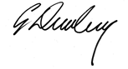  Graham Duxbury OBE, Chief Executive

ABOUT GROUNDWORK
Groundwork is a charity working locally and nationally to transform lives in the UK’s most disadvantaged communities.

We help people to carry out thousands of diverse projects each year. Projects that tackle climate change and help people out of fuel poverty. Projects that bring out the best in young people by helping them to improve their local area. Projects that build stronger communities by improving green space or creating jobs.

Last year Groundwork accessed £96 million of funding to support our mission and distributed £29 million in grants to help local groups improve their neighbourhoods.

This contributed to the following outputs and outcomes.

 | More than 9,100 community organisations supported
 | Learners of all ages supported to achieve nearly 6,000 qualifications
 | 50,000 days of social action unlocked
 | 25,750 people helped to achieve new goals in education, training or employment
 | 7.4 million m² of land improved and nearly 59,000 trees planted
 | 5.9 million kg of CO₂ and 1.4 million kg of waste prevented

You can read more about the impact our work has here.

Our strategy for 2020 – 2023 sets out our ambition to build our visibility, our reputation and our resource base so that we can be a significant, radical, national force for driving change in attitudes, behaviours, places and prospects in the local communities that need it most.

Our strategy document has been provided with this information pack.

GROUNDWORK UK

Groundwork UK is the national body of the Groundwork federation, supporting, championing and representing the work of Groundwork Trusts across the country.

This includes building national relationships with funders and policymakers, securing resources to support local delivery and acting as a managing agent for programmes and contracts delivered by Groundwork Trusts and other partners.

WORKING FOR GROUNDWORK UK

01  VALUES  Our values inform what we do and how we do it.  We are environmentally aware and focused on communities in need.  We are collaborative, show integrity and strive for quality in everything we do. |  | INTEGRITY  - We are open, honest and transparent  - We are polite and professional  - We demonstrate our integrity in all our dealings with colleagues, customers and partners  QUALITY  - We monitor all our work to make continuous improvement  - We train and develop ourselves and inspire others  - We encourage and welcome feedback  - We value the opportunities for personal and career development  COLLABORATIVE  - We actively engage with colleagues to find innovative solutions to problems and tasks  - We celebrate success together  - We work closely with partners to develop join initiatives  ENVIRONMENTALLY AWARE  - We respect the local and global environment  - We strive to minimise our own environmental impacts  - We ensure environmental impacts are considered in all our work  COMMUNITIES IN NEED  - We put communities at the centre of our planning  - We encourage staff volunteering to help communities in need  - We place vulnerable people at the heart of all our work
02  EQUALITY AND DIVERSITY |  | We are fully committed to eliminating discrimination and promoting equality and diversity in our workforce and employment practices, in the work we undertake, and in the provision of all our services.  We value diversity and flexibility in our workforce as we think it gives us access to a wider range of skills. We therefore strive to be an equal opportunities employer. This means that decisions concerning recruitment, promotion or any other aspect of employment will be based on the needs of the organisation and not any assumptions based on sex, race, age, disability, gender reassignment, sexual orientation, married or civil partnership status, pregnancy or maternity, religion or belief (these are known as ‘protected characteristics’). This is an important commitment, which all employees are expected to share.
03  SAFEGUARDING |  | We commit to doing everything we can to ensure the safety of those involved in our projects, programmes and services. Our safeguarding team ensures that our safeguarding policy and practices are rigorously implemented and continually reviewed and improved.  Our safer recruitment practices help us to ensure that we recruit colleagues who share our high standards and expectations. All job offers are conditional on the receipt of satisfactory references. Where appropriate, we ask our workers to complete a Disclosure and Barring Service (Criminal Records Bureau) check. We are also obliged to confirm your identity and obtain proof of your right to work in the UK. We ask all staff to undertake safeguarding training when they join us.
04  SUSTAINABILITY |  | Groundwork UK is committed to minimising its environmental impact and promoting positive environmental behaviour among its employees, service users, suppliers and partners. Our sustainable development policy sets out how we will manage our assets and activities in a way that’s consistent with our values and demonstrates our commitment. The policy relates to all areas of our work and contains responsibilities for all employees.
Communications Trainee

This role has been created as part of the Department for Work & Pension’s Kickstart scheme. You must be eligible for Kickstart in order to apply. The Kickstart scheme is specifically designed for those aged between 16 and 24, who are currently claiming Universal Credit, and may be at risk of long-term unemployment.
The Communications Trainee will contribute to all aspects of communicating with our audiences, working with traditional media, as well as digital and social media to raise the profile of our work, services and programmes, in order to increase Groundwork’s visibility and income. The Communications Trainee will also be tasked with providing support across the Communications Team, with a particular emphasis on digital marketing and fundraising and website content development and technical support.

BENEFITS

12.5 days holiday entitlement (over the 6 month period)
Flexi-time arrangements
Travel loan scheme
Health cash plan through BHSF
Salary sacrifice benefits including childcare vouchers and cycle to work scheme
Training on environmental sustainability and community development
Join a peer network – meet people, learn about career paths, have fun!

RECRUITMENT PROCESS

Closing date:
Noon, Friday 10th December 2021

In order to apply for this role you must be eligible for the DWP Kickstart scheme. The Kickstart scheme is specifically designed for those aged between 16 and 24, who are currently claiming Universal Credit, and may be at risk of long-term unemployment.

To apply for this role please:

Contact your local Jobcentre Plus
… to find out whether you’re eligible to apply, quoting Kickstart job reference 251320
Send your CV to recruitmentUK@groundwork.org.uk
Help us to understand how your knowledge, skills, experience and values meet the requirements of the role by sharing your CV with us. Please note the equal opportunities monitoring form will be removed by our HR team prior to shortlisting*
Talk to us
If we think your CV matches what we’re looking for, we’ll contact you to arrange an informal interview (by phone or video conference) to tell you more about the job and to help us decide whether it’s the right role for you

JOB DESCRIPTION

COMMUNICATIONS TRAINEE
Responsible to: | Communications Manager
Location: | Central Birmingham (remote working considered)
Term: | Fixed term

JOB SUMMARY

The Communications Trainee will contribute to all aspects of communicating with our audiences, working with traditional media, as well as digital and social media to raise the profile of our work, services and programmes, in order to increase Groundwork’s visibility and income. The Communications Trainee will also be tasked with providing support across the Communications Team, with a particular emphasis on digital marketing and fundraising and website content development and technical support.

MAIN DUTIES

- Provide advice and support to Groundwork UK colleagues and Groundwork Trusts on managing content and quality on the Groundwork website.

- Generate and publish new content to Groundwork’s website, to ensure that it is regularly updated and appropriate to external audiences.

- Support the production of content designed to increase engagement with Groundwork through social media and digital communications.

- Support the development and production of e-newsletters and publications, including segmentation of supporters for campaigns, newsletters and other marketing materials from multiple data sources.

- Support the development of film, photography and beneficiary case studies.

- Support and promote the development of digital corporate fundraising, through the promotion of online events and employee fundraising activities.

- Support the communications team in the service of national contracts and programmes, assisting in all communications and PR activity as required by funders.

MISCELLANEOUS

- The postholder will be expected to participate in our Kickstart learning programme – a series of remote sessions with other Kickstart employees from around the country, where you will learn about environmental sustainability and community development – core disciplines for careers in our sector.
- The postholder will be expected to fulfil all duties in adherence with Groundwork UK’s values (environmentally aware, focused on communities in need, acting collaboratively, with integrity and striving for quality) and in accordance with our sustainable development policy.
- Groundwork UK is committed to being an inclusive employer and offers flexible working arrangements, job share opportunities and supportive, family friendly policies. Part time/Jobshare arrangements considered

