Senior Landscape Architect 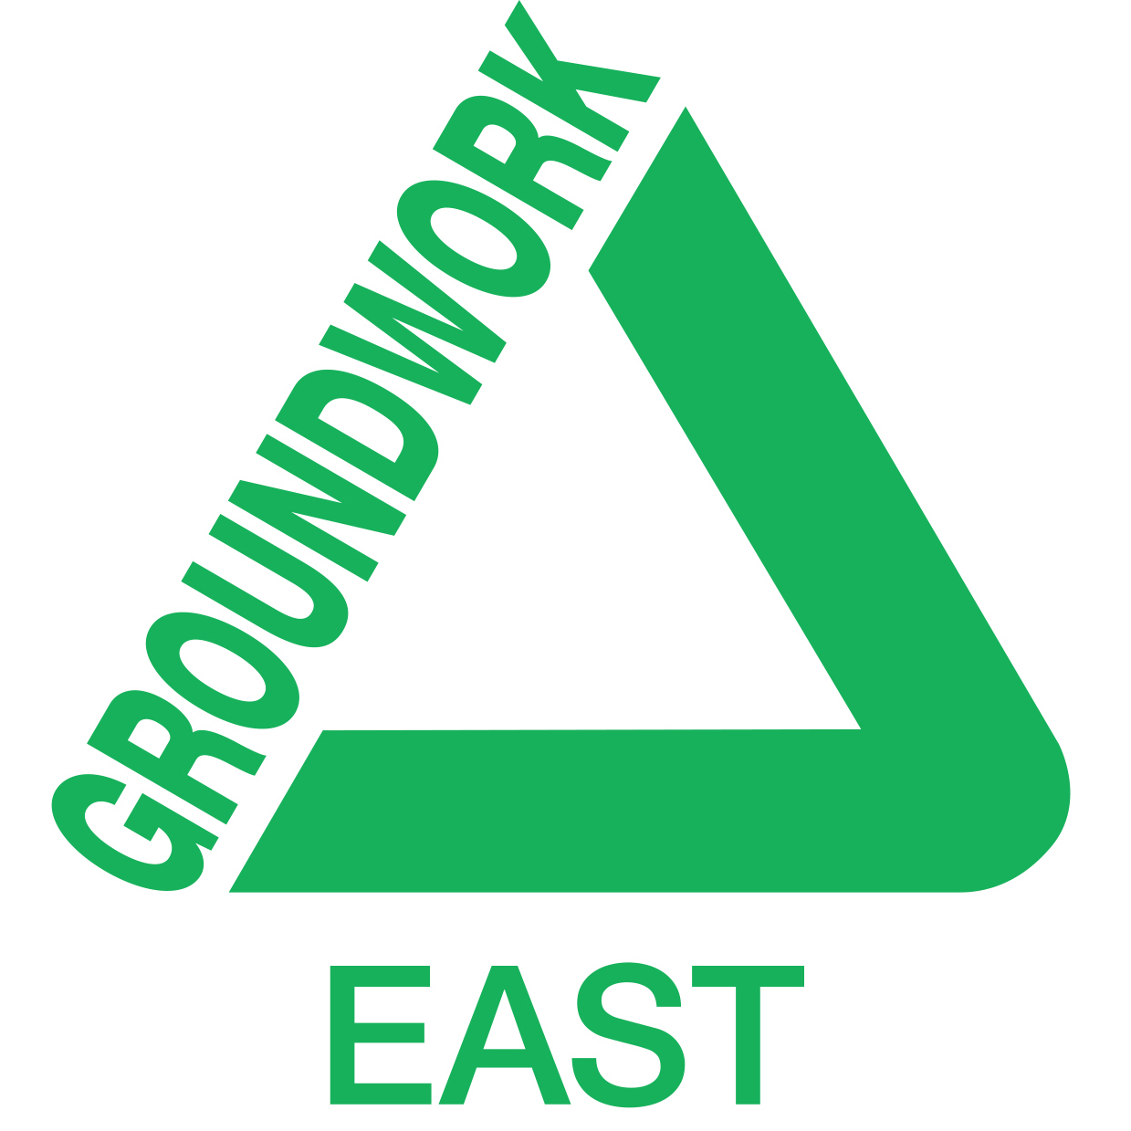

Job Description

Title: Senior Landscape Architect

Responsible for: Supporting the design team including landscape architects and landscape students. Line management responsibilities to depend on experience of successful applicant

Job summary: To assist in the development of the team programme of works, undertake landscape design, fee proposals, procurement and delivery of landscape improvement projects. Provide management, peer review and technical mentoring for team members.

Place and Hours Based at one of the Groundwork offices in the region the work will be

of Work: throughout Groundwork East’s operating area and potentially supporting other Groundwork Trusts. Hours of work are up to 37 hours per week with some flexible working required to deliver projects.

Main Duties and Responsibilities

- To assist the delivery of the landscape design team programme to meet the requirements and targets of the Business Plan through skills, experience and excellent communication.

- To provide a high-quality design and effective contract management service including outline and detailed designs, specifications, tendering and management of projects on site. To develop fee proposals and tender documentation on request.

- To provide professional advice and recommendations together with accurate reports and quotes relating to landscape matters for internal and external clients using the full range of appropriate resources including but not limited to CAD & Photoshop.
- To provide guidance, training and personal support/development to individuals, including volunteers and work experience placements. Including supporting an effective peer review and development process and ensuring adherence to professional standards

- To ensure compliance with all Trust’s policies, systems and with insurance and statutory requirements. With particular emphasis on health and safety including monitoring and advising on procedures and plans as required under the Construction (Design & Management) regulations.
Other responsibilities
- To promote Groundwork activities at a local and regional level

- To ensure compliance with the Trust’s policies, and with insurance and statutory requirements, particularly health and safety, the Children’s Act and equal opportunities.
- To undertake other administrative duties as required by the post.
- Provide support and assistance in respect of other Groundwork projects.
- To undertake any task that may be requested from time to time by the Executive Director, Operations Director or line manager as may be consistent with the nature and scope of this post.

Personal Development and Training

- To attend team meetings and supervision with line manager.

- To undertake training and development as agreed with line manager.

- To be a positive force within the staff team taking personal responsibility for ensuring good morale and positive work relations.

- To keep abreast of developments in the landscape industry and to ensure the designs of Groundwork East remain innovative and creative

Senior Landscape Architect

Person Specification

 | Essential | Desirable | Evidence
Qualifications | • Chartered Member of the Landscape Institute • Valid driving licence/ability to travel to/between sites |  | • Application form  • Certificates
Experience | • Evidenced experience of managing and implementing landscape projects  • Preparation of fee proposals  • Preparation of outline and detailed design proposals  • Schedules of quantity and cost estimates  • Managing programmes and budgets  • Proficient use of AutoCAD  • Team work  • Working to exacting standards | • Experience of line management  • Experience of  implementing projects  other than through a  traditional landscape  contract e.g. volunteers  • Dealing with a wide range of people in the public and private sector  • Using digital map data in CAD/GIS  • Delivering SuDS  projects  • Mentoring candidates  on their Pathway to  Chartership | • Application form  • Interview/  Portfolio  • LI CPD record
Skills | • Confident drawing ability  • Techniques for community  participation  • Ability to respond to changing circumstances on projects  (resilience)  • Ability to undertake research  • Confident communicator  • Motivation and support of staff |  | • Application form  • Interview/  Portfolio  • LI CPD record
Knowledge | • Use of AutoCAD & Keyscape,  Photoshop  • Project management  • Use of Microsoft Office and National Building Specification software  • CDM regulations | • Regeneration issues  • Risk management  • GIS software  • Horticultural and  arboricultural expertise | • Application form  • Interview  • Portfolio

