Little terns get a little help
Ten Trainee River Estuary Rangers have been working to help protect and provide a safe nesting site for rare little terns at the South Gare in Redcar. The bird is the smallest of the UK tern family, a sweet gentle seagull looking bird it hunts for small fish in the sea. Groundwork NE & Cumbria through their Revitalising our Estuaries project are working with Teesworks, the Tees Valley Mayor and Combined Authority, to fence three small areas of the beach to prevent the eggs, chicks and adult birds being trampled, predated or scared away. Its ground nesting sites and its decline in Europe are what makes it vulnerable to serious population declines.
The UK breeding population is in serious decline with numbers decreasing across its range and if successful this will be the first time in four years since the little terns have tried to breed on the south bank of the Tees. For over 100 years little terns (Sternula albifrons) have nested around Teesmouth and until recently they had traditionally nested on the south side of the Tees at Coatham Sands. More recently, the birds have preferred Crimdon Dene or Seaton Carew on the north side of the river but the project hopes to give them a boost and encourage them to nest back at the South Gare.
Tees Valley Mayor Ben Houchen said: “We talk a lot about the massive redevelopment we’re seeing on Teesworks, and central to this is remediating land from old steelworks to create sites in the cleaner, safer and healthier industries of the future.
“There’s no point driving our low carbon agenda if we’re not taking care of the environment right on our doorstep. That’s why, as part of our wider work, we’re also supporting the transformation of South Gare to nurture, protect and grow its wildlife and improving it for local people. This scheme has also helped employ local young people and back their passion for conservation.”

Revitalising Our Estuaries
Groundwork NE & Cumbria are employing 38 young people in an exciting new project called Revitalising Our Estuaries (RoE). Supported by the Green Recovery Challenge Fund and the Caterpillar Foundation, we will respond to the ongoing environmental issues on the north east coast by delivering improvements to six river estuaries across the North East. Revitalising our Estuaries aims to combat the dual climate and biodiversity crisis by developing innovative nature based solutions that enhance habitats, provide space for nature and bolster populations of native species.
Using nature-based solutions, the programme will improve intertidal habitats and riparian corridors, create saltmarshes, mudflats and vertipools, and restore sand dunes, all while providing transferable workforce skills for green jobs. With more than 430 acres of to be

restored or improved, the habitat interventions are expected to help mitigate flood impacts while capturing and sequestering nearly 20 short tons of carbon.
In the north the project focuses on the Wansbeck and Blyth, centrally the Tyne and Wear, and finally in the south the Tees and Esk. The project will deliver high profile habitat protection and creation schemes in order to keep the natural diversity that our coasts strong.
In the Tees and Esk areas the project is designed to deliver improvements to Seaton Common and the South Gare by removing invasive species, providing habitat for birds such as little tern and improving footpaths along the English Coastal Path. On the river Esk in Whitby we are creating a small area of saltmarsh and mudflat. Mudflat and saltmarsh is a priority habitat which is vital in the battle against climate change, as it captures and stores carbon dioxide. It also is home to unusual plant and animal species, which add to the uniqueness of this area.
RoE has created many new jobs ranging from our River Estuary Ranger team to senior office roles, providing transferrable skills for green jobs. There are three River Estuary Ranger teams each consisting of a Supervisor and five River Estuary Ranger Trainees, that through their time working on the project will learn valuable qualifications in landscaping and management of outdoor environments. The additional Project Assistants support the wider development and implementation of the project including landscape design, marketing, monitoring and community engagement.
RoE has started to deliver various events for the local communities including days out for local schools and community groups - taking them around the estuaries teaching them the importance of these environments. Volunteer days will be organised for members of the public or corporate groups to help out, and also major events linked to the installation of the ecological enhancements. Free educational trips, events and volunteer days are open to all local communities, educational establishments and corporate groups.
This project is jointly funded by the Government's Green Recovery Challenge Fund and The Caterpillar Foundation. The Green Recovery Challenge Fund was developed by Defra and its Arm's-Lengths Bodies. It is being delivered by The National Lottery Heritage Fund in partnership with Natural England, the Environment Agency and Forestry Commission.
For more information and to get involved in the project please contact:
Hellen Hornby
Project Manager – Revitalising our Estuaries
Hellen.hornby@groundwork.org.uk
07548223757
https://www.groundwork.org.uk/revitalising-our-estuaries/
https://www.facebook.com/GWKNE/

Logos
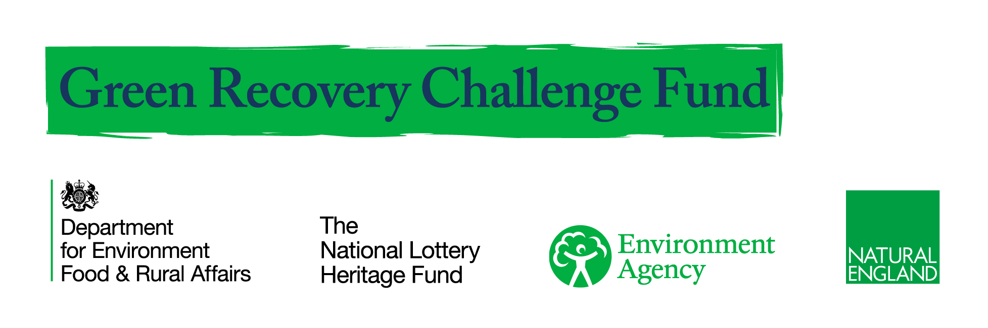
Photos
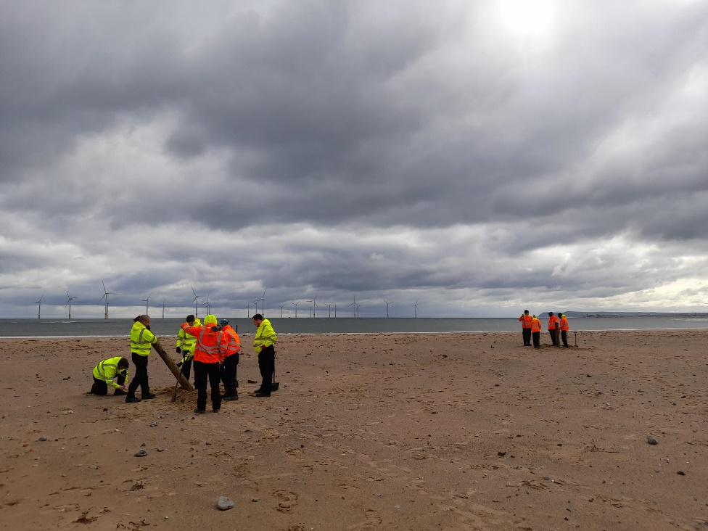
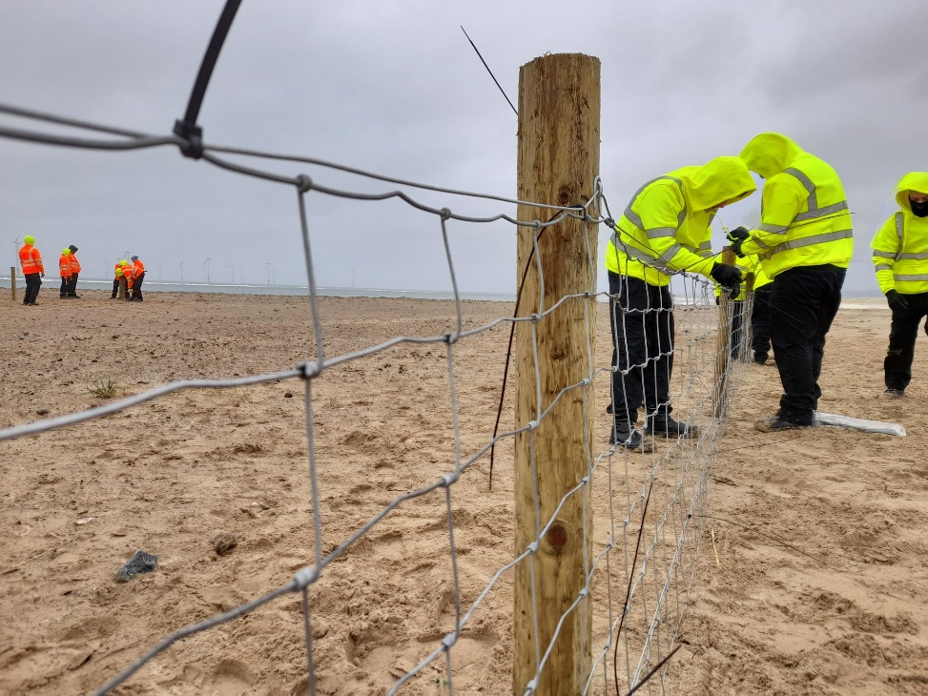
River Estuary Rangers start work on little tern fencing at South Gare, Redcar & Cleveland.

Photo opportunity: Contact Mike Dent: 07918777983 for dates when the team are on site.

