Mayor of London’s Shared Endeavour Fund
Standing together against racism, hate, intolerance, extremism and radicalisation

Prospectus

Groundwork London is delighted to continue to administer the Shared Endeavour Fund on behalf of The Mayor of London.

In January 2020, the Mayor of London, Sadiq Khan, launched the Shared Endeavour Fund, a grants programme to support civil society projects that strengthen communities against extremism, encourage more Londoners to stand up to hate and intolerance, safeguard Londoners vulnerable to radicalisation and stop the spread of hateful and supremacist ideologies.

In Call 1 of the fund, despite exceptionally challenging circumstances against the backdrop of a global pandemic, 31 civil society led projects were delivered across the capital. In Call 2 a further 19 projects were funded. Tens of thousands of Londoners have benefited from directly participating in these innovative and impactful projects.

However, despite so much effective delivery, the threat we face from hate, extremism and terrorism has not diminished, meaning that this vital work needs to continue now more than ever.

In the last 12 months there have been two perpetrated terrorist attacks in the UK and since the start of the pandemic the police and security services have foiled at least seven late stage terrorist attacks. There have been a record number of young people arrested on terrorism offences with the youngest being just 13 years old. Furthermore, so-called self-initiated terrorism remains a key challenge.

Data revealed that racially and religiously motivated hate crimes hit a new high across England and Wales in 2020 and numbers are predicted to remain high when reporting for 2021 is released this year.

Extremists continue to utilise local, national and international issues and incidents to further their hateful and poisonous ideologies. The COVID-19 pandemic, alongside what is expected to be a continuing challenging economic environment, have provided fertile breeding grounds for extremism.

There continues to be multiple groups and individuals who wish to promote intolerance and divide our communities by sowing hate, promoting conspiracy theories and preying on individuals vulnerable to radicalisation who are spending more and more time online.

To most effectively counter extremism, all in society must work together as a shared endeavour. The challenge from racism, hate, intolerance, extremism and radicalisation—and moreover the solution to these issues—is often best understood by community groups working at a truly local level. These organisations are at the coalface of London’s diverse communities and have the insight, traction and skills to make a real difference. They often serve those that are most impacted, and they can reach into marginalised audiences who ordinarily might be unlikely to engage with the authorities.

The Mayor will continue to lead from the front in countering racism, intolerance, hate and extremism whilst also protecting Londoners vulnerable to radicalisation. Whilst there continues to be a vital opening for civil society to lead the charge in tackling hate and extremism whilst safeguarding those vulnerable to indoctrination, the Mayor will offer support. That is why in his re-election manifesto he committed to continue investing in the Shared Endeavour Fund.

This latest funding round invites applications from civil society groups delivering projects that will contribute towards the priority themes listed below.

Fund priority themes

The Shared Endeavour Fund supports initiatives that challenge racism, intolerance, hate, extremism and terrorism, offline and online, in London. Call III of the scheme will provide funding for projects that contribute to one or more of the Shared Endeavour Fund’s four priority themes. These themes overlap and connect in a number of ways. While it is recognised that project proposals may address multiple themes, applicants are strongly encouraged to select the primary theme to which they feel their project can demonstrate the greatest contribution.
Applications must demonstrate that the proposed project addresses one or more of the Shared Endeavour Fund’s four priority themes for Call III:
- Awareness raising: Increase Londoners’ awareness of the existence, impact and counter-arguments to racism, intolerance, hate, extremism and/or terrorism.
- Building psychosocial resilience: Strengthen psychosocial factors among Londoners that promote resilience to radicalisation and extremist recruitment.
- Encouraging prosocial behaviours: Empower Londoners to actively, confidently and safely challenge intolerant, hateful and extremist attitudes and behaviours.
- Stakeholder capacity building: Support key stakeholders such as teachers, practitioners, community leaders and activists to work with communities to prevent and counter intolerance, hate, extremism and radicalisation.

The amount of funding available for prospective projects will be distributed across the Shared Endeavour Fund’s four priority themes. Special consideration will be given to supporting project proposals that address theme number 2, building psychosocial resilience to radicalisation and extremist recruitment.

Please note: Projects must address one or more of the priority themes of the Shared Endeavour Fund. It is NOT necessary for projects to address more than one theme. We have found that the highest performing SEF projects have focused their delivery and evaluation on contributing to only one or two of the themes. While it is understood that some projects will work across multiple objectives it is highly recommended, and indeed preferred, if applicants pick only those themes to which their projects can make the greatest contribution.

Awareness raising: Increase Londoners’ awareness of the existence, impact and counter-arguments to racism, intolerance, hate, extremism and/or terrorism.
Most awareness raising projects supported by the Shared Endeavour Fund will be expected to reach a large number of beneficiaries: primarily young Londoners or members of the general public. While beneficiary targeting will likely be broad under this theme, careful consideration must be given to ensuring projects remain relevant for their intended audiences and salient to the overall aims of the Shared Endeavour Fund. The volume of contact hours with project participants is anticipated to be relatively low for awareness raising initiatives.
Possible focus areas may include, but are not limited to:
- Sensitisation to the existence and impact of racism, intolerance, hate, extremism and terrorism on individuals and society.
- Inoculating Londoners against extremist messaging through exposure to counter / alternative narratives.
- Promoting digital and media literacy to counter online harms and reduce susceptibility to misinformation / disinformation.
- Signposting support, resources and services (online or offline) related to racism, intolerance, hate, extremism, radicalisation or online harms.

Building psychosocial resilience: Strengthen psychosocial factors among Londoners that promote resilience to radicalisation and extremist recruitment.
Psychosocial resilience building projects should work with vulnerable individuals and groups in London to address identified risk factors. Project proposals must provide a robust justification for why groups of beneficiaries are potentially at-risk of being radicalised into supporting supremacist, hateful or extremist ideologies, or being recruited into extremist groups. Applications must also clearly explain how selected activities will promote psychosocial factors associated with resilience and how these factors link with wider counter-extremism outcomes. Projects funded under this theme are anticipated to reach a low-to-medium number of beneficiaries with a relatively high number of contact hours per individual.
Possible risk factors and focus areas may include, but are not limited to:
- Lack of purpose / lack of opportunity - Helping beneficiaries to find a tolerant, non-violent sense of purpose or opportunity in order to reduce the likelihood of finding meaning through identification with hateful or extremist views, or affiliation with extremist groups.
- Ostracism - Helping beneficiaries to feel a sense of belonging within mainstream social relations in order to reduce the potential attractiveness of recruitment to extremist organisations.
- Sense of cultural threat - Reducing cultural and political beliefs that cast out-groups as potential sources of harm and that can lead to the adoption of xenophobic, racist, intolerant or supremacist views.
- Low self-esteem - Helping beneficiaries to develop a greater sense of self-worth in order to reduce the potential for scapegoating out-groups.
- Lack of empathy / lack of perspective-taking - Helping beneficiaries to increase their empathy and tolerance for others in order to reduce their support for ideologically-driven discrimination and violence.

Encouraging prosocial behaviours: Empower Londoners to actively, confidently and safely challenge intolerant, hateful and extremist attitudes and behaviours.
Projects that contribute towards this theme should focus on motivating and equipping beneficiaries to adopt prosocial behaviours that challenge intolerance, hate and extremism when they are encountered offline or online. Projects in this area are anticipated to be relevant for a wide range of beneficiaries, including young Londoners and members of the general public, but applications should still demonstrate why selected audiences are in greater need and are more likely to adopt prosocial behaviours. The strongest applications will include a plan for measuring changes in motivation and assessing if beneficiaries are challenging intolerance, hate and extremism outside of the project. Prosocial behaviour projects are anticipated to engage with a low-to-medium number of beneficiaries with at least a moderate volume of contact hours per individual.
Possible focus areas may include, but are not limited to:
- Training and motivating Londoners to actively call out and challenge racist, intolerant, hateful and extremist views they encounter, offline or online, in a safe and constructive manner.
- Equipping and motivating Londoners to perform safe, victim-centric bystander interventions.
- Raising awareness of offline and online reporting processes for hate incidents and hate speech and encouraging their use.
- Promoting support and engagement with social causes associated with building community cohesion and challenging racism, hate and intolerance.

Stakeholder capacity building: Support key stakeholders such as teachers, practitioners, community leaders and activists to work with communities to prevent and counter intolerance, hate, extremism and radicalisation.
Applications submitted for this theme should train, equip, motivate and/or otherwise support key stakeholders to carry out SEF aligned activities during the funding term and beyond. Key stakeholders may include teachers, social workers, faith and community leaders, activists and other practitioners working in schools and local communities throughout London. Project plans under this theme must include a component for monitoring the activities stakeholders deliver to their ultimate beneficiaries during the funding term. Project impact should also be assessed at both the stakeholder and ultimate beneficiary level. Stakeholder capacity building projects are anticipated to reach a low number of key stakeholders with a medium-to-high volume of contact hours per individual.
Possible focus areas may include, but are not limited to:
- Aiding stakeholders to identify warning signs of radicalisation and make suitable referrals.
- Empowering stakeholders to have difficult conversations around racism, intolerance, hate, extremism and/or terrorism, and use these skills to educate others in their schools and communities.
- Empowering stakeholders to safely challenge intolerant, hateful or extremist views and conduct limited interventions with individuals in their schools and communities.
- Training stakeholders to design and implement advocacy or counter / alternative narrative campaigns.
- Forging partnerships and connections between and among civil society organisations, community-based organisations and key stakeholders.

Theory of Change

Applicants are advised to consult the full Theory of Change for Call III of the Shared Endeavour Fund when designing their projects. This document can be found on the Groundwork London website here.

A logic model diagram summarising the Theory of Change is also featured in the appendix.

Organisation eligibility

The following groups are eligible to apply for the Shared Endeavour Fund:

- Registered UK Charities
- Charitable Incorporated Organisations
- Companies Limited by Guarantee
- Not for Profit Registered Community Interest Companies
- Constituted Community Groups
- Voluntary Sector Organisations

The Shared Endeavour Fund aims to support those organisations who can undertake impactful and innovative work in countering racism, hate, intolerance, extremism and radicalisation. It aims to provide the opportunity for creative, innovative, pioneering and sustainable work to grassroots organisations who can work with London’s diverse communities. Groundwork London as an administrator will work with the applicants to ensure they are eligible to apply for the fund.

The Shared Endeavour Fund may prioritise project applications from organisations which currently do not have access to current funding in this policy area.

Location criteria

Groundwork London is administering the grants across the capital. Project outputs must be London based. Organisations must demonstrate their ability to work in and across sufficient London borough areas dependent on the tier of grant they are applying for (further details can be found below).

Beneficiary criteria

Proposed projects must work with participants who live in London. Applicants are encouraged to consider which audiences are most in need of their activities, who is most likely to participate and benefit from the project and how project activities will lead to counter extremism-related outcomes that support the objectives of the SEF.

Applicants should consider their reach, credibility and the sustainability of their project with the cohort of communities they have identified as wishing to work with.

Applicants should provide evidence and a rationale as to why they have chosen their direct participant cohort, explaining what specific need they have identified in this group and why this cohort is best placed to benefit from the project.

How much can applicants apply for?

This £600,000 fund will be divided into two-tiered grant opportunities. Organisations may only submit one application within this funding round.

Available grant sizes:

Tier 1 grants – From £10,000 up to £25,000
Work will take place in at least one or more London boroughs.

Tier 2 grants – From £25,001 up to £45,000
Work will take place in at least three or more London boroughs.

It is the intention of the Mayor’s Office for Policing and Crime that projects should be completed by the end of March 2023.

There are separate application forms for the two tiers. The required information that applicants will be asked to submit will increase through the ascending tiers. Applicants will need to complete the whole application specific to their desired tier for them to be considered for the grant. Applicants will need to clearly explain how the grant funding will be used particularly in respect to how it will efficiently and effectively contribute towards SEF priorities.

Groundwork London may follow up applications with clarification questions.

What can I apply for?

The Fund aims to support a broad and innovative range of activities to address the priority themes listed above. This means that there may be several different types of projects which could help achieve those objectives.

Projects can tackle a broad array of ideological issue areas including Right-Wing extremism, DAESH & Al Qaeda inspired ideology and Inceldom. Projects can also work across the harms driven by extremist ideology such as antisemitism, anti-Muslim hate, anti-minority hate, sectarianism, supremacy and misogyny.

Project activities could include but are not limited to:

- Community Action - activities that empower community members to challenge hate, intolerance and extremism locally.
- Education – awareness raising or activities specifically with students in schools or universities.
- Creative and Performing Arts - including drama, theatre, arts, games, traditional arts, role-playing themed delivery.
- Sports - inclusion of physical activity as part of the core project delivery.

Direct beneficiaries could include but are not limited to school, college & university pupils, young adults, youth club / sports club / extracurricular activity services users, adults, parents etc…

This is not an exhaustive list and we are keen to hear applicant’s ideas.

When would I receive the money?

The eligibility sifting, evaluation, moderation and due diligence processes will take place from the closing of the application window, with decisions hopefully being announced late summer with the first payment to be made shortly afterwards. It is expected that projects will be able to start in September 2022.

Grant monies will ordinarily be paid in instalments, as follows:
- 40% upfront
- 40% after three months of delivery on completion of mid-project monitoring
- 20% paid in arrears on receipt of all monitoring, evaluation and expenditure information.

What will I need to provide reporting/monitoring on?

Monitoring and evaluation is a critical requirement when spending public service resources. It is of paramount importance to this fund and applicants should take note of the monitoring and evaluation requirements as these are mandatory.

The Institute for Strategic Dialogue (ISD) have been commissioned by MOPAC to continue to provide independent evaluation of the Shared Endeavour Fund. Successful applicants will be required to collaborate with ISD to collect primary data from project beneficiaries to be submitted along with their reporting. Data collection tools will consist of a single survey to be administered to beneficiaries upon project completion by the participant (e.g. after each workshop in a schools-based education project). The specific questions included in each survey will be tailored to individual projects based on their objectives and activity plans and will be drawn from a shared framework of common survey measures. These measures were selected from the academic literature based on their reliability and validity for measuring outcomes related to intolerance, hate and extremism.

In addition to the survey provided by the evaluators, applicants are encouraged to develop and implement whatever monitoring and evaluation processes they feel would assist them in assessing the impact of their projects.

Monitoring and evaluation documentation will also be requested by Groundwork. More information on the requirements will be provided with other awarding documentation after decisions have been announced. These will set out the precise information that will be required, though we can confirm that we will ask for the following types of information:
- Overview of your project
- Evidence of outputs and outcomes
- Number of participants
- Demographic data of participants (which will ensure anonymity)
- London boroughs that the project was delivered in
- Expenditure of grants monies, including evidence as required
- Testimonials and case studies
- Skills, Opportunities and Knowledge gained by participants, both formal and informal.

Can I apply multiple times?

No. Applicants may only submit one application during this funding round. For consortium bids and collaborative projects, please see below the answer to the question ‘Can groups of organisations apply?’

Who is providing the funding?

The Mayor of London is providing funding as part of continued investment in the London Countering Violent Extremism (CVE) Programme.

How are funding decisions made?

This is an open and competitive funding opportunity. Once the application deadline has passed, all applications will go through a decision-making process to ascertain which should receive funding. This consists of several stages:
- Eligibility of each application will be checked.
- Each application will be reviewed by at least three individuals from different organisations. These individuals will come from a range of organisations including MOPAC, Groundwork London and ISD to ensure a range of relevant experience.
- There will then be a panel meeting including those who have reviewed applications, where awards will be decided.
- Applications will be considered on their own merits; however, prioritisation will take place to ensure geographical, organisation, project theme, and activity type spread.
- Those that are awarded grants in principle will then need to pass due diligence.

Can groups of organisations apply?

Yes, a group of organisations can apply as a partnership or consortium. However, organisations can only submit one substantive application in which they are the lead organisation.

If applying as a group of organisations, you must clearly set out the responsibilities of the different organisations, and the application must be made by a lead organisation, who will be responsible for all monitoring and financial reporting and will be the organisation that will sign the funding agreement in order to release the grant monies.

It is possible for an organisation to make a substantive application whilst also featuring as a non-lead collaborator on another application. For example, in a small consultancy capacity or to deliver a small percentage of another project. The roles of all organisations will need to be clearly set out in the application.

For more information contact Groundwork London:

SharedEndeavourFund@groundwork.org.uk
0207 239 1292

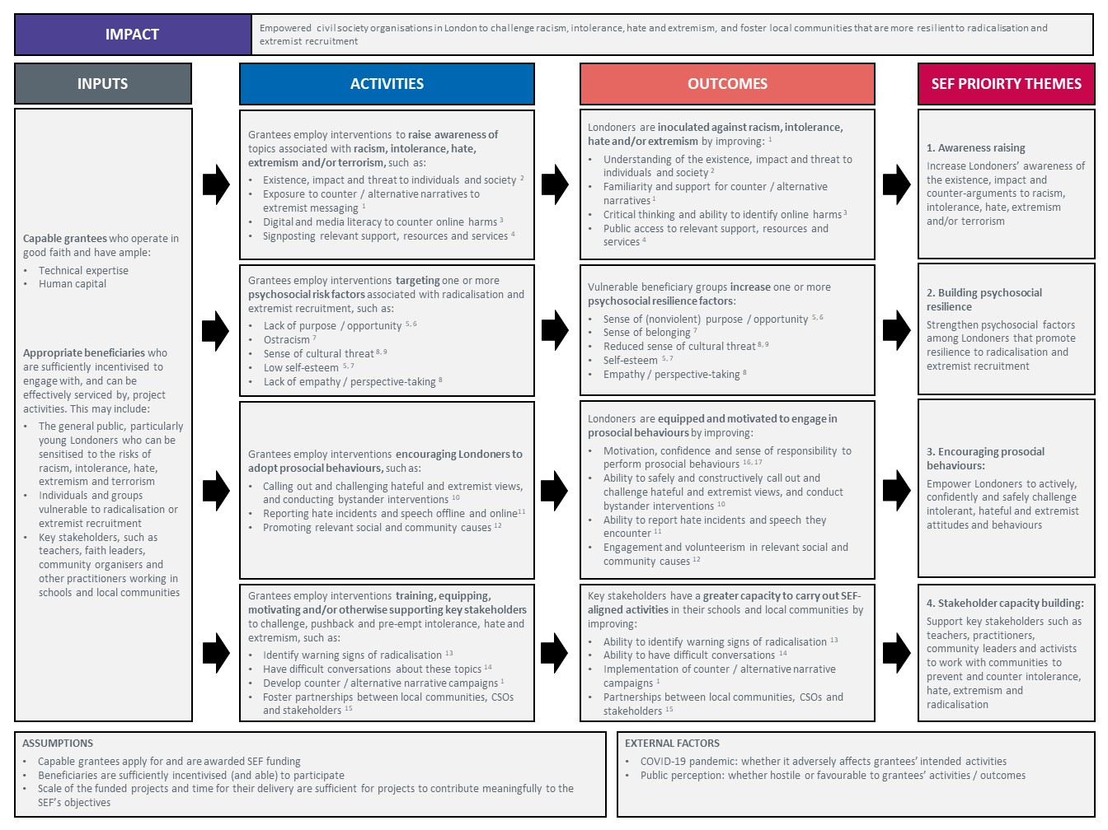
Appendix: Logic Model for the Shared Endeavour Fund (Call III)

