GROUNDWORK CLM
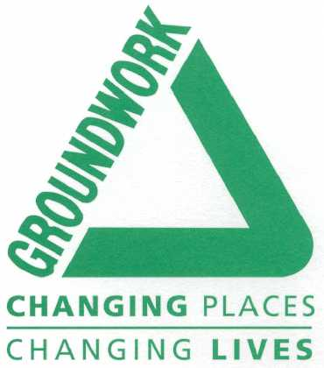
DECLARATION OF CONVICTIONS FORM

CONFIDENTIAL OFFICE USE ONLY

POSITION APPLIED FOR:

The post you have applied for involves contact with children, young people or vulnerable adults. Under the Police Act 1997, Protection of Children Act 1999, Criminal Justice and Court Services Act 2000 you are required to tell us about all convictions you have, whether spent or unspent. Please detail below.

Date of conviction | Conviction details | Spent or Unspent

I declare that the above information is correct to the best of my knowledge.

Signed: ………………………………………………………………………………… Date: …………………………..

