Wednesday 20th July 2022
PRESS RELEASE

21 YEARS LATER, FROM VOLUNTEER TO NEW CHIEF EXECUTIVE OF GROUNDWORK NE & CUMBRIA

Leading community and environmental charity Groundwork NE & Cumbria has appointed Steve Roberts, currently its Director of Youth, Employment & Skills, as its new Chief Executive, replacing Kate Culverhouse who has led the charity for over 20 years.

Steve has worked at Groundwork for 21 years, joining what was then Groundwork West Durham as a Millennium volunteer, working with local communities to tackle climate change.

Steve’s first paid role involved the creation of employment opportunities to help deliver local environmental improvement in East Durham – an early contributor towards the green economy. Over the following years, Steve led the expansion of Groundwork’s Youth, Employment and Skills activities to include every area within the North East and Cumbria, now employing over 135 staff and working with partners across the public, private and voluntary sector.

Steve embraces the challenges faced by charities and the communities we serve always looking for new solutions to provide real, life changing help that makes the biggest difference to people's lives and the neighbourhoods that they live in. Currently focusing his agenda on alleviating post Brexit impacts on the North East and Cumbria, helping to ‘Level Up’, build resilience and pride of place in some of the country's poorest communities, encouraging them to thrive. He has a big vision; enabling Groundwork to continue changing places and changing lives for the next 20 years and onwards.

Talking about his journey with Groundwork, Steve explained: “Groundwork gave me the opportunity to make a meaningful difference on two key agendas that I care most about - inequality and the environment. Empowering people, communities and stakeholders to take practical action is what Groundwork does best! Now, as Chief Executive, I will lead Groundwork to be ever more creative and resourceful in tackling the growing challenges we all face… the opportunity lies in our ability to tap into the potential of those people and communities that have been overlooked.”

Kate extended her congratulations, adding “Deciding to move on from Groundwork after 20 years was a difficult decision, but now that I know Steve will be at the helm, I feel confident that the Trust will continue to thrive and make a real difference to the people and places across the North East and Cumbria“

Andrew Thurston, Chair of Groundwork NE & Cumbria, said: “Following a highly competitive recruitment process, I am delighted that Steve has been appointed and is leading Groundwork’s next chapter. The board and I are confident he will be an outstanding leader and we look forward to working together to make a lasting positive difference.”

To find out more please contact: steve.roberts@groundwork.org.uk
Find out more about Groundwork visit: www.groundwork.org.uk/north-east-and-yorkshire

------- ENDS -------

NOTES TO EDITORS

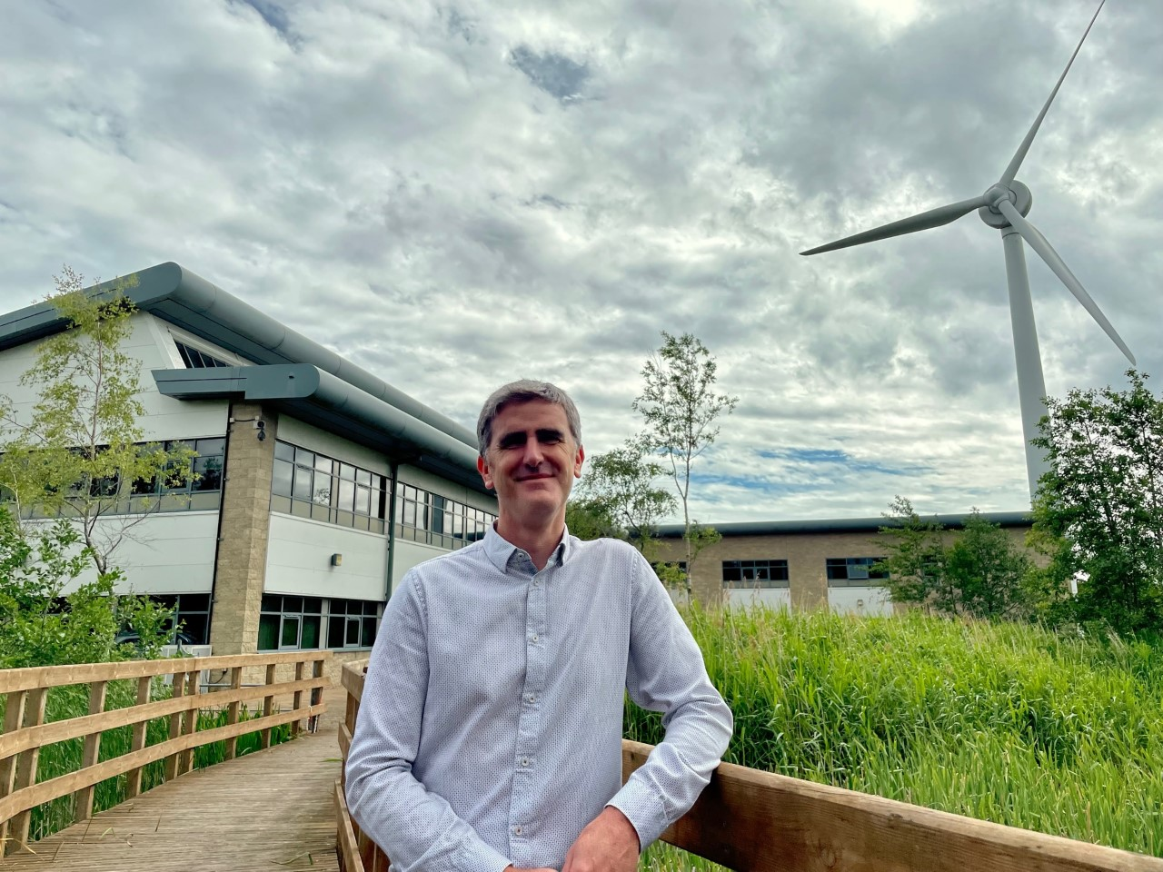

ABOUT GROUNDWORK

Groundwork North East & Cumbria
Groundwork North East & Cumbria is the community charity with a green heart that operates across the North East and Cumbria to transform places and lives in some of the most disadvantaged communities. Activity focuses on positive sustainable change in places of need across the region.

Unit 14 Parsons Court, Welbury Way, Aycliffe Business Park DL5 6ZE Newton Aycliffe, UK.
Tel: 01388 662 666

Groundwork UK
Groundwork is a charity working locally and nationally to transform lives in the UK’s most disadvantaged communities. We’re passionate about creating a future where every neighbourhood is vibrant and green, every community is strong and able to shape its own destiny and no one is held back by their background or circumstances. We help people gain confidence and skills, get into training and work, protect and improve green spaces, lead more active lives and overcome significant challenges such as poverty, isolation, low skills and poor health: www.groundwork.org.uk

