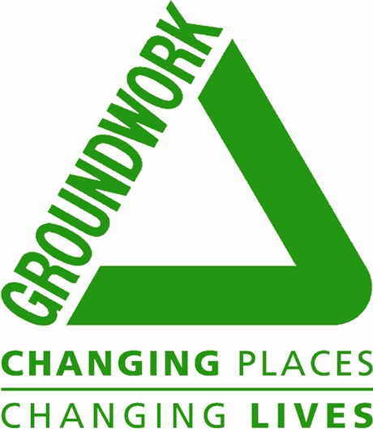

GUARANTEED INTERVIEW SCHEME

We are committed to the employment and career development of disabled people. To demonstrate our commitment we have been awarded the Disability Confident Employer Symbol, which is awarded by the Employment Service. We guarantee an interview to anyone with a disability whose application meets the essential criteria for the post.

What do we mean by disability?

To be eligible for the scheme you must meet the definition of disabled under the Equality Act 2010. You must have a long-term disability or health condition, which put you at a disadvantage in either obtaining or keeping jobs. The disability could be physical, sensory or mental and must have lasted or be expected to last at least 12 months.

How do I apply?

Complete the declaration below and let us know if there is any help you need in completing the form or if you would like it in an alternative format please contact the local Business Support Officer Laura Dyke on laura.dyke@groundwork.org.uk

To ensure we do not create any barriers in our selection process, please let us know if you would like us to provide any particular assistance for your interview below:

Declaration

I consider myself to have a disability as defined above and I would like to apply under the Guaranteed Interview Scheme

Name __________________________

Signature __________________________ Date ______________________
