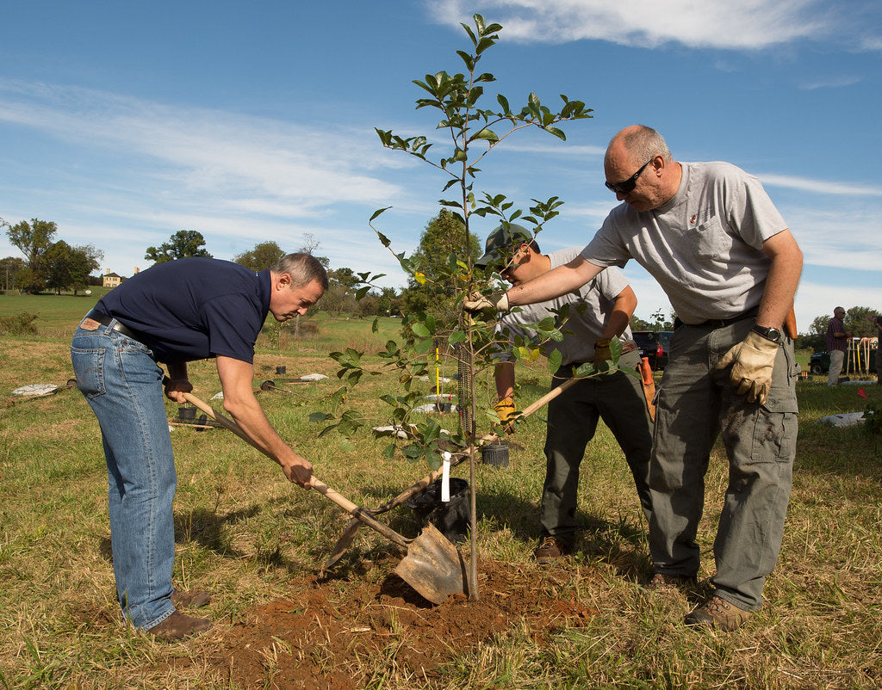

ROLE TITLE: Environmental Project Volunteer

LOCATION: Groundwork Wales Offices, Pontllanfraith

RESPONSIBLE TO: Project Co-Ordinator

NUMBER OF HOURS: Flexible – Up to 30 hours a week
To support the Project Officer and promote the development and delivery of community environmental and maintenance projects, creating and facilitating opportunities for local people and organisations to play a central part in environmental, social and economic regeneration of their local areas. To ensure Groundwork has quality provision in all of the relevant areas of coverage.

Role of the volunteer

- Support the Project Officer to deliver community outdoor environmental projects, such as river clean-ups, woodland / habitat management projects, conservation and tree planting projects
- Prepare equipment and resources required for task delivery
- Setting up and securely packing away of equipment during task delivery
- Support the Project Officer to develop and deliver community programmes that are externally funded, including volunteer management, health and safety, risk assessment and all other responsibilities when working with communities on outdoor programmes.
- Delivery of maintenance tasks including outdoor physical work, ground maintenance, site clearance and other environmental work including landscaping, tree felling
- To support the Project Officer to ensure the Health and Safety of all clients, beneficiaries, volunteers and staff while working on Groundwork projects and sites
- To support the Project Officer to compile reports on progress against targets to the Trust through maintenance of all internal project management processes, including financial management of relevant projects, to report to partners as required.
- To undertake appropriate training and assessment processes assigned by Groundwork Wales

Person Specification

- Flexibility and willingness to work on own initiative and as part of a team
- The ability to engage with a wide range of individuals
- Good communication skills
- Self-confidence, self-motivation and enthusiasm.
- A willingness to learn new skills
- Have a calm temperament and be able to deal with visitors and staff in a professional manner
- Dependable and Reliable

Training Opportunities
- Opportunities for other training relevant to your volunteer role can be provided

Benefits offered
- Motivation and sense of achievement
- Boost your career opportunities
- Teamwork
- Gets you in the great outdoors

Contact us

If you have any questions about the recruitment process for this role you should contact Groundwork Wales on:

Tel: 01495 222605
Email: wales@groundwork.org.uk




@groundworkGG4H

