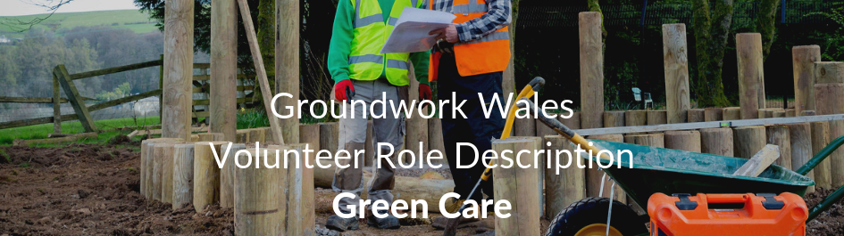

ROLE TITLE: Greencare Grounds Maintenance Volunteer

LOCATION: Groundwork Wales Offices, Pontllanfraith

RESPONSIBLE TO: Greencare Co-Ordinator

NUMBER OF HOURS: Flexible – Up to 30 hours a week
The Project

Greencare provide grounds maintenance and site specific grounds upgrades for a local Housing Association. We also provide light construction services for community groups. Services includes:

- Fencing
- Ground clearance and grass cutting
- Footpath construction
- Tree felling

Role of the volunteer

- Support staff to deliver existing projects
- To work within different teams on all aspects of grounds maintenance
- Load and unload vehicle for daily work load
- Routine grass cutting and general maintenance of open spaces and communal areas
- Clearance of gardens in order to return them to a maintainable standard.

- Routine garden maintenance to occupied dwellings such as grass cutting, hedge cutting, basic plant care, pruning and weeding
- Undertaking hard landscaping tasks such as work on fencing/gates and paths
- Follow the Groundwork Wales Health & Safety Policy at all times
Person Specification

- Flexibility and willingness to work on own initiative and as part of a team
- The ability to engage with a wide range of individuals
- Good communication skills
- Self-confidence, self-motivation and enthusiasm.
- A willingness to learn new skills
- Have a calm temperament and be able to deal with visitors and staff in a professional manner
- Dependable and Reliable

Training Opportunities
- Opportunities for other training relevant to your volunteer role can be provided

Benefits offered
- Motivation and sense of achievement
- Boost your career opportunities
- Gets you in the great outdoors

Contact us

If you have any questions about the recruitment process for this role you should contact Groundwork Wales on:

Tel: 01495 222605
Email: wales@groundwork.org.uk





@groundworkGG4H

