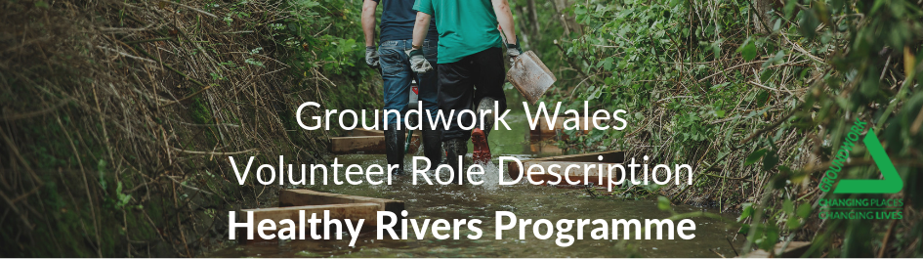

ROLE TITLE: Activity Volunteer – Healthy Rivers

LOCATION: Groundwork Wales, Ty Mynyddislywn Environment Centre, Bryn Road, Pontllanfraith, Blackwood, NP12 2BH (and various locations in local area)

RESPONSIBLE TO: Healthy Rivers Project Officer

NUMBER OF HOURS: Between 2 and 10 hours a week.
THE PROJECT

The Healthy Rivers project at Groundwork Wales aims to work with volunteers to make river habitat improvements to the local rivers in southeast Wales. The purpose is to create improved river habitats that can support larger and more diverse populations of native fish.

Volunteers may expect to take part in some of the activities listed below:
- Building fish passes
- Building instream river habitats
- Building river bank protection
- Litter picks and river clean ups
- Control of invasive species
- River monitoring and surveying

Healthy Rivers will also provide volunteers with training that is appropriate for Healthy Rivers work and personal volunteer development, which may include:

- Agored Cymru – River Restoration

Volunteers Role

- Assisting Healthy Rivers staff deliver river improvement projects as listed above
- Preparation of materials for project delivery
- Use of hand and electrical power tools
- Attend training where required
- Attend Healthy Rivers promotional events
- Follow health and safety procedures, understand risk assessments and wear PPE
- Maintain a positive attitude towards work
- Respect and work effectively with other volunteers

PERSON SPECIFICATION

- Flexible and willing to work as part of a team
- The ability to interact with a wide range of people
- Good communication skills
- Interest in outdoor work and conservation
- Interested in boosting self-confidence and esteem.
- A willingness to learn new skills
- Dependable and Reliable

Training Opportunities

- Agored Cymru – River Restoration

Benefits offered

- Motivation and sense of achievement
- Boost your career opportunities
- Teamwork and leadership

Contact Details for Recruitment

If you have any questions about the recruitment process for this role you should contact Groundwork Wales on:

Contact Number: - 01495 222605 or Email: - wales@groundwork.org.uk


@groundworkGG4H

