GROUNDWORK  CHANGING PLACES  CHANGING LIVES |  | 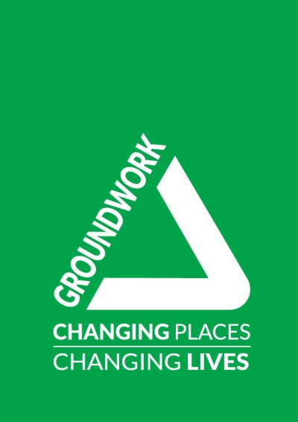
EQUAL OPPORTUNITIES MONITORING FORM

Please complete this form and return it to the HR Department with your application pack. The information on this form will be used for monitoring purposes only and will not be used in any decision affecting you.

Groundwork South and North Tyneside wants to meet the aims and commitments set out in its equality policy. This includes not discriminating under the Equality Act 2010, and building an accurate picture of the make-up of the workforce in encouraging equality and diversity.

This form is intended to help us maintain equal opportunities best practice and identify barriers to workforce equality and diversity. The organisation needs your help and co-operation to enable it to do this, but filling in this form is voluntary. The information provided will be kept confidential and will be used for monitoring purposes.

Please tick one box in each section
Gender

Male Female Intersex Non-Binary Prefer not to say

If you prefer to use your gender identity, please specify here

…………………………………………………………………………………………………..

Is the gender you identify with, the same as your gender registered at birth?

Yes No Prefer not to say

Age

16-24 25-29 30-34 35-39 40-44 45-49

50-54 55-59 60-64 65+ Prefer not to say

What is your ethnicity?
Ethnic origin is not about nationality, place of birth or citizenship. It is about the group to which you perceive you belong. Please tick the appropriate box
White
English Scottish Welsh Northern Irish Irish

British Gypsy or Irish Traveller

Any other white background, please write in: ……………………………………………

Mixed/multiple ethnic groups

White & Black Caribbean White & Black African White & Asian

Any other mixed background, please write in: ………………………………………….

Asian/Asian British

Indian Pakistani Bangladeshi Chinese

Any other Asian background, please write in: ……………………………………………

Black/African/Caribbean/Black British

African Caribbean

Any other Black/African/Caribbean background, please write in:……………………

Other Ethnic Group

Arab

Any other ethnic group, please write in: ……………………………………………

I prefer not to say

Do you consider yourself to have a disability or health condition?

Yes No Prefer not to say

What is the effect or impact of your disability or health condition on your work?

………………………………………………………………………………………………………….

The information in this form is for monitoring purposes only. If you believe you need a ‘reasonable adjustment’, then please discuss this with your manager, or the manager running the recruitment process, if you are a job applicant.

What is your sexual orientation?

Heterosexual Gay Lesbian Bisexual Asexual

Pansexual Undecided Prefer not to say

If you prefer to use your own term, please specify here: ………………………………………….

What is your religion or belief?

No religion or belief Buddhist Christian Hindu

Jewish Muslim Sikh Prefer not to say

If other religion or belief, please write in: ………………………………………………………….

What is your current working pattern?

Full-Time Part-Time Prefer not to say

What are your flexible working arrangements?

None Flexi-time Staggered hours Term-time hours

Job-share Annualised hours Flexible shifts Homeworking

Compressed hours Prefer not to say

If other, please write in: ……………………………………………………………………………….

Do you have caring responsibilities? If so, tick all that apply

None
Primary carer of a child/children (under 18)
Primary carer of disabled child/children
Primary carer of disabled adult (18 and over)
Primary carer of older person
Secondary carer (another person carries out the main caring role)
Prefer not to say

Many thanks for completing this questionnaire – please be assured, all information will be kept in the strictest of confidence

