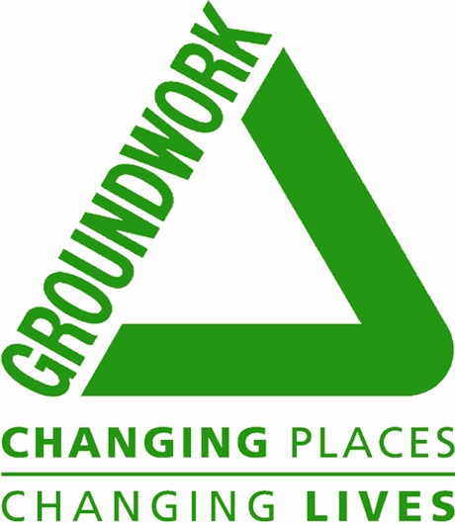

How to Apply

First, read the relevant job description and person specification

- Are you happy with the responsibilities?
- Do you fulfil the essential criteria?
- Are you aware of and satisfied with the terms of the post?

If you answer yes to all the above, please complete the application form that addresses the criteria in the person specification. The application form is designed to only accept your last four employers.

We do not accept CV for this role. If you wish to include any further information, please include these in a covering letter.

All applications must be received by the closing date.

Email: Recruitment.South@groundwork.org.uk
Contact Number: 07736 133058

Please note, we reserve the right to close applications early in the event of a large response.

Shortlisting will depend on how well you demonstrate your ability to meet the criteria. Please provide evidence of experience of how you meet the criteria. Include relevant voluntary or non-work experience as well as experience from previous employment. Due to the large number of applications that we receive we will not be able to provide feedback on your application and we will only contact shortlisted candidates. If a candidate is shortlisted, he/she will normally be notified by email with further details of the interview time and process.

Due to the limited resources of Groundwork South as a non-profit organisation, we are unable to reimburse expenses incurred by candidates attending the interview.

As a Disability Confident Employer, we interview every disabled applicant who meets the minimum criteria for the job. Once you’ve applied, please send us an email stating that you have a disclosed disability, and we’ll interview you. If you need any support or adjustments with your application or attendance at interview please let us know.

