GROUNDWORK  GREATER MANCHESTER |  |  | 
 | Green Doctor

SALARY
Pay Grade: F to E following successful qualification.

GGM operates a graded pay scheme which permits salary progression within grade subject to appropriate performance level. Our normal policy is to appoint at base of grade.

DURATION OF THE POST
Permanent

HOURS
36hrs 40mins
Part-time and flexible working options are available and we are happy to discuss preferred working patterns with candidates.

LOCATION
Tameside office with travel across Greater Manchester

ACCOUNTABLE TO
Energy Advice Service Manager

RESPONSIBLE FOR
Volunteers and trainee Energy Advisors

OVERVIEW OF THE POST
The team of Energy Advisors offer practical energy, water saving and retrofit advice and guidance to low income and vulnerable people across Greater Manchester, making their homes more energy efficient and cheaper to run. This includes providing measures to keep people warm, identify financial support when needed and fit energy saving equipment along with helping refer residents to other organisations that can help with finances, health or home safety.

This post is recruited as a trainee with automatic progression to qualified Energy Advisor on successful completion of the level 3 qualification in Energy Awareness within 6 months.

ROLE & MAIN PURPOSES OF THE POST
Delivery
- Deliver energy, water saving and retrofit advice services across Greater Manchester, including:
- Undertake home visits to install simple and effective measures to help residents to reduce their energy and water consumption and to save money.
- Provide advice to residents and encourage them to further reduce their energy consumption and make cost savings by making changes to their behaviour which also support a changing climate.
- Carry out an energy efficiency survey in each home visited.

- Meet deliverables and quality standards and collect impact and outcome data for learning and reporting.

Business & Service Development
- Manage existing project relationships and networks and generate new relationships or opportunities to support the sustainability of the service.
- Promote energy advice services through marketing and networking.
- Seek stakeholder feedback and use internal and external data and learning to make recommendations for improvements to services.
Financial & Resource Management
- Plan and manage activity budgets and resources.
- Support the preparation of smaller funding proposals including design, writing and pricing, under guidance.
- Produce statistical analysis and progress reports for funders and partners.

People Management & Development
- Share specialist skills and knowledge with others.
- Supervise volunteers or trainees.
- Embed GGM culture and values through own behaviours and providing supportive challenge to others.

Internal Management
- Embed GGM policy and procedure within energy advice service.
- Support delivery of business improvement priority plans within energy advice service.
- Support organisational needs/development as required.

Person Specification
Essential Experience  None required. | Desirable Experience  - Working with people from a diverse range of backgrounds
Essential Knowledge, Skills and Qualifications  - Willingness to achieve L3 qualification in Energy Awareness within 6 months.  - Computer literate with practical experience of using MS Office and willingness to learn and use other software packages  - Good knowledge of the challenges facing communities.  - Hold a full clean driving licence and have access to a vehicle. | Desirable Knowledge, Skills and Qualifications  - Experience of supporting people to save money/energy in their homes.
Values and ethos:
Demonstrates practical understanding of organisation values and can describe how these might apply to role and how they would embed these across the organisation.
Passion for the organisation and our work, including empowering people to make informed choices in the face of the climate crisis.
Actively seeks learning and development.

ADDITIONAL FACTORS
- Able to work outside of normal office hours within a flexi time / time off in lieu system.
- Comply with the organisation’s policies and procedures including, but not exclusively, Equality, Diversity and Inclusion, Data Protection, Health and Safety, Safeguarding and Environment.
- This post will be subject to a basic DBS check.

PREPARED BY: | 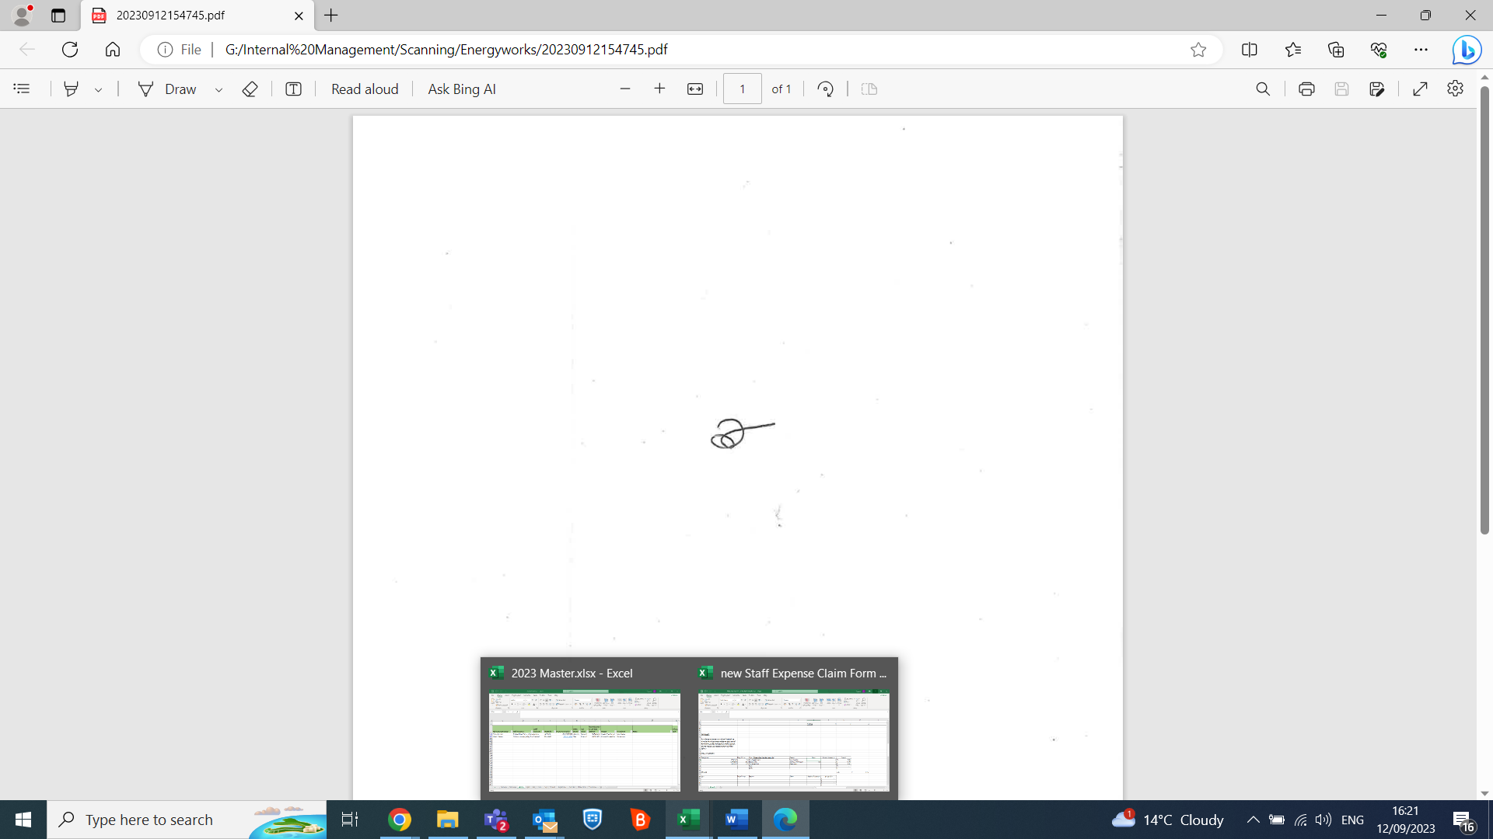
PREPARED ON: | 09/05/2025

