Brief for the position of

Community & Environment Project Officer

Groundwork West Midlands

April 2025

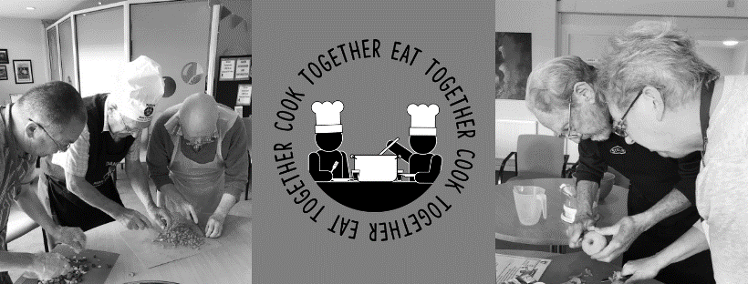



# Overview

Groundwork is a charity working to transform lives in the UK’s most disadvantaged communities.

We are passionate about creating a future where every neighbourhood is vibrant and green, every community is strong and able to shape its own destiny and no-one is held back by their background or circumstances.

We help people gain confidence and skills, get into training and work, protect and improve green spaces, lead more active lives and overcome significant challenges such as poverty, isolation, low skills and poor health.

**We create better places**



By making communities greener, safer and healthier and by enabling people to work together to bring about change in their local area

**We improve people’s prospects**

By increasing the confidence, skills, wellbeing and employability of those struggling in education or out of work.

**We promote greener choices**

To help people and businesses reduce their environmental impact, improve their health, cut waste and save money.



# Our Vision

“To help shape vibrant communities across the West Midlands, where people are healthier, more resilient and enterprising”



# Our Mission

“To enable people to flourish, and to support the creation of sustainable environments through collaboration, behavioural change and practical action”



# Our Social Objectives

We are passionate about;

o Creating better places & connections to the natural world

o Improving peoples’ prospects & raising aspirations

o Promoting healthier & greener choices

We believe that working with local communities to build their resilience is vital in facing up to the challenges of a post-Covid-19 West Midlands. We know that the negative effects of climate change and environmental breakdown impact first and worst on those who have the least power in society, and who contribute least to the cause of the crisis. A ‘just transition’ to an inclusive, net-zero economy must tackle, rather than entrench, this inequality and provide a springboard for better work and healthier, happier lives in the places that need it most.

This means creating green jobs that build wealth in local communities, changing behaviour to reduce wasted food, energy and water, providing biodiverse, accessible green spaces, supporting businesses to be more responsible and empowering communities to lead activities that improve their quality of life and promote health and wellbeing.

# The Future

The charity has an income of around £3.5M per year and is having a positive impact across the region. Following an extended period of lockdown where the organisation has discovered new and innovative ways of delivering our work, GWWM now has clarity around its purpose and is fit for the future. The CEO and senior team are now working hard to plan an organisation that delivers relevant and meaningful work in a post-Covid crisis world, to build on the excellent work already undertaken in our turnaround plan, shaping and embedding a culture in an organisation that is excited by future opportunities.

The CEO’s primary task is to now ensure that GWWM is a visible, active and recognisable positive presence in the region, building relationships with partners and exploring the development of new activities and initiatives.

This is an exciting time in the evolution of Groundwork West Midlands, and as such, we are delighted to be recruiting a Project Officer to join our team and help to take the organisation forward at this vital time in our development, when the organisation is effectively being relaunched to grow and play an active and vital role in making the West Midlands a better place to live and work.

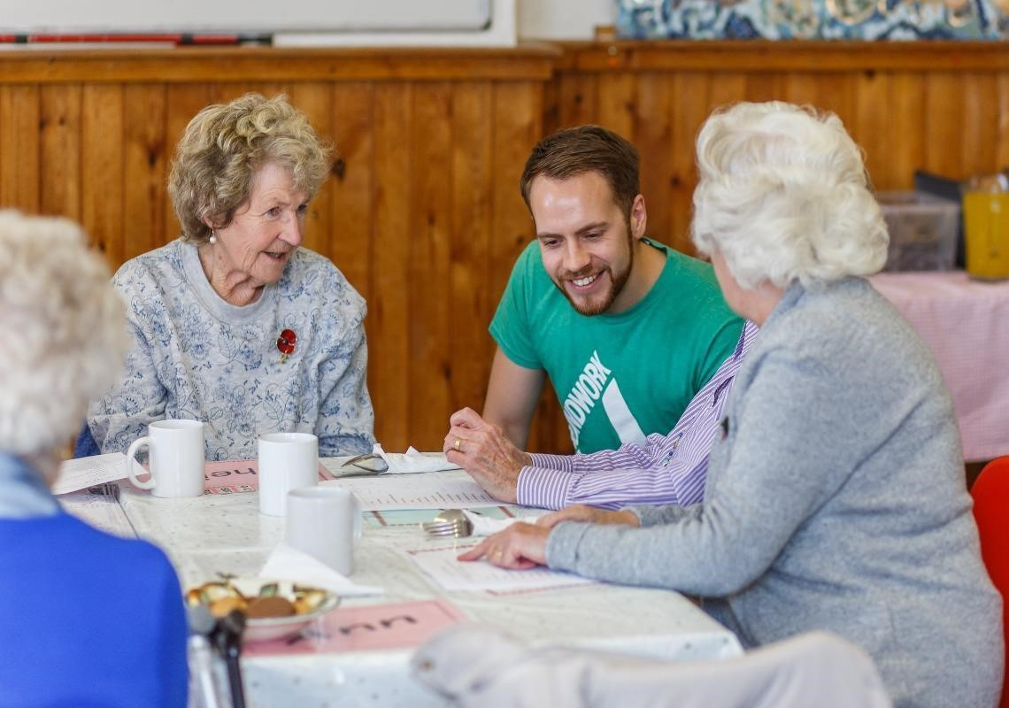

# Job Description

|  |  |
| --- | --- |
| **JOB TITLE:** | Community and Environment Project Officer |
| **SALARY:** | £24,858 |
| **REPORTS TO:** | Land Manager |
| **LOCATION:** | Tipton (travel around the West Midlands area). |

**ROLE SUMMARY**

We are looking for a passionate and proactive Land and Environment Project Officer to lead community-driven initiatives that enhance the use and stewardship of local parks and green spaces. This role aims to increase community engagement, reduce anti-social behaviour, and promote well-being through nature-based activities for both adults and children.

**KEY RESPONSIBILITIES**

* **Community Engagement:** Foster strong relationships with local communities to encourage active participation in park usage and environmental stewardship.
* **Volunteer Coordination:** Recruit, train, and support volunteers, empowering them to take positive, practical actions in preserving and enhancing green spaces.
* **Environmental Projects:** Plan and execute site-based improvement works in parks and green spaces, focusing on sustainability and ecological restoration.
* **Education and Outreach:** Develop and deliver educational programs that teach practical skills and promote environmental sustainability, aiming to connect people with nature and foster long-term behavioural change.
* **Well-being Promotion:** Implement initiatives that leverage natural environments to improve the physical and mental well-being of community members.

**MAIN DUTIES**

* Assist in planning and delivering community engagement projects.
* Undertake site-based conservation and environmental improvement activities across a range of urban green spaces
* Work as part of the Land Team – working closely with colleagues and volunteers to ensure projects are completed safely, on time, and to a high quality
* Work in a co-operative and professional manner with other Groundwork staff and community volunteers
* Ensure the safe use of all work equipment, tools and vehicles
* Ensure work equipment, tools and vehicles are maintained regularly in accordance with Trust guidelines
* Adhere to written risk assessments and verbal instruction for each job or as site conditions change
* Help to generate new ideas to improve the Land Team
* Undertake additional tasks or duties that may be reasonably requested as necessary to improve job performance or to support the overall functioning of the organisation.

**PERSONAL DEVELOPMENT AND TRAINING:**

* Engage with training and development opportunities, including on-the-job, practical skills development, and classroom based activities
* Please note: Appointment to this post is subject to a DBS check, in line with Groundwork’s Safer Recruitment policy

**OTHER RESPONSIBILITIES:**

* To play an active role as appropriate more widely across Groundwork West Midlands to develop Groundwork’s project programme; and influence the Trust’s work overall.
* Promote Groundwork activities at a local and regional level; providing an efficient and courteous service.
* Ensure compliance with Trust policies, insurance and statutory requirements, particularly health and safety, safeguarding (including Prevent) the Children’s Act and equal opportunities.
* To undertake any task that may be requested from time to time by the Management Team as may be consistent with the nature and scope of the post.

**Date:** **May 2025**

**This post is exempt from the provisions of the Rehabilitation of Offenders Act. A DBS check will be required prior to appointment.**

# Person specification

Note to Applicant: When submitting your CV and cover letter, you should demonstrate the extent to which you have the necessary education, experience, knowledge and skills identified as a requirement for the post. (Note: Where items appear which have not been deemed essential, you should assume they have been considered desirable).

|  |  |  |  |  |
| --- | --- | --- | --- | --- |
| **Factor** | **Criteria** | **Ranking** | **Shortlist Criteria** | **Selection method used to evidence criteria** |
| **Qualifications** | Educated to Level 2 or equivalent in Maths and English i.e. GCSE Grade 9-4 or A*-C | Essential | Yes | CV & Cover Letter |
| Qualification in one or more of the Charities core areas of work i.e. Community, Youth, Environment, Health, Education. Or relevant experience. | Desirable | Yes | CV & Cover Letter |
| Full driving Licence and access to own car for business travel. | Essential | Yes | CV & Cover Letter |
| CSCS Card | Desirable | No | CV & Cover Letter |
| **Experience** | Experience in planning and delivering community and environmental activities for various audiences such as adult volunteers, families or young people. | Essential | No | CV & Cover Letter/Interview Process |
| Proven experience of delivering practical environmental, conservation or landscape work, including the use of hand tools. | Essential | Yes | CV & Cover Letter/Interview Process |
| Experience of partnership working from a variety of different sectors i.e. voluntary, statutory and corporate. | Desirable | No | CV & Cover Letter/Interview Process |
| Experience in using social media for business purposes. | Desirable | No | CV & Cover Letter/Interview Process |
| Experience of adhering to H&S regulations relating to working with tools and the community. | Desirable | No | CV & Cover Letter/Interview Process |
| Experience in the use of tools such as strimmer’s, hedge trimmers, brush cutter and general hand tools. | Desirable | No | CV & Cover Letter/Interview Process |
| Knowledge | A general understanding of the needs of people living in disadvantaged neighbourhoods and the issues they face. | Essential | Yes | CV & Cover Letter/Interview Process |
| Awareness around the safeguarding of children, young people, and vulnerable adults, along with the understanding of procedures to follow. | Essential | Yes | CV & Cover Letter/Interview Process |
| Passion for connecting people with nature and fostering community-led environmental action. | Essential | Yes | CV & Cover Letter/Interview Process |
| Knowledge of environmental sustainability practices and principles. | Desirable | No | CV & Cover Letter/Interview Process |
| Interest in local and global environmental issues | Essential | Yes | CV & Cover Letter/Interview Process |
| Skills | Excellent communication, (e.g. clear and concise written work) and social skills. | Essential | Yes | CV & Cover Letter/Interview Process |
| Able to work on own initiative and as part of a team. | Essential | Yes | CV & Cover Letter/Interview Process |
| Flexible:  - Can adapt to changing circumstances  - Problem solve  - Travel for the role, transporting equipment / resources if required  - Work out of office hours, i.e. late afternoons and occasional weekend events. | Essential | Yes | CV & Cover Letter/Interview Process |
| Able to maintain a professional attitude and boundaries when working with communities, including children, young people and vulnerable adults | Essential | Yes | CV & Cover Letter/Interview Process |
| Computer literate, including MS Word, Excel, email, Teams / Zoom and social media (Facebook). | Essential | Yes | CV & Cover Letter/Interview Process |



# How to apply

To apply, please submit your CV and a covering letter outlining your skills and reasons for applying for the role at Groundwork West Midlands to wmhr@groundwork.org.uk

*In line with GDPR, we ask that you do NOT send us any information that can identify children or any of your Sensitive Personal Data (racial or ethnic origin, political opinions, religious or philosophical beliefs, trade union membership, data concerning health or sex life and sexual orientation, genetic and / or biometric data) in your CV and application documentation. Following this notice, any inclusion of your Sensitive Personal Data in your CV/application documentation will be understood by us as your express consent to process this information going forward. Please also remember to not mention anyone’s information or details (e.g. referees) who have not previously agreed to their inclusion.*