Online application
user guide 2025/26

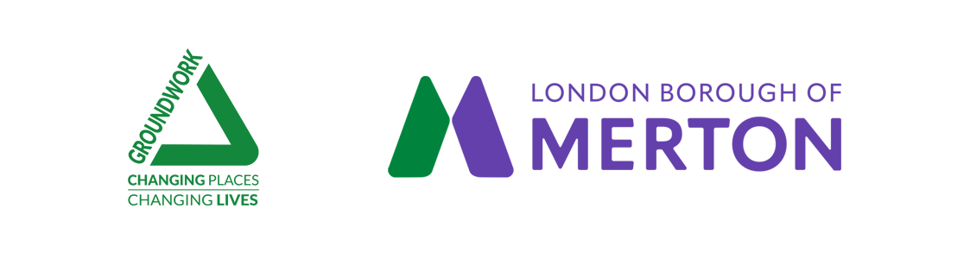

Introduction to this user guide

This guide takes you through the process of registration, logging in, site navigation, and completing and submitting your application. It should be read alongside other guidance documents including the Application Questions and Guidance.

You apply through a web portal called Blackboard Grantmaking (BBGM). This portal helps you to manage your application by providing a dashboard where you can view the status of your application and any supporting documents all in one place.

You will be able to save and come back as many times as you like to your application form before you submit it, and you can receive updates on the status of your application. BBGM will also allow us to provide you with support throughout the process.

- Registration

You will be provided with a link by Groundwork to apply online. This will be either following your Audit report or following a conversation with Groundwork.

This link will take you to the Blackbaud Grantmaking (BBGM) portal where you may need to create a new account or login.

How do I create an account?

To create an account, follow the steps below:
- Select to continue with your Email
- Enter in a valid email address
- Click send verification code to verify your email address
- Enter the one-time passcode to confirm your email
- Enter in a valid password

Tip: Password requirements: At least 12 or more characters, with at least one uppercase, lowercase, number, and special character.

- Enter first and last name
- Click the button Sign Up to create the account

You should receive the confirmation email within a few minutes of the request. If your confirmation or invitation emails are not delivering to your mail inbox, follow these troubleshooting steps:

- Check your junk or spam folder.
- Delete your cookies
- Try using an email address associated with a person (e.g. jane@company.co.uk), rather than a generic business email address (e.g. admin@company.co.uk). These email addresses may get blocked for security reasons.
- Navigate to app.blackbaud.com > Click continue with email > Enter your email address > Click the Forgot Password link to begin the password reset process.

To ensure that you receive all correspondence relating to your application, please save the following email address within your contacts: noreply@yourcause.com. Otherwise, some important emails may go to your junk/spam folder.

- Logging in

Once registered, you can log in to your dashboard area by clicking on the link provided in your verification email. You will be asked to enter your email address and password. If you have forgotten your login information you can reset your password by clicking on the ‘Forgot your password?’ link.
Once logged in, you will be able to access your dashboard where you will find your in-progress application.

- Dashboard

Your dashboard will display the application that you have started, and any that are in progress (on the basis that you may have applied for other grants through Groundwork). The image below is an example of what you will see once you have logged into your account.

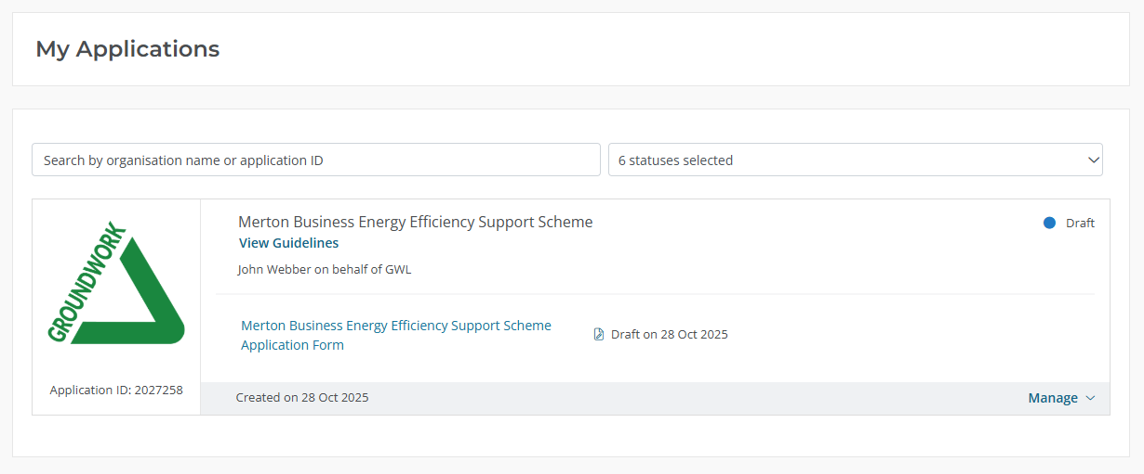

- Applying online

The online application form has seven sections:

- Business Information
- Proposed Works
- Budget
- Declarations
- Confirmations
- Privacy Information

You should complete each section in this order, moving onto the next section once you have completed the previous one. You can browse through all sections to see all the questions at any time.

The application saves automatically when you complete a question and move onto the next one.

If you select the ‘Applications” button in the top left-hand corner of the page you will be taken to the dashboard.
The application form will highlight any missing information on each section with a red exclamation mark (!) if they are not completed. You will need to answer each highlighted question before you are able to submit the application form.

You can edit your responses in any completed sections by re-entering the details.

Once submitted, your application can no longer be edited. Its status will be changed to ‘Submitted’ with a date this was submitted on. You can log in to your account and view this application within your dashboard at any time.

- Help

Guidance and supporting documents are available to download from the Merton Business Energy Efficiency Support Scheme webpage here. We advise that you review these before starting your application, especially the Prospectus and Application Questions and Guidance.

For some questions, additional explanations are provided.

If you need further guidance, email us on MertonBEESS@groundwork.org.uk or call 0207 239 1390.

- Logging out

To log out of your session, either click on ‘Applications’ or exit the website. But remember – the answer you are editing will only be saved when you exit the box you have been editing.

The first deadline to submit your grant application is 8th December 2025 (extended by a week from 8th December 2025).

