Benefits of Outdoor Residential Experiences

We know that school life and home life can be very busy. Your residential, provides an opportunity to get into the outdoor, manage time away from your screens and digital world (TV, Phones & Tablets). It isn’t just about that though; there are numerous other benefits. Groundwork London connects young people with nature, adventure, and the environment, this has a positive impact on your brain and how you feel.
Reduces Stress & Anxiety
Your residential trip to Yenworthy Lodge in North Devon, offers you a chance to get away from any stressful routines and situations. This can help your brain relax, which can result in feeling refreshed and more energetic.
One of the more awesome benefits of connecting with nature is that it regulates the hormones in your body; improving your mental health.

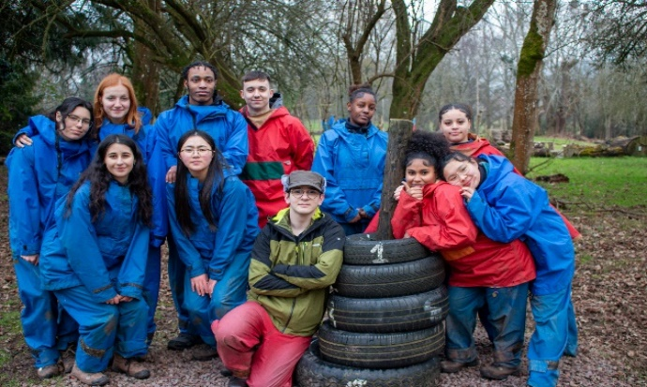
Engaging in outdoor activities can often reverse the symptoms of stress and anxiety. Through your daily reflections this week, it may also help you find some of the cause or reasons behind them.
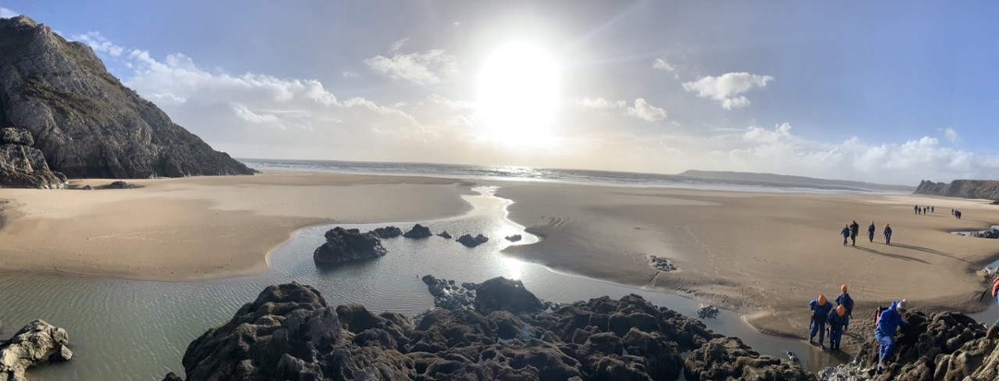

It Stimulates Your Senses
Engaging in the outdoors and connecting with nature stimulates all your senses. Being in a new environment can help you to think and interact in new and different ways. It can assist you in staying focused, it can also sharpen your memory alongside your environmental and spatial awareness.
We hope this residential will provide the perfect opportunity to explore the outdoors and natural environments, and that these new experiences help you to think more positively.
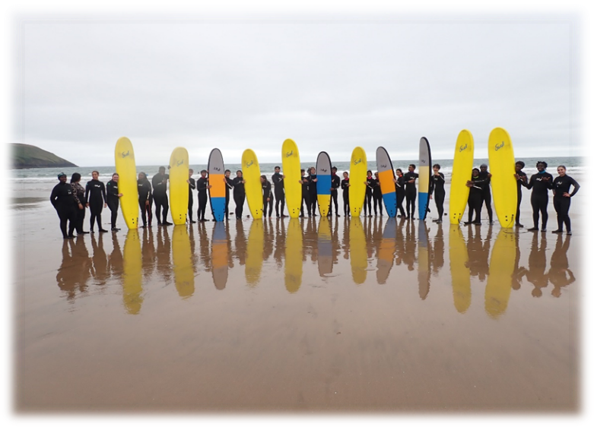
When you spend time connecting with nature, you will observe amazing sceneries, leading to mental restoration. This can also help you to positively and emotionally connect with the environment and the people around you.
Leads to Better Sleep
We know that there is always a temptation to stay up late on residentials.
However, you will be kept very busy, in the fresh air, taking part in lots of activity. Inadequate sleep can be detrimental to your mental health. It leads to stress, physical and mental tiredness, and other health issues. Being outdoors can improve your sleep.
Outdoor activities also release endorphins and dopamine in your body, which relaxes you. As you will be taking part in various adventurous activities, alongside some workshops and on-site activities in the evening, you will be using up lots of energy. These long days will leave your body feeling very tired, so the chances of falling asleep early will increase; don’t resist!
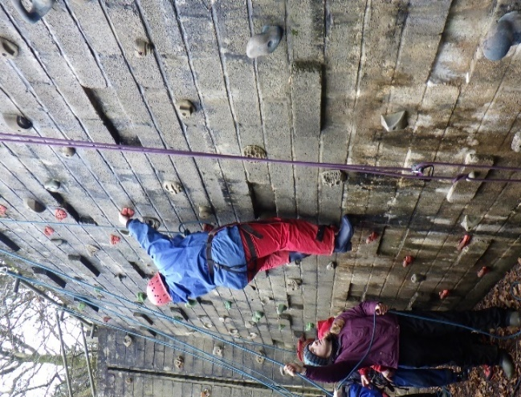
Increases your ‘Vitamin D’ Intake
Vitamin D plays a really important role in your body. It boosts calcium deposits in your bones, increasing their density and strength. It also has a positive impact on your mental health as the sunlight you will absorb when outdoors is a natural source of Vitamin D.
So, from Vitamin D, both mental, as well as physical benefits can arise from your outdoor residential experience.
