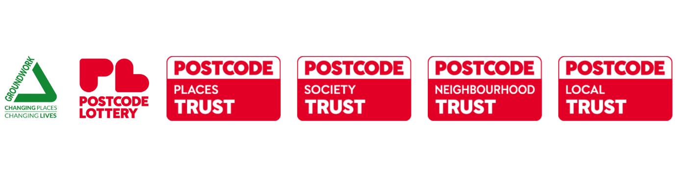
Communications Guidance
Postcode Lottery Grassroots Grants programme

Introduction

We encourage you to promote your success in securing a grant through the Postcode Lottery Grassroots Grants programme and have provided some handy tips
to help you. You can do this through the local media, social media and online, and this guidance lets you know how to use Groundwork and Postcode Lottery branding.

Postcode Lottery manages multiple society lotteries promoted by different charities supporting a range of good causes. Players of the Postcode Lottery have raised more than £1.4 billion for thousands of charities and local good causes to date. At least 30% of each ticket goes towards good causes and charities.

Groundwork UK is managing the ‘Grassroots Grants’ programme on behalf of Postcode Lottery.

PR & Press

We want to help you celebrate and commemorate your project. However, your project should not be publicly announced until you have met all of the conditions of your Award and had this confirmed by your Grants Officer.

Once you have received this you are then free to promote the grant and your project in line with your Terms and Conditions and this guide. Groundwork must approve any media releases or publicity materials before they are issued.

Local media is a great way of raising support and awareness for your project. To help you do this, you may wish to issue a press release to announce your project has received funding from the Postcode Lottery Grassroots Grants programme. If you would like to issue a press release about your involvement an example template is included on the documents page which you can adapt and use yourself – simply fill in your information and find your local media contacts through a quick Google search.

For approval of any media releases or if you have any questions about your press release, please email media@groundwork.org.uk.

Groundwork and Postcode Lottery may contact you during the delivery of your project for assistance with press or media activity such as to take part in an interview.

Case studies

At Groundwork, we are always looking for stories to tell about the amazing people we work with. We would like to hear from our grant recipients about their projects and the people they support.

If you are interested in telling your story you can submit more information about your
project using this link and we will be in touch: https://www.surveymonkey.co.uk/r/gwk-community-stories

Social media

Social media is a good way to spread the word about your project. To help, we have produced some example text for you to use:

“Absolutely delighted to have been awarded a Grassroots Grant for £[INSERT AMOUNT] thanks to funds raised by Postcode Lottery players. #PostcodeLottery”

“We’ll be using our £[INSERT AMOUNT] Grassroots Grant to [DETAILS OF PROJECT]. Thanks to the support of Postcode Lottery players! #PostcodeLottery”

These are just examples, so please feel free to come up with some of your own. You
could also include images from your project to show how the grant will help.

Please use the hashtag #PostcodeLottery when talking about the grant on social media and tag the following accounts:
Facebook | @PostcodeLotteryUK / @Groundwork
Instagram | @PostcodeLotteryUK / @groundwork_uk
X (formerly Twitter) | @PostcodeLottery / @groundworkuk
LinkedIn | Postcode Lottery UK / Groundwork

Top tip: pictures and videos help make people interested and share your message.
It’s also a good idea to take a ‘before’ picture if relevant, so you can show the
difference the grant has made.

Project photography and film

Groundwork and Postcode Lottery may contact you during the delivery of your project to arrange for professional photography and film to be taken at your project.

Any resulting photography and film may be used by Groundwork and Postcode Lottery for promotional activities.

Please do share with us any films or photographs that you produce to promote your
project by emailing us. By sharing this content with us, you confirm that you have the
explicit consent of anyone featured in the film or photographs for the content to be
used by Groundwork and Postcode Lottery for promotional activities.

Please email any film or photography to media@groundwork.org.uk.

Contacting your local MP

You can also write to your local MP with details of your Postcode Lottery Grassroots Grant and invite them to visit as this can be an excellent way of drawing your MP’s attention to your project. If you’re unsure of who your local MP is, you can
find a searchable database of MPs here.

Blog/website/newsletter

If you have a blog, website or newsletter, you can use the following text to describe
your Postcode Lottery Grassroots Grant.

“Our project has received a £[INSERT AMOUNT] grant from the Postcode Lottery Grassroots Grant programme. Find out more about Postcode Lottery here: www.postcodelottery.co.uk”

Logos and branding

We have logos that you should use in relation to your project, for example on posters
or reports. The logos must not be changed in any way other than making them smaller or larger. If you want to use either Groundwork or Postcode Lottery logos on any products or permanent locations please speak to us first.

You can download the logo via this link: Grassroots Grants Communications Toolkit - Groundwork

Please ensure you use the logo of the correct Postcode Lottery Trust. You can find the name of the Trust that you have been funded by in your offer letter. There are four Trusts:
- Postcode Neighbourhood Trust
- Postcode Local Trust
- Postcode Places Trust
- Postcode Society Trust

Events and invitations

If you would like to generate further publicity for your project and receipt of the award,
you may like to consider arranging an official launch event for your project or a
celebration for project beneficiaries at the end, at which Groundwork and Postcode Lottery may be represented. You should email us with details of the event, giving at least two weeks’ notice: grassrootsgrants@groundwork.org.uk.

Media enquiries

If you have any national media or journalists’ enquiries regarding the Postcode Lottery Grassroots Grants programme or your funded project, we ask that you contact us as soon as possible:

Email: grassrootsgrants@groundwork.org.uk and media@groundwork.org.uk
Telephone: 01212 373640

Queries regarding your funding

If you have any questions about your project or about receiving the funding, please
contact:

Email: grassrootsgrants@groundwork.org.uk
Telephone: 01212 373640

