

Groundwork East
Carbon Reduction Plan

July 2026

Table of Contents

About Groundwork East 3
Commitment to achieving Net Zero 3
Baseline Emissions Footprint 4
Current Emissions Reporting 6
Emissions Reduction Targets 7
Carbon Reduction Projects 9
Completed Carbon Reduction Initiatives 9
Future Carbon Reduction Initiatives 9
Declaration and Sign Off 10

About Groundwork East

Groundwork East is a charity mobilising practical community action on poverty and the environment across the East of England.

We believe that working with local communities to build their resilience is vital in facing up to the challenges of a globalised economy and a changing climate. This means creating green jobs that build wealth in local communities, changing behaviour to reduce wasted food, energy and water, providing biodiverse, accessible green spaces, supporting businesses to be more responsible and empowering communities to lead activities that improve their quality of life and promote health and wellbeing.

The UK Government amended the Climate Change Act 2008 in 2019 by introducing a
target of 100% reduction in the net UK carbon account (i.e. reduction of greenhouse gas emissions compared to 1990 levels) by 2050.

This is otherwise known as the ‘Net Zero’ Target. This plan outlines our compliance with Action Note PPN 006 (the public procurement note outlining the requirement for Carbon Reduction Plans for government and NHS procurement which came into effect in September 2021).

Commitment to achieving Net Zero
Groundwork East is committed to achieving Net Zero by 2050 or sooner.

Baseline Emissions Footprint

Baseline emissions are a record of the greenhouse gases that have been produced in the past and were produced prior to the introduction of any strategies to reduce emissions. Baseline emissions are the reference point against which emissions reduction can be measured. Groundwork East’s baseline emissions year has been set as April 2019 to March 2020.

Baseline Year: 2019/20
Additional Details relating to the Baseline Emissions calculations.
Groundwork East has been accurately and consistently measuring its emissions from 2019.
Scope 1
Since the 2019 baseline emissions, natural gas was confined to the Norfolk office which has now been closed. There are therefore no emissions coming from natural gas at present.
Trust fuel use is being reported based on recorded litres purchased to improve the accuracy and better reflect any improvements from vehicle choice and driver style.
Scope 3
Business travel emissions is calculated via employee expenses claims.
Staff commuting emissions have been quantified based on each staff’s contracted workdays each month and their declared daily commute mileage minus the ‘avoided mileage by working from home’ recorded in staff expenses for that period, which will therefore correctly include assumed ‘commutes’ to both offices and work sites and conversely record homeworking days.

Baseline year emissions: 2019/20
EMISSIONS | TOTAL (tCO₂e)
Scope 1 | 16.2
Scope 2 | 18.7
Scope 3  (Included Sources) | 125.1  Including:
 | 3. Fuel and Energy Related Activities Not Included in Scope 1 or Scope 2 | 8.2
 | 5. Waste Generated in Operations | 0.8
 | 6. Business Travel | 38.6
 | 7. Employee Commuting | 77.3
Total Emissions | 160.0

Current Emissions Reporting

Reporting Year: 2025/26
EMISSIONS | TOTAL (tCO₂e)
Scope 1 | 3.3
Scope 2 | 5.4
Scope3  (Included Sources) | 50.9 Including:
Scope3  (Included Sources) | 3. Fuel and Energy Related Activities Not Included in Scope 1 or Scope 2 | 2.9
Scope3  (Included Sources) | 5. Waste Generated in Operations | 0.1
Scope3  (Included Sources) | 6. Business Travel (including employee mileage in own vehicles, rail travel and accommodation) | 18.8
Scope3  (Included Sources) | 7. Employee Commuting & Homeworking | 28.9
Location Based Emissions | 59.6
Market Based Emissions | 59.4

Emissions Reduction Targets

Groundwork East has committed to reach net zero before the government’s current target of 2050. Following careful consideration and review of our operations and associated emissions we have set the following interim targets for this pathway;

1. To reduce our baseline emissions by one third (32%) by March 26
2. To reduce our baseline emissions by half (50%) by March 35

Our emissions have decreased by 63% since our baseline year (from 160.0tCO₂e in 2019/20 to 59.6tCO₂e in 2025/26.

Our market-based emissions statement (taking into account the purchase of renewable and zero carbon electricity supply) is 59.4tCO₂e in 2025/26.

As we have now exceeded both of our interim targets, we are currently reprofiling our decarbonisation pathway, and we continue to improve data collection systems and investigate additional carbon reduction measures. This will enable us to set additional interim targets to 2050.

A breakdown of proposed carbon reduction measures and when they will be implemented can be seen in the graph overleaf.

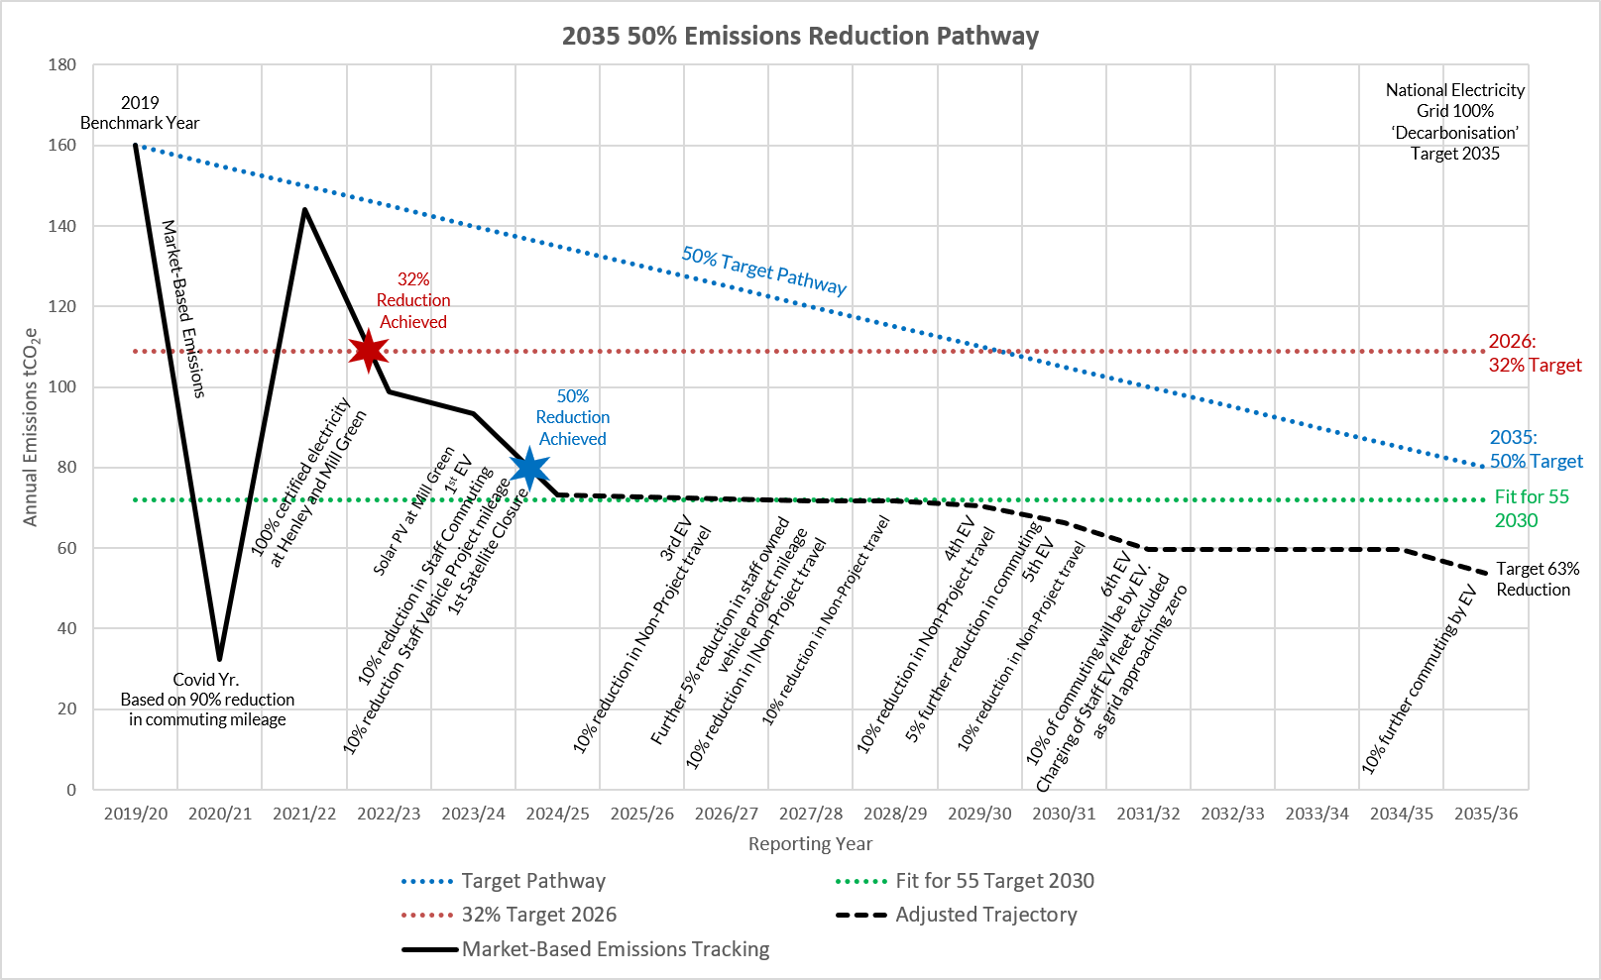

Carbon Reduction Projects

Completed Carbon Reduction Initiatives
The following environmental management measures and projects have been completed or implemented since the 2019/20 baseline.
- Over the past 5 years completed accreditation with the BS8555 Environmental Management Scheme. This is a systematic approach for Groundwork East to bring environmental considerations into decision making and day-to-day operations. An EMS helps ensure that major environmental risks and liabilities are identified, minimized and managed. This is annually audited with regular monitoring and recording of all key emissions sources and associated reduction objectives that are reviewed quarterly by the EMS team, the leadership and EMS representatives in all work locations.
- Closed both our Norfolk and our Essex offices to promote homeworking for our staff based in these counties. This has reduced our staff commuting emissions, as well as reducing emissions associated with heating and powering of the now closed offices.
- Further encouraged hybrid/remote working across the rest of our workforce where possible. Staff in our Mill Green, Stockwood Park, Alconbury, and Henley offices have the option to work from home. This has also reduced emissions associated with staff commuting and heating and powering of the offices.
- The premises at Mill Green have been rebuilt to a higher insulation level with the main heating being provided by energy efficient heat pump systems.
- Improved heating control has been implemented at our Henley offices.
- Solar PV (8kWp) has been installed at Mill Green.
- An electric Citroen van has been purchased to replace a diesel vehicle.
- EV charging points have been installed at the Mill Green premises.
- Improved employee commuting and working from home data recording systems have been introduced.
- The above measures have helped to reduce our overall emissions and increase the efficiency in which the charity operates (kgCO₂e/£’000 running costs and project delivery hours).

Future Carbon Reduction Initiatives
Groundwork East has identified the following additional measures to reduce emissions:
- Adopt relevant standards under the environmental management certification scheme, ISO14001 and self-assess against these best practices.
- Replacing our existing fossil-fuelled business use vehicles to electric vehicles.
- Reducing staff business travel via vehicles by encouraging more remote working and offering staff EV alternatives.
- Commuting mileage reductions through increased hybrid working and offering staff EV incentives.
- Expanding GHG reporting to include Scope 3 – Purchased Goods & Services and engage further with our own suppliers.

Declaration and Sign Off

This Carbon Reduction Plan has been completed in accordance with PPN 006 and associated guidance and reporting standard for Carbon Reduction Plans.
Emissions have been reported and recorded in accordance with the published reporting standard for Carbon Reduction Plans and the GHG Reporting Protocol corporate standard and use the appropriate Government emission conversion factors for greenhouse gas company reporting.
The required subset of Scope 3 emissions have been reported in accordance with the published reporting standard for Carbon Reduction Plans and the Corporate Value Chain (Scope 3) Standard.
This Carbon Reduction Plan has been agreed by the Board of Trustees and is signed off by Groundwork East’s Chief Executive.
Signed: Carolyn Reid

Date: 02.07.26

https://ghgprotocol.org/corporate-standard
https://www.gov.uk/government/collections/government-conversion-factors-for-company-reporting
https://ghgprotocol.org/standards/scope-3-standard

